1). Prepare a rank ordered list of top 10 countries with most players. Which countries are producing the most numbers of footballers that plays at this level?

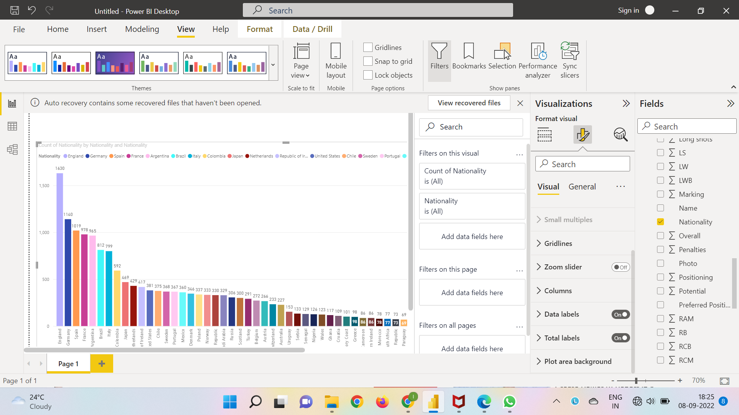

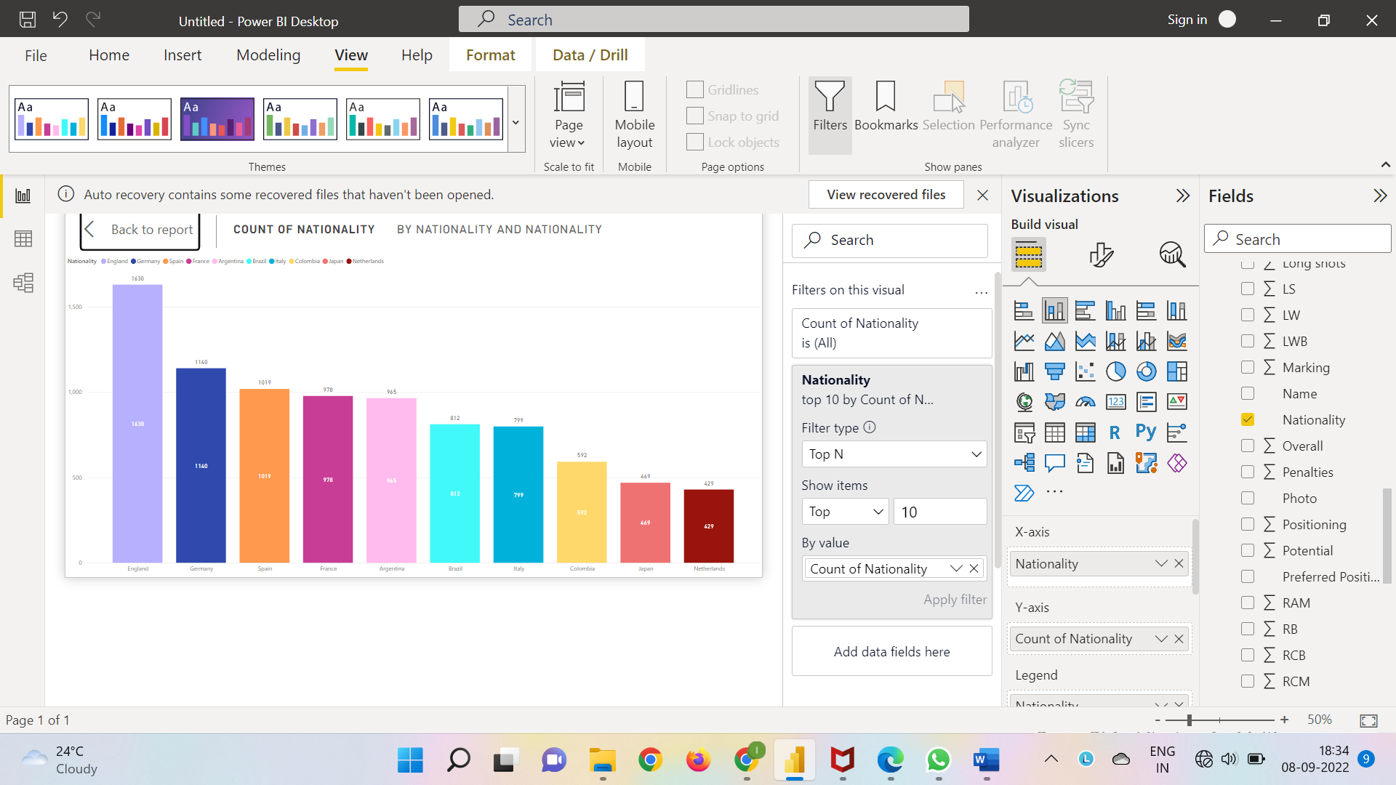

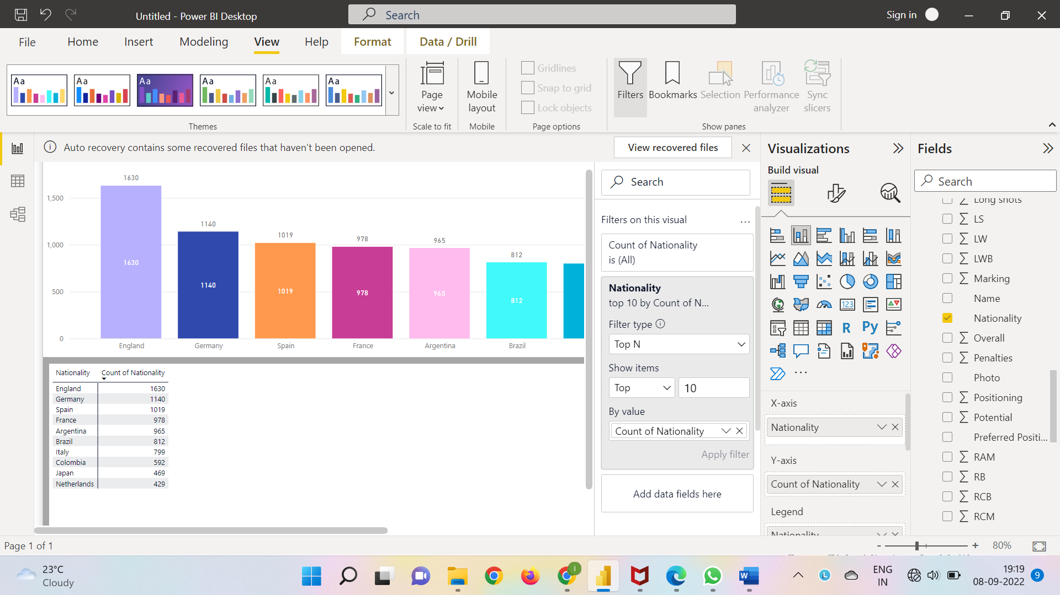

**From the above analysis it’s pretty obvious that the top 10 countries are England, Germany, Spain, France, Argentine, Brazil, Italy, Colombia, Japan and Netherland with respective totals as 1630, 1140, 1019, 978, 965, 812, 799, 592, 469 and 429.**

2). Plot the distribution of overall rating vs. age of players. Interpret what is the age after which a players stops improving?

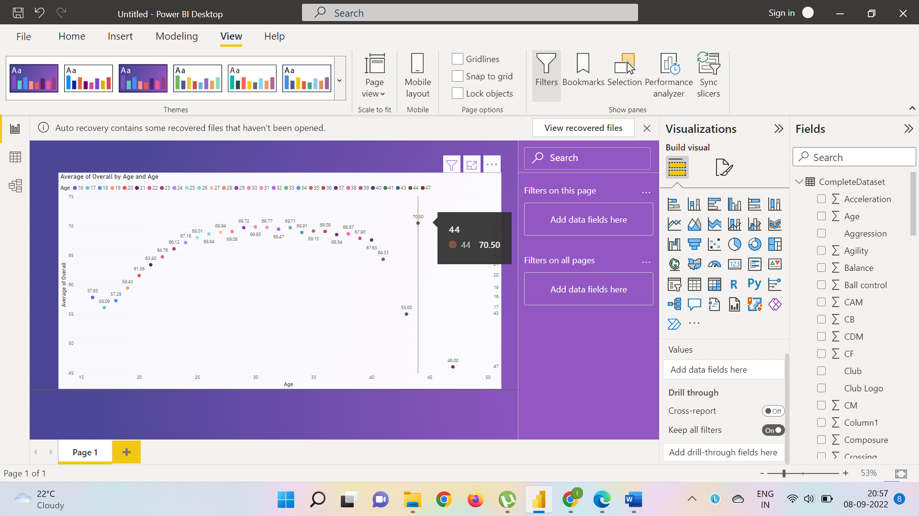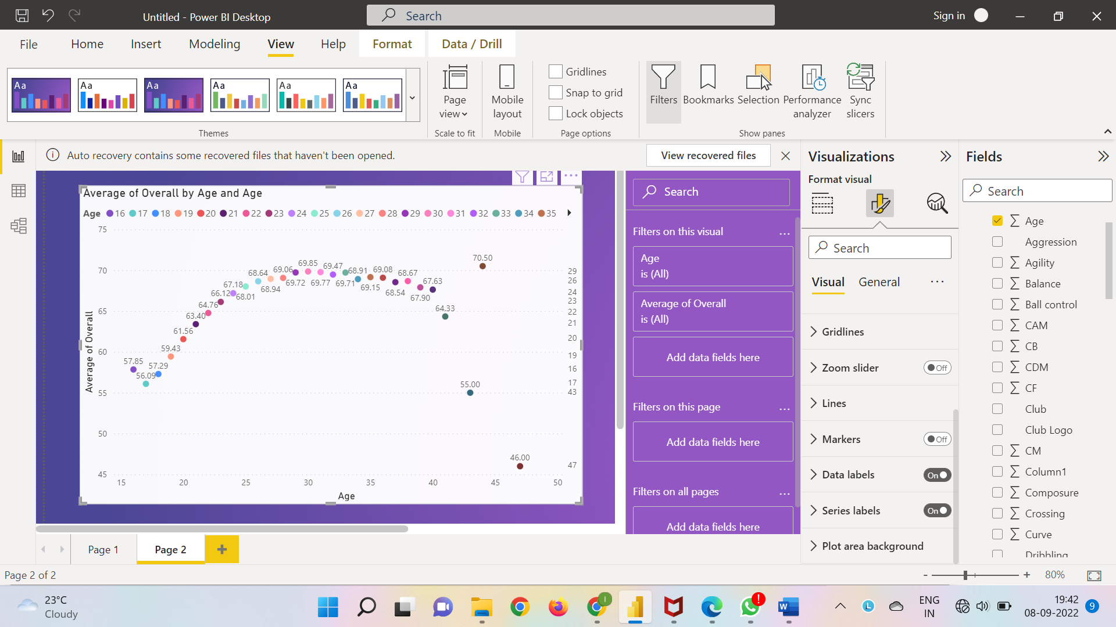

**It is observed that a player stops improving after at an age of 44 and the average of overall starts decreasing from 70.5.**

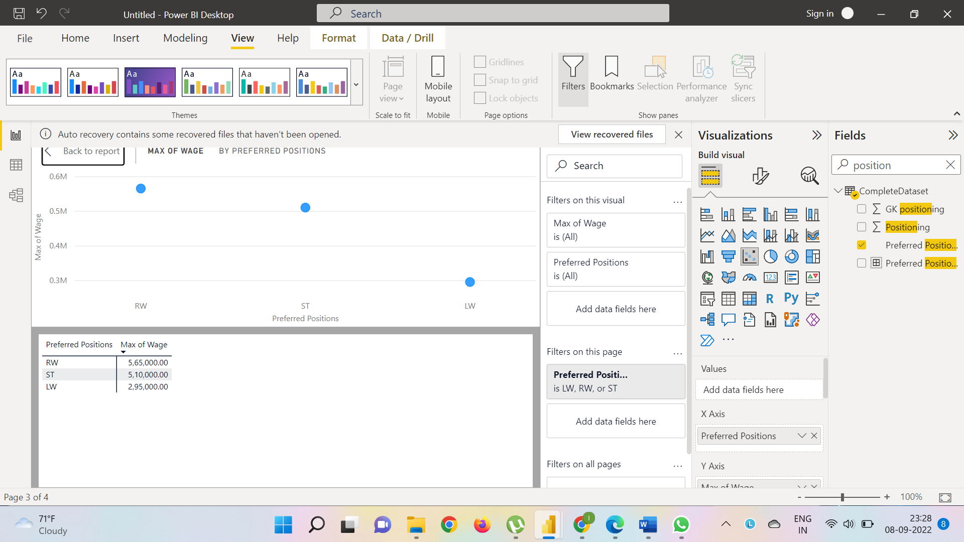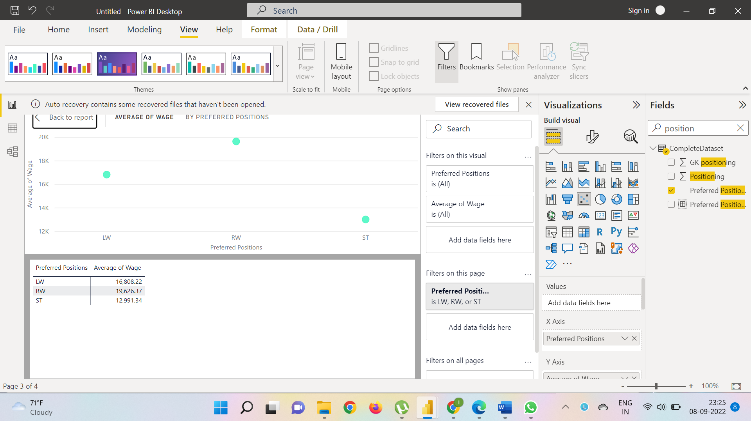3). Which type of offensive players tends to get paid the most: the striker, the right-winger, or the left-winger? Visualize through a scatter plot

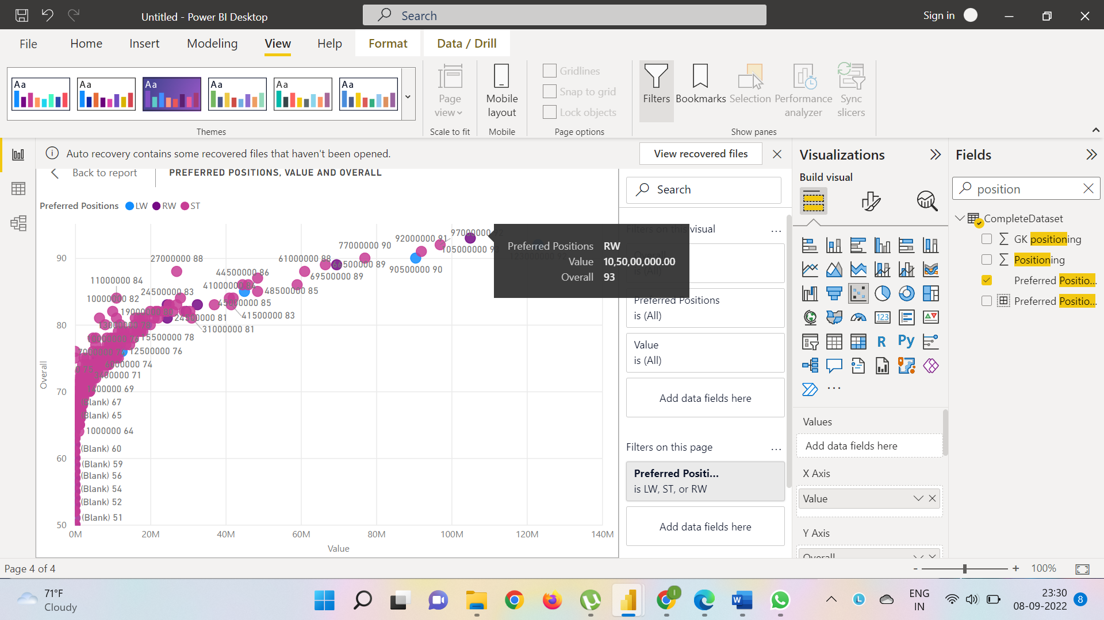

**According to the scatter plot one can observe that RW(right-winger) is being paid the highest sum;**

**The right winger’s value is 10,50,00,000.00**

**Average Wage is 19,626.3**

**& Maximum Wage is 5.65,000.00**

4). Top 5 players for every preferred position in terms of overall as well as potential points. Who were the best in 2018? Who were destined to be the future superstars in that year?

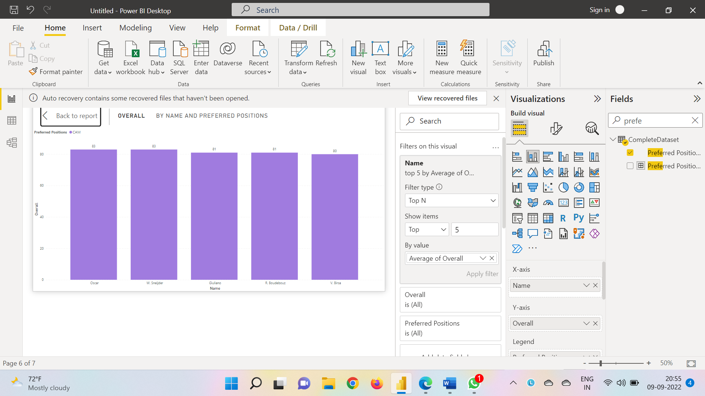CAM Overall

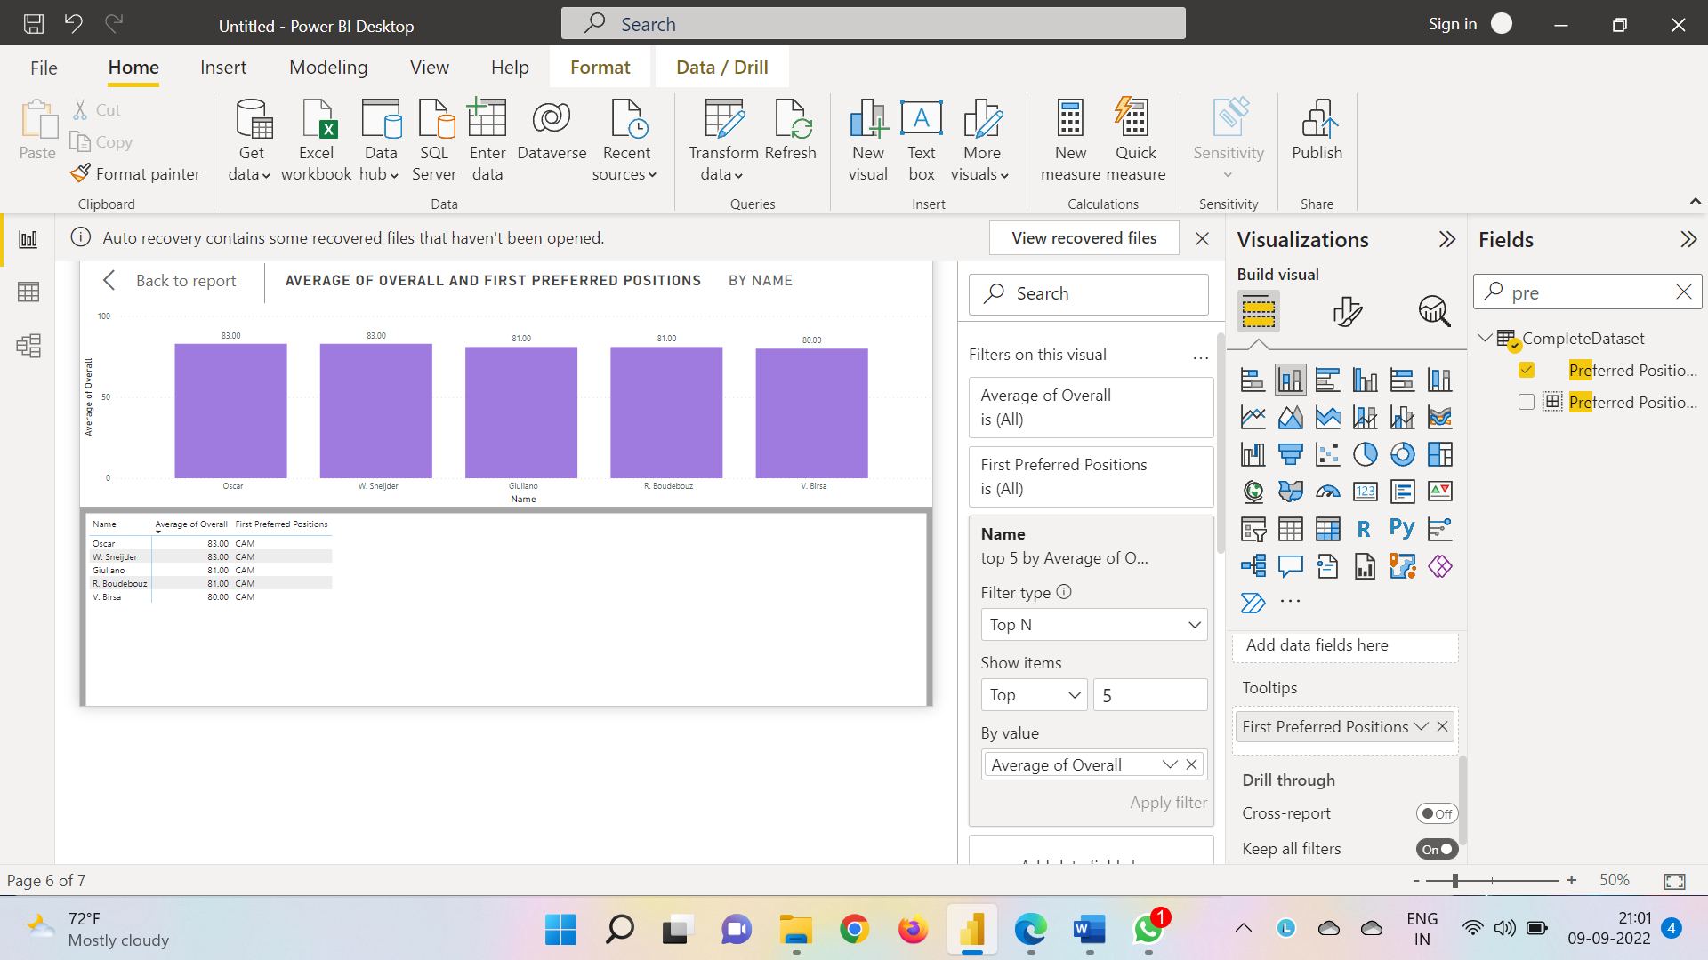

RWB Overall

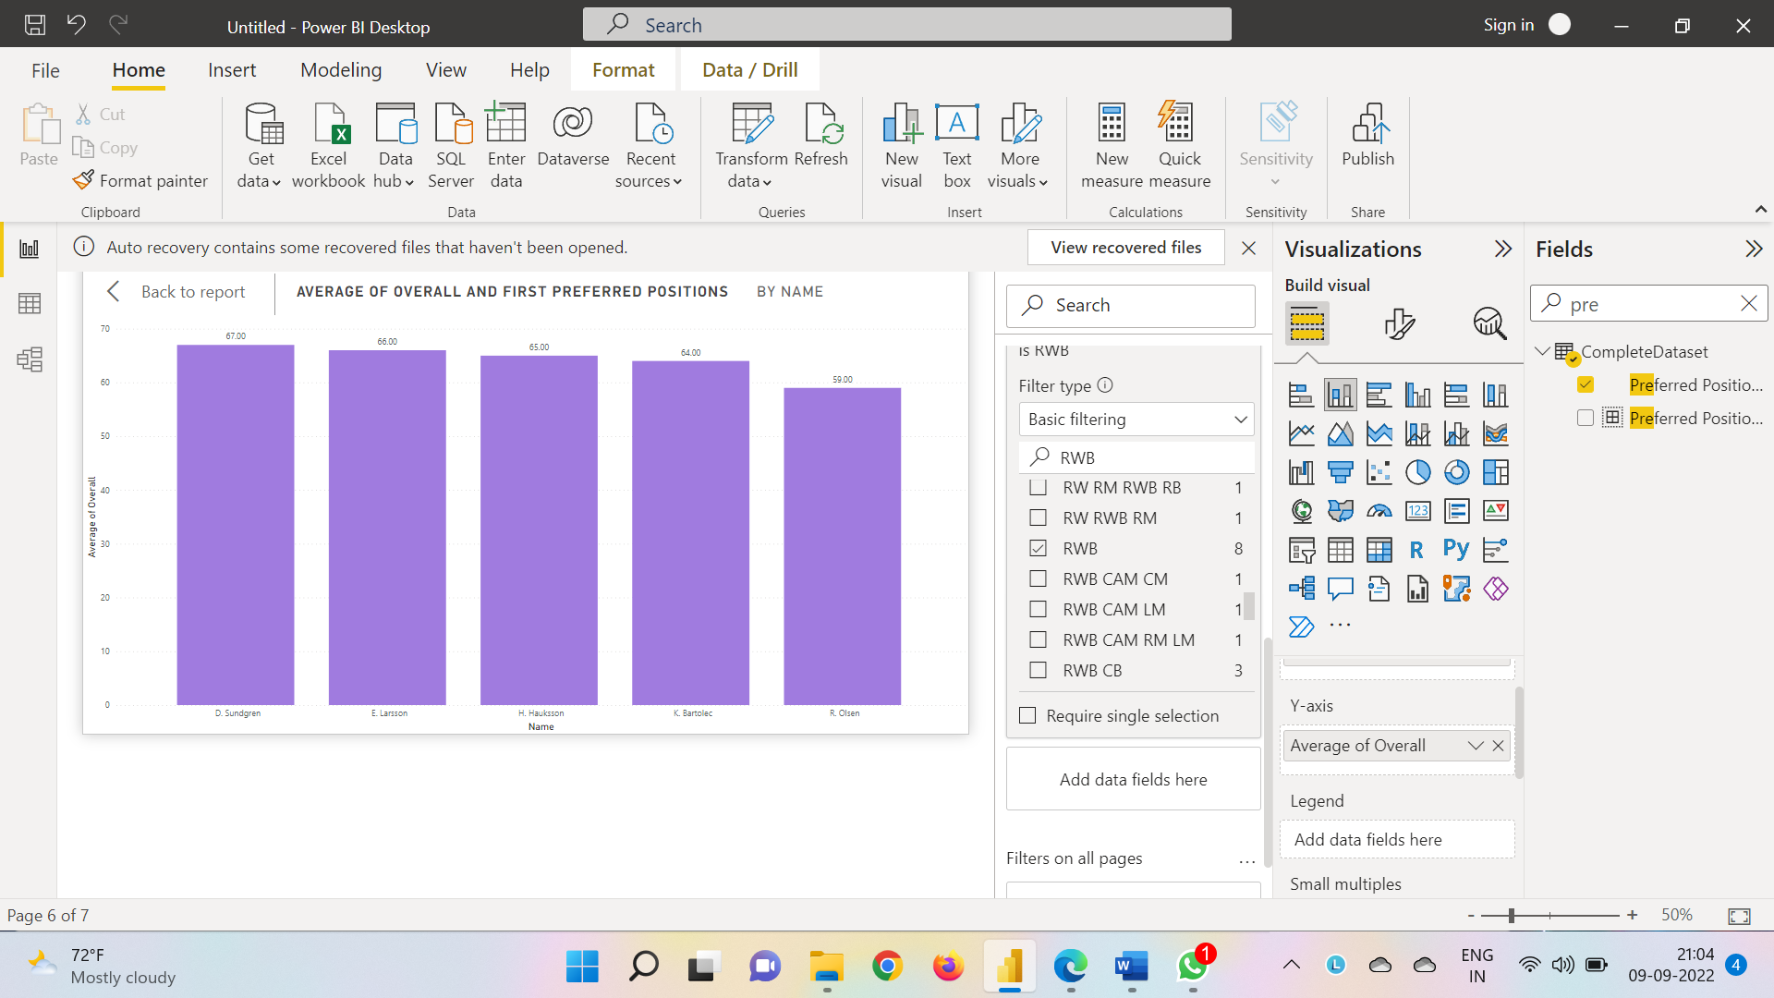

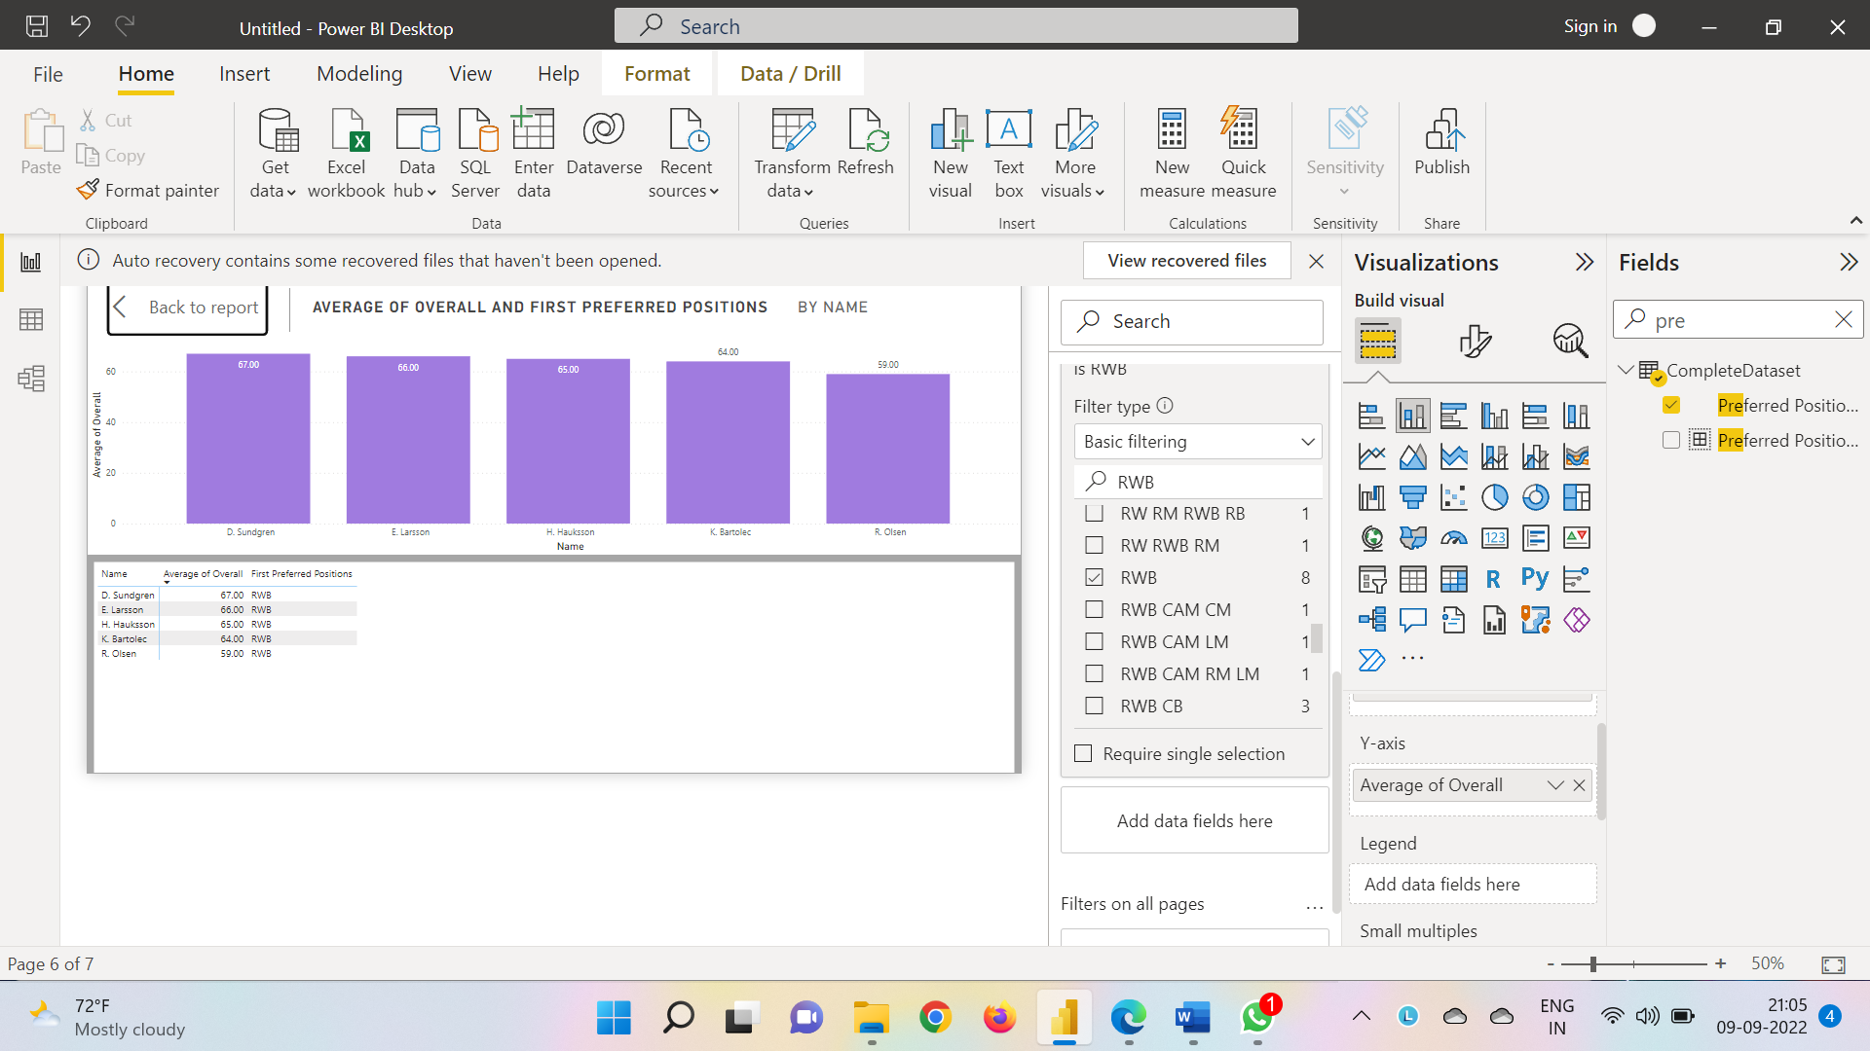

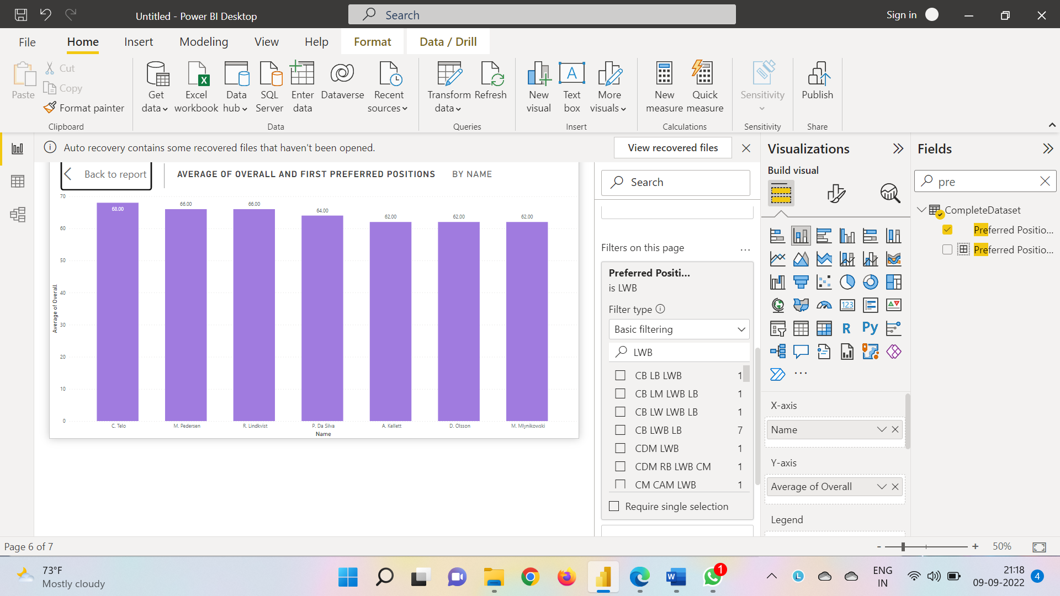LWB Overall

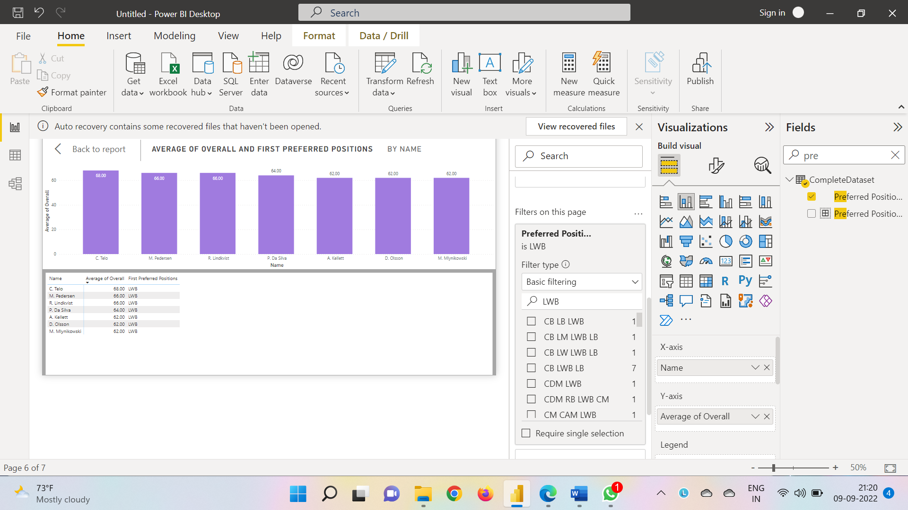

CF Overall

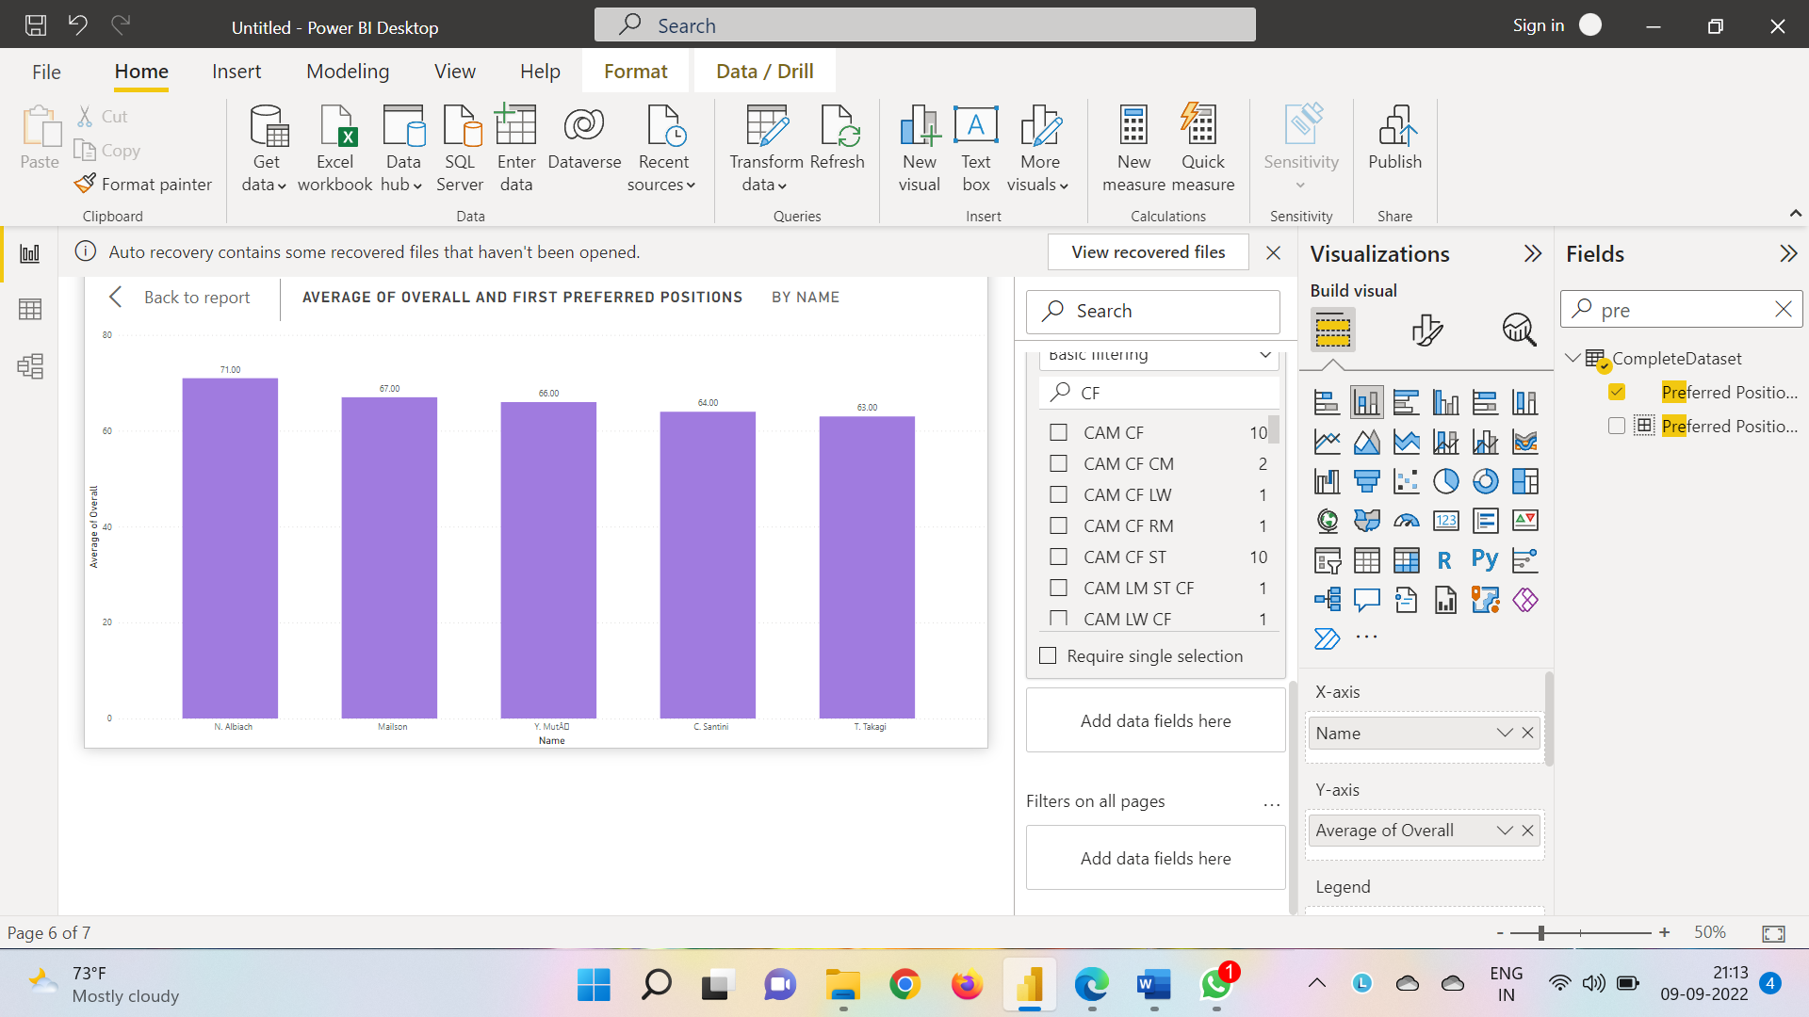

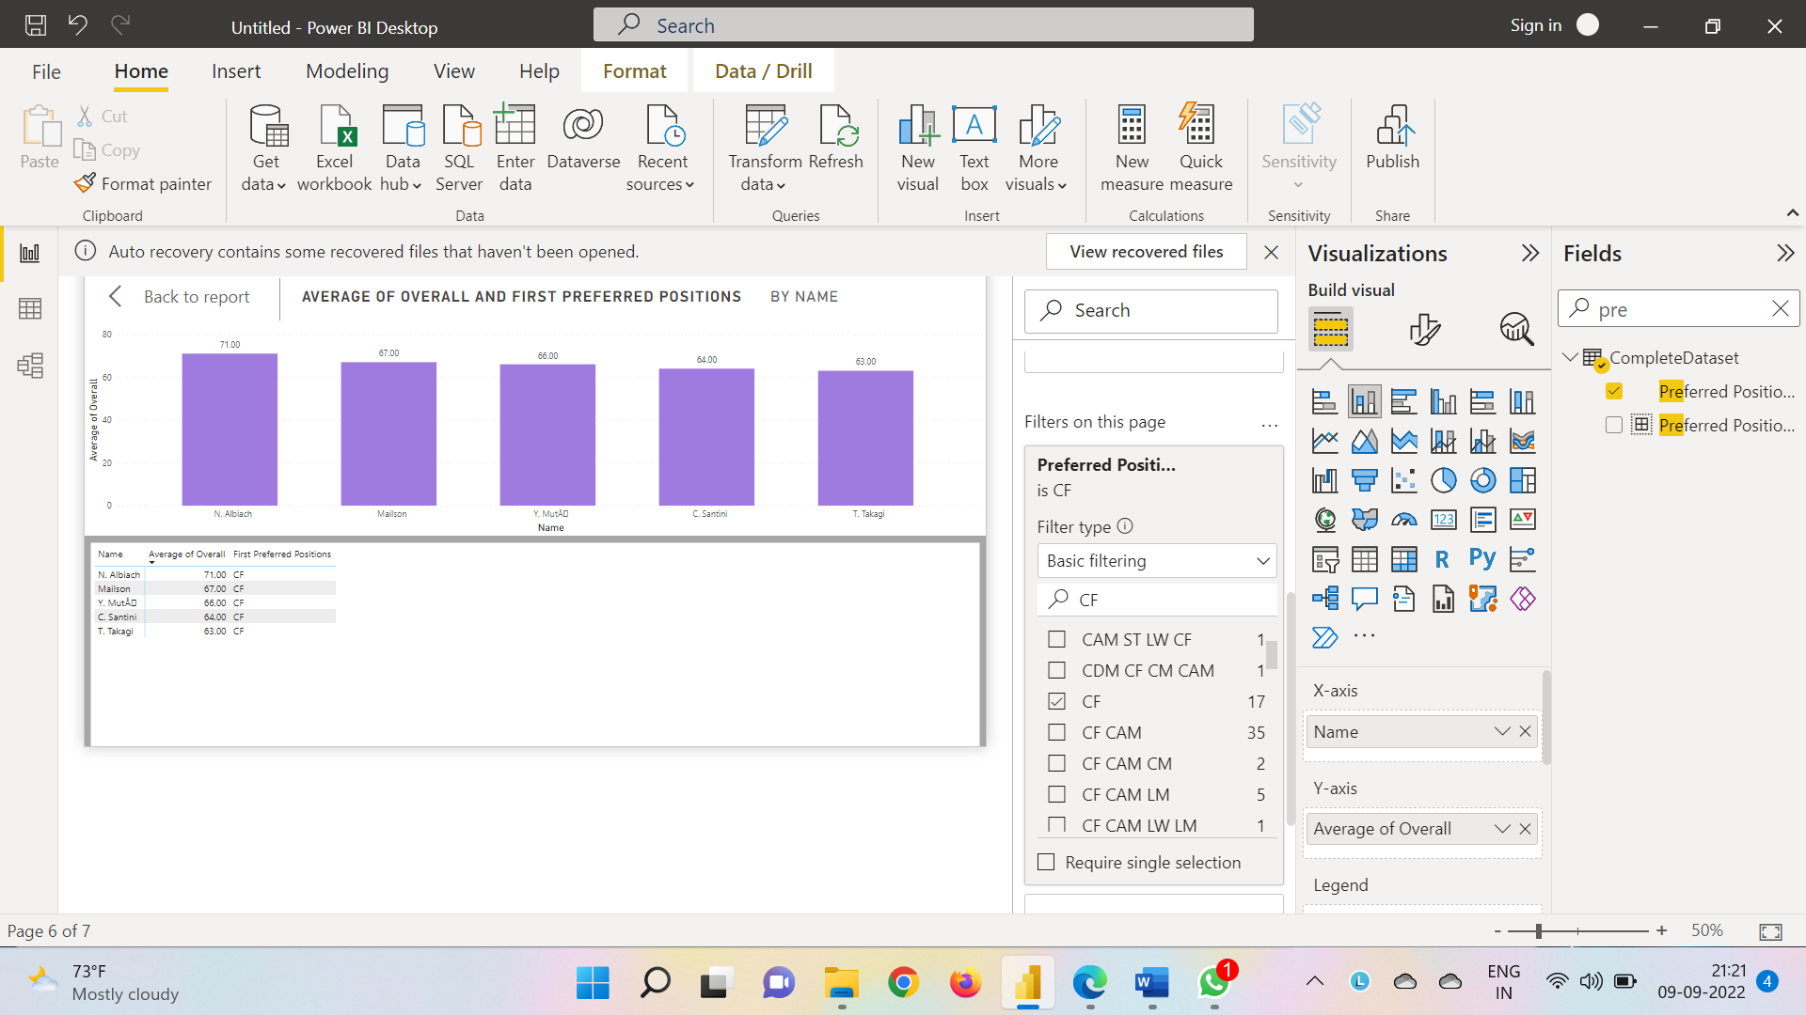

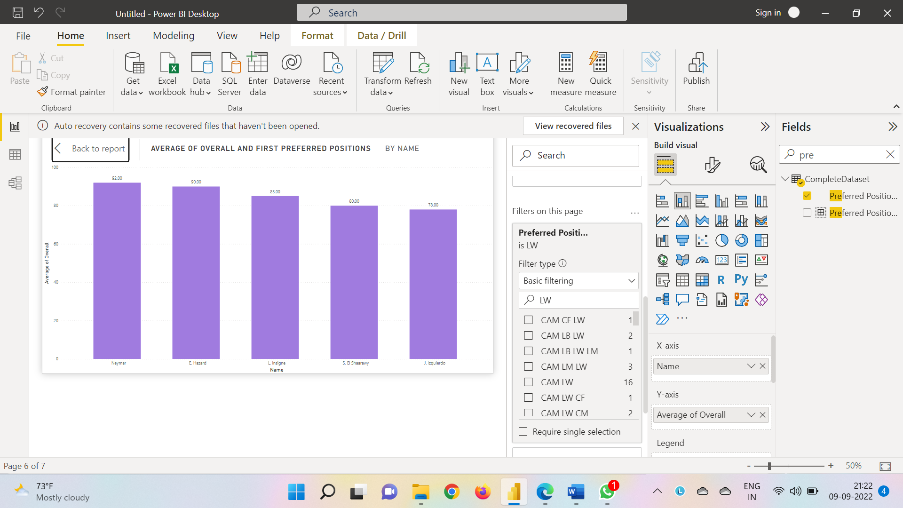LW Overall

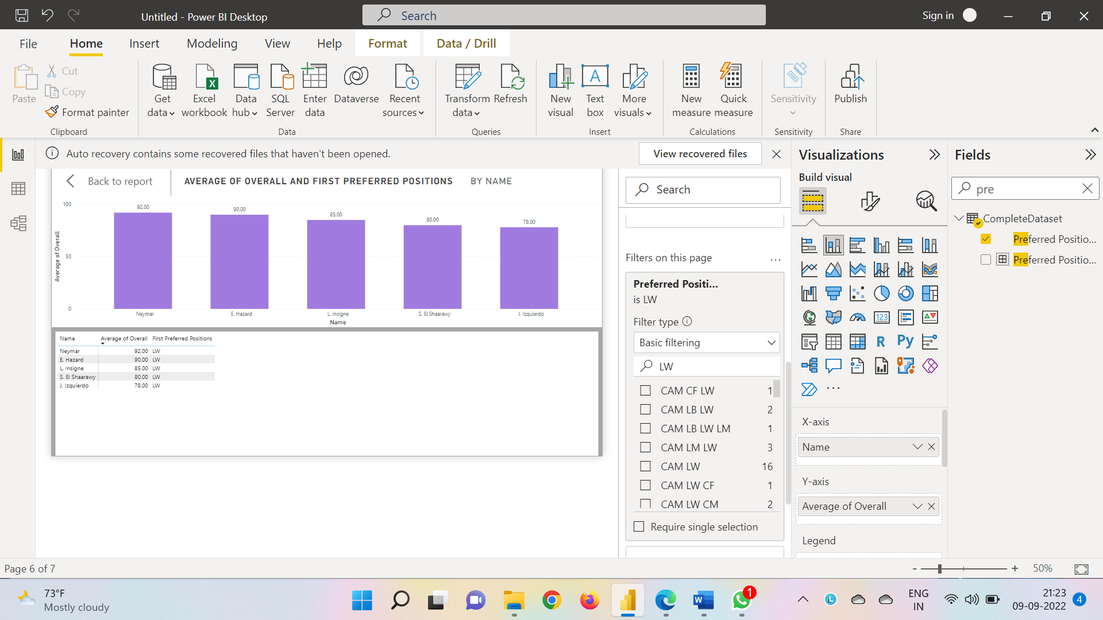

RW Overall

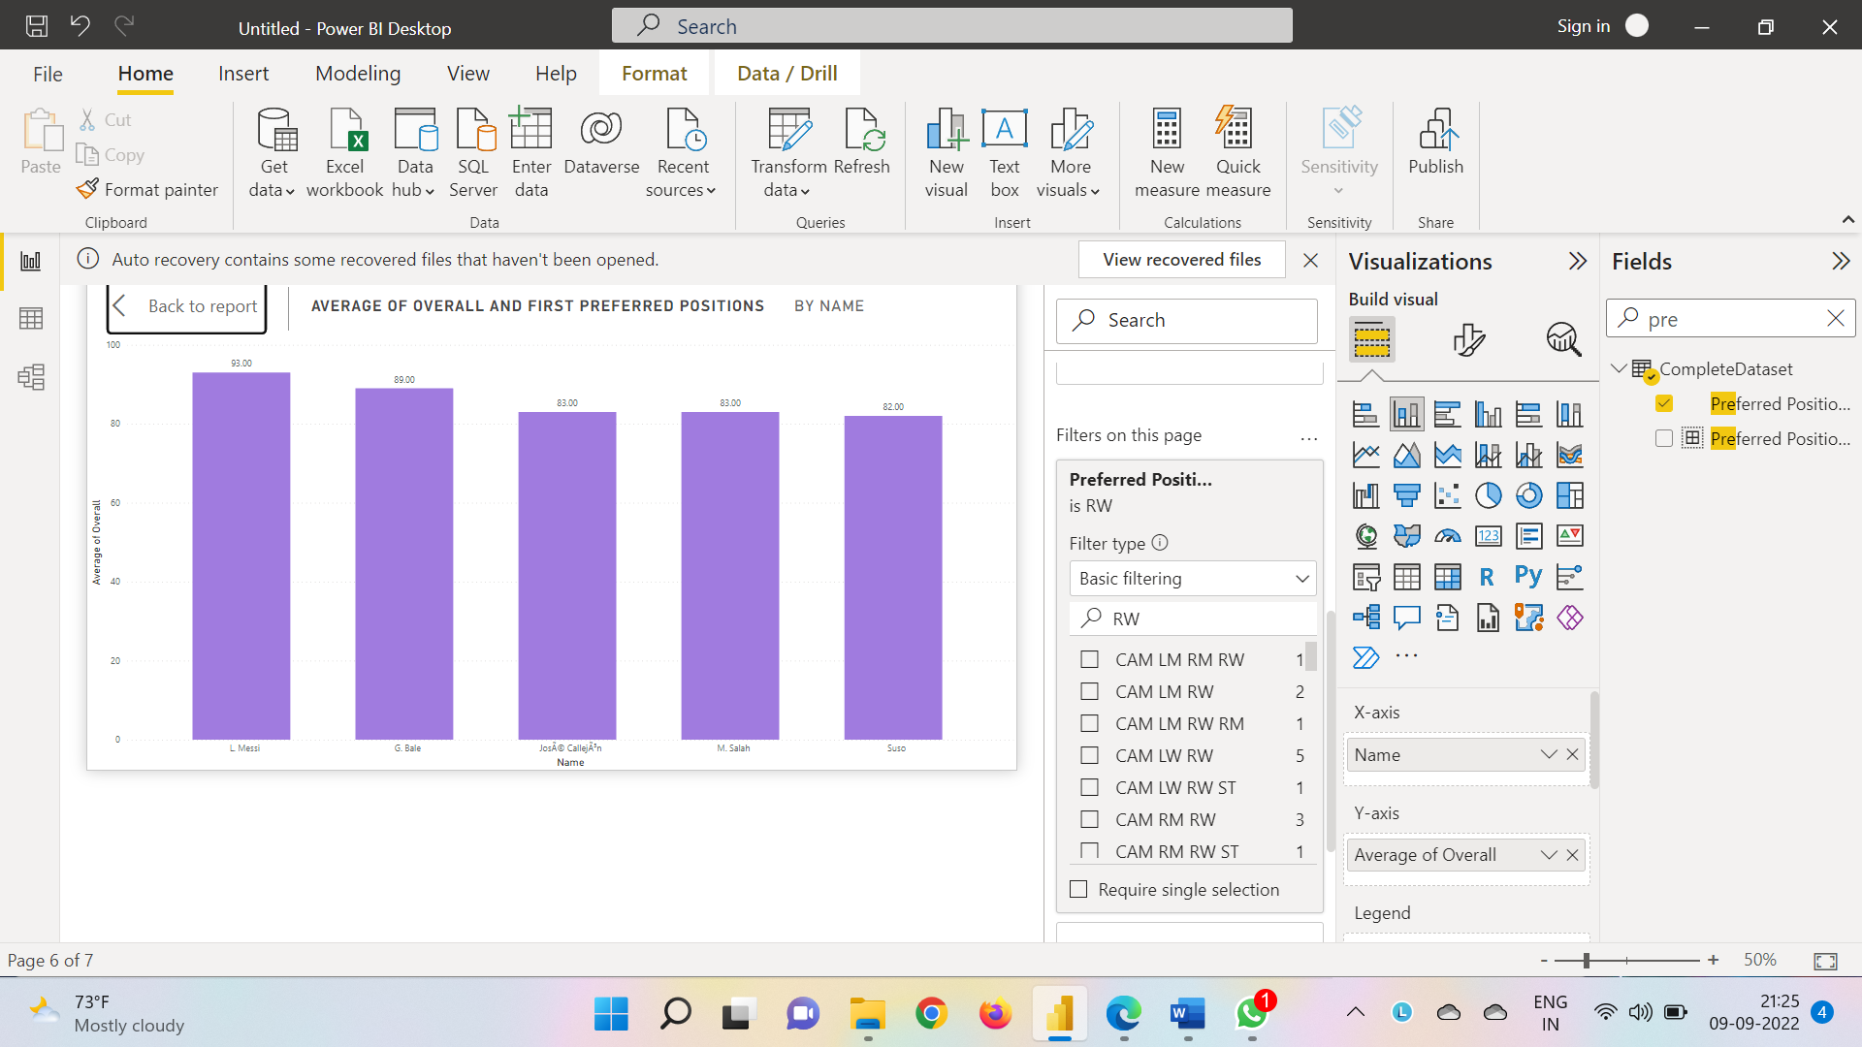

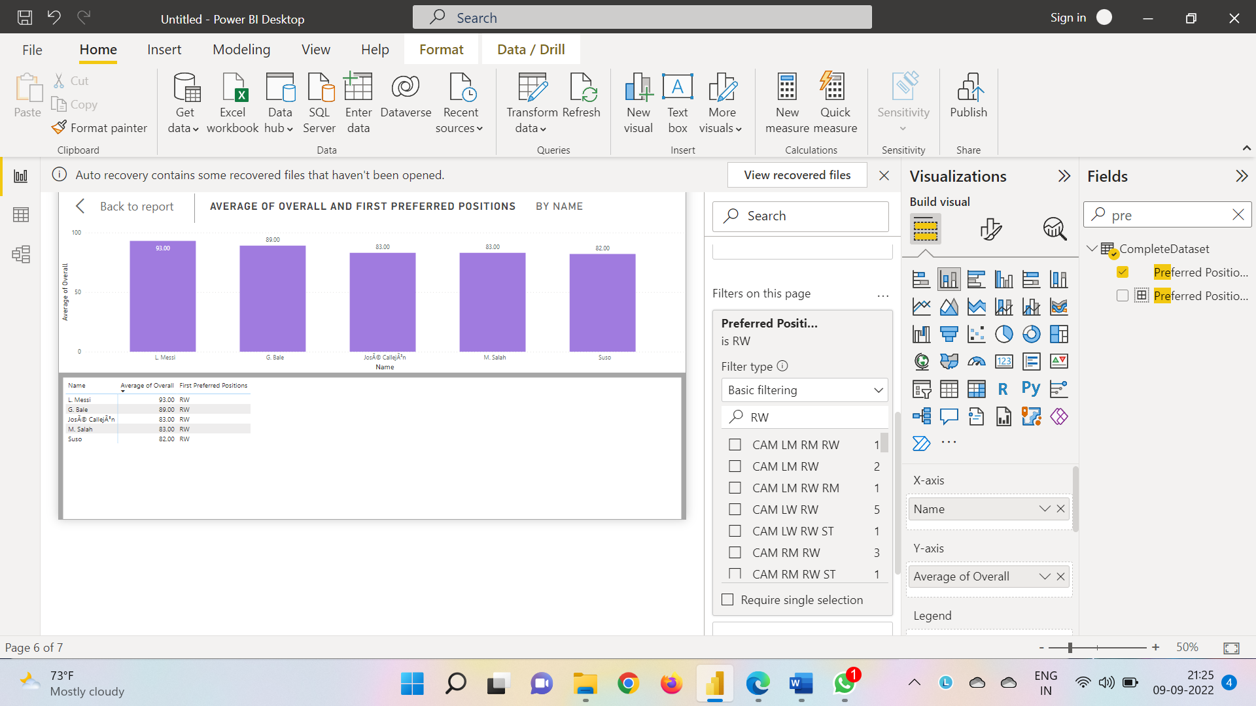

LB Overall

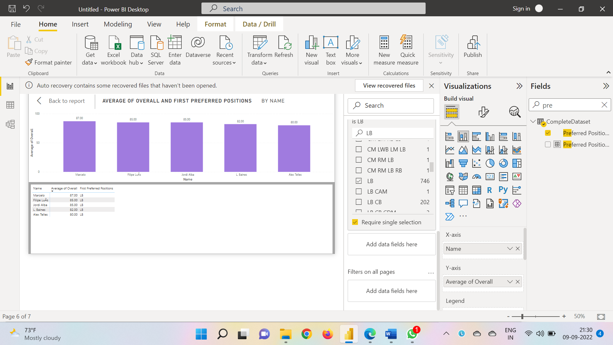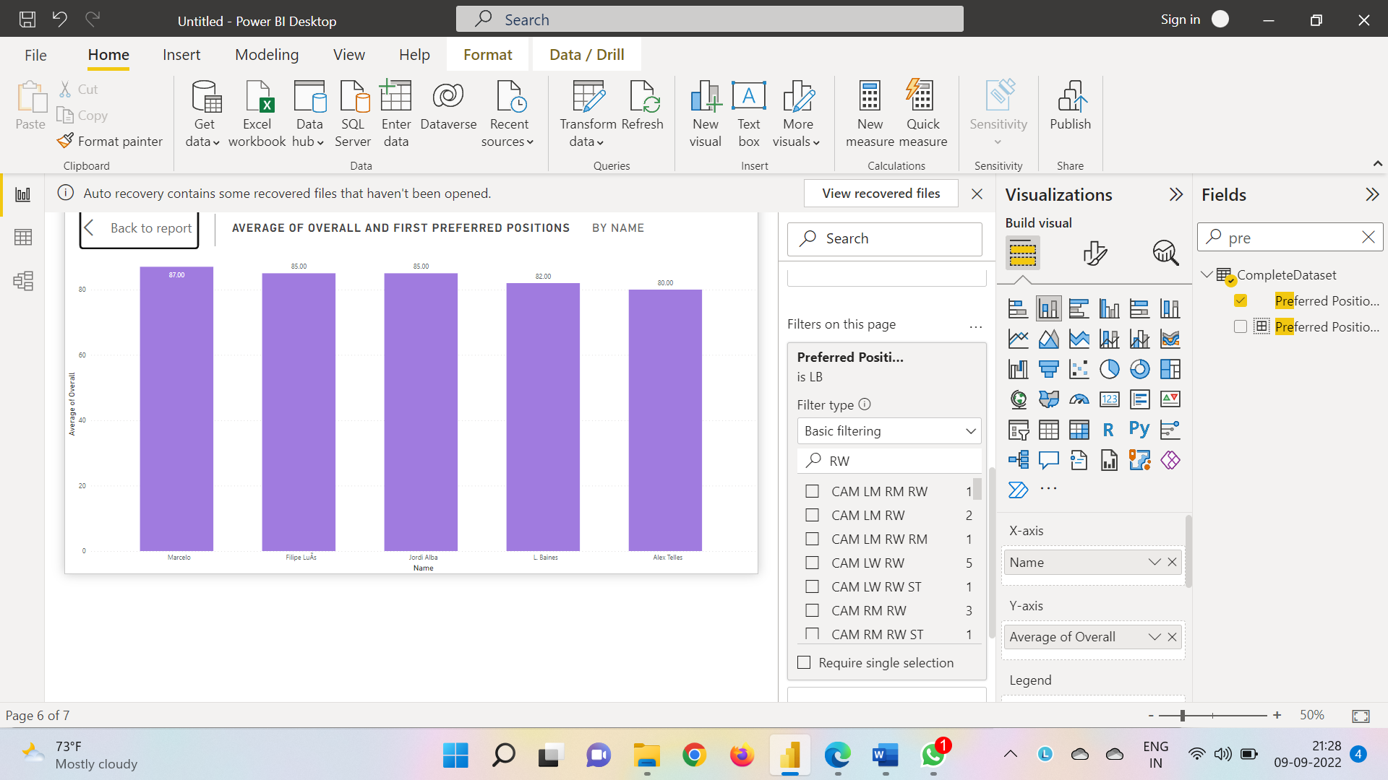

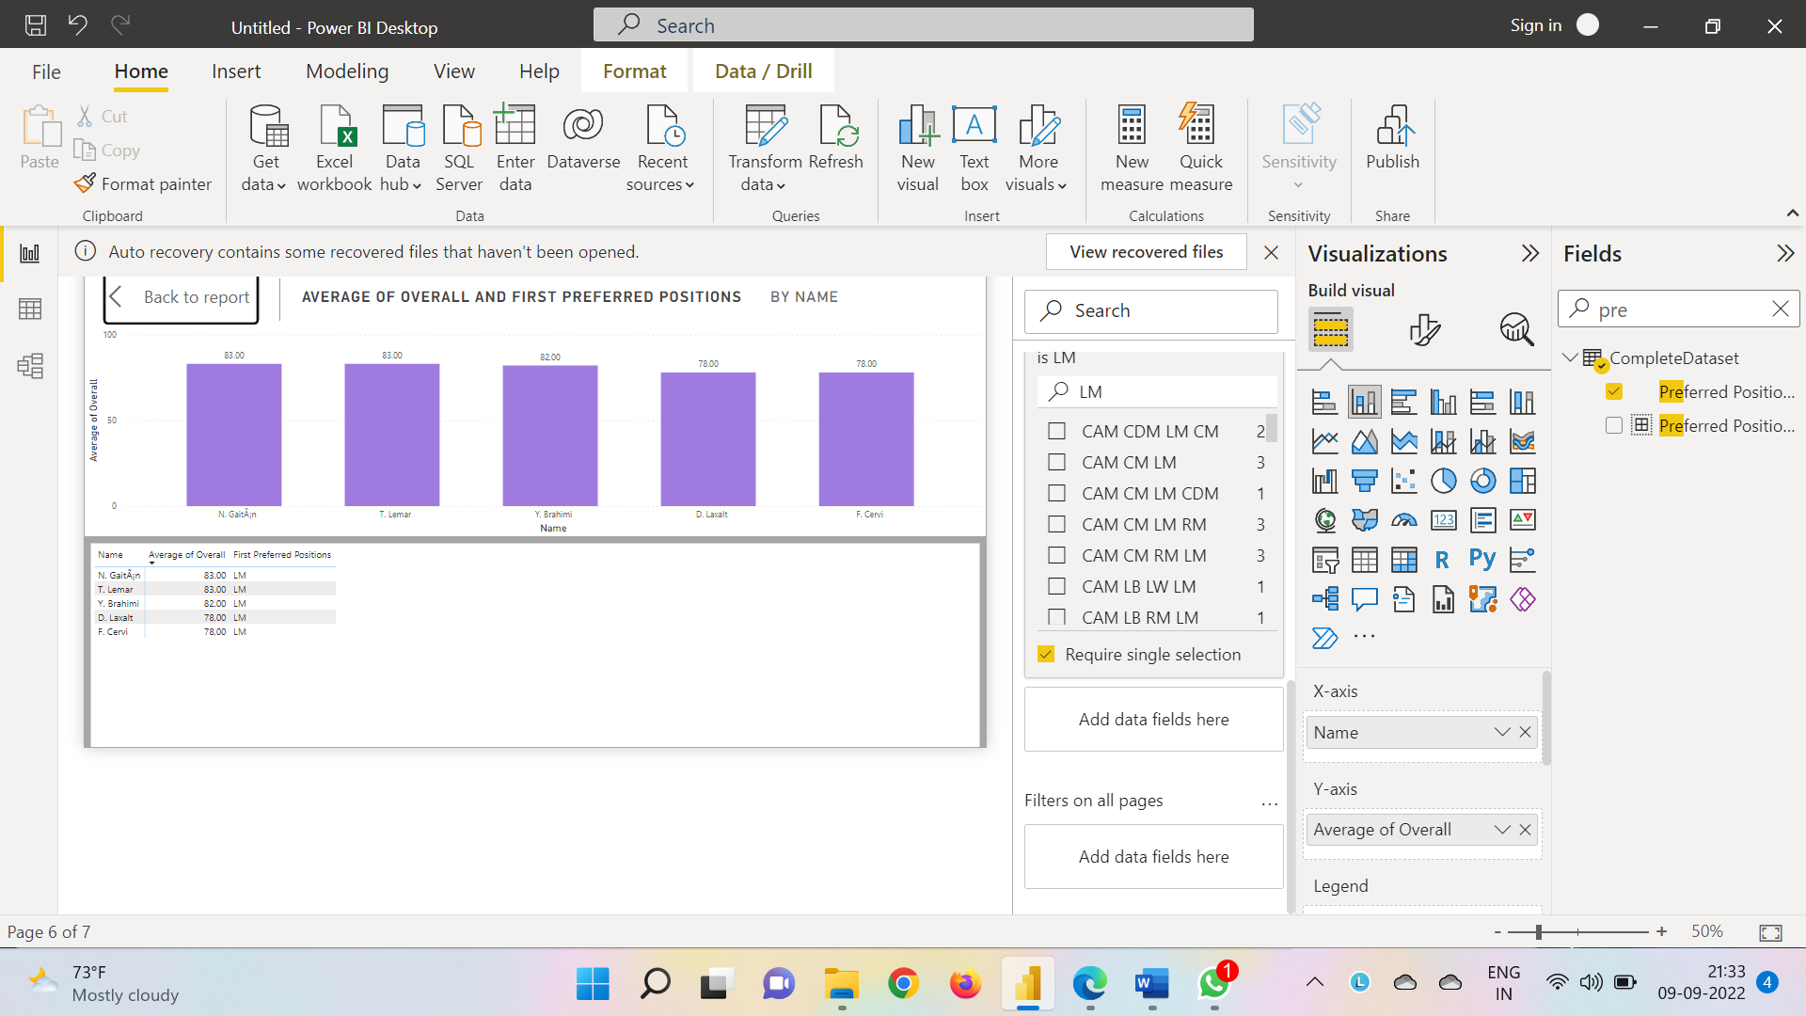LM Overall

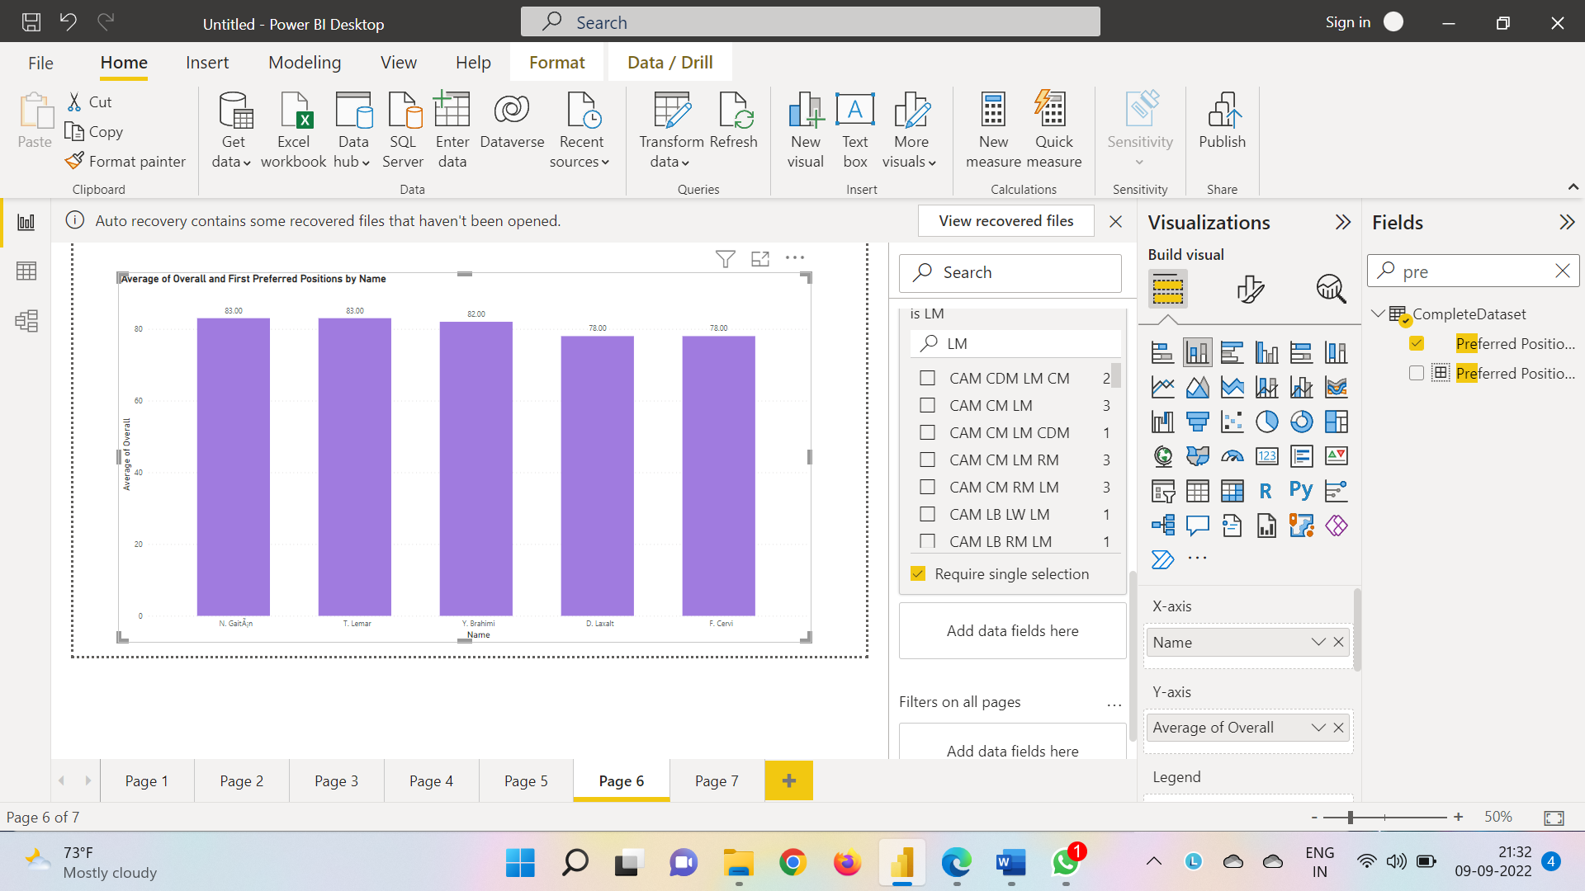

GK Overall

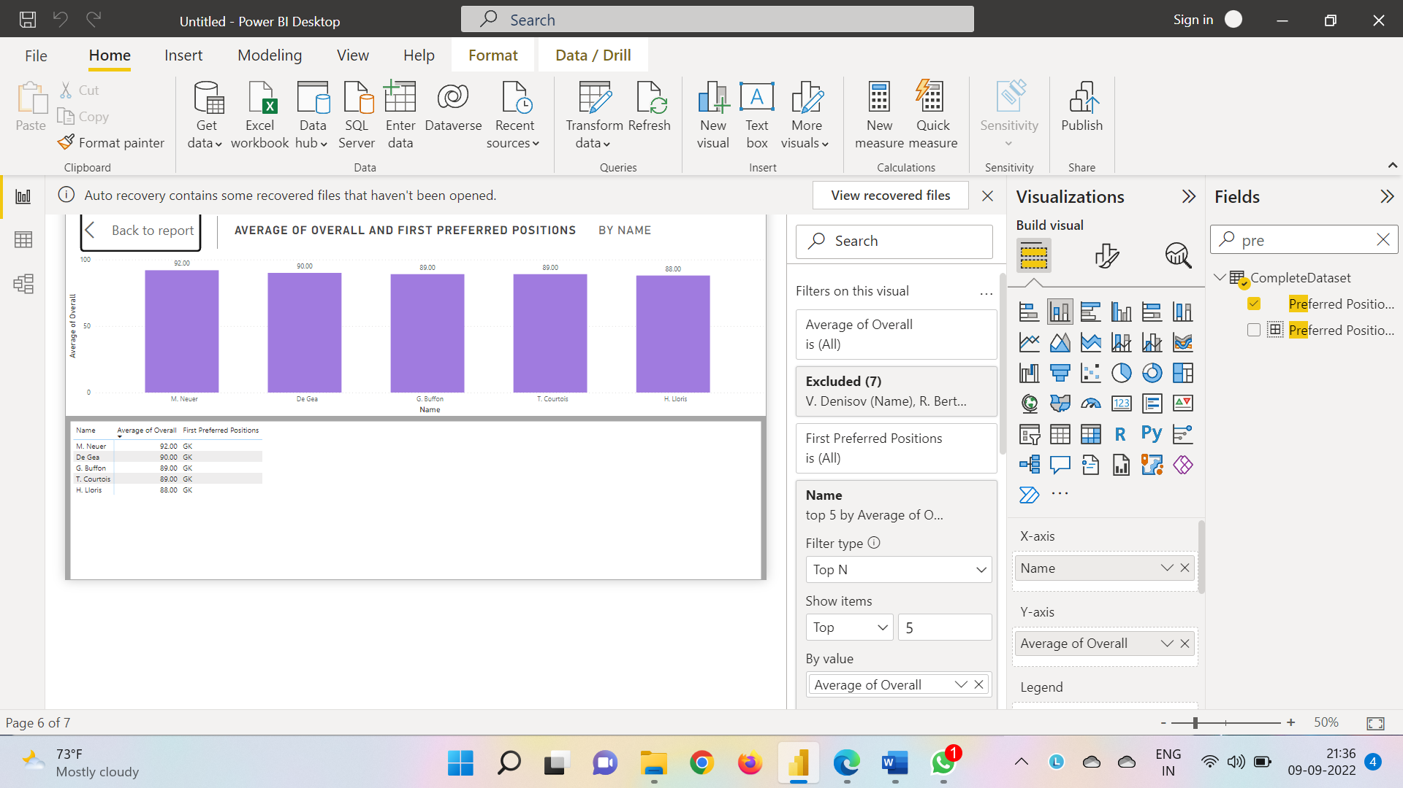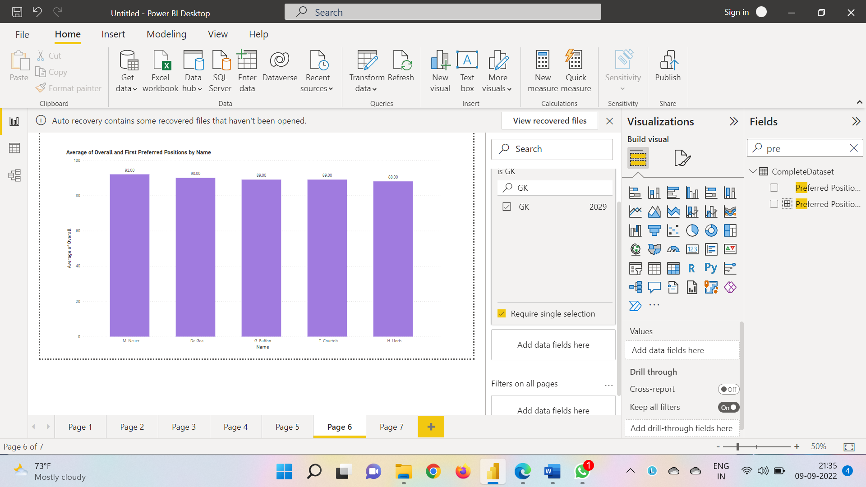

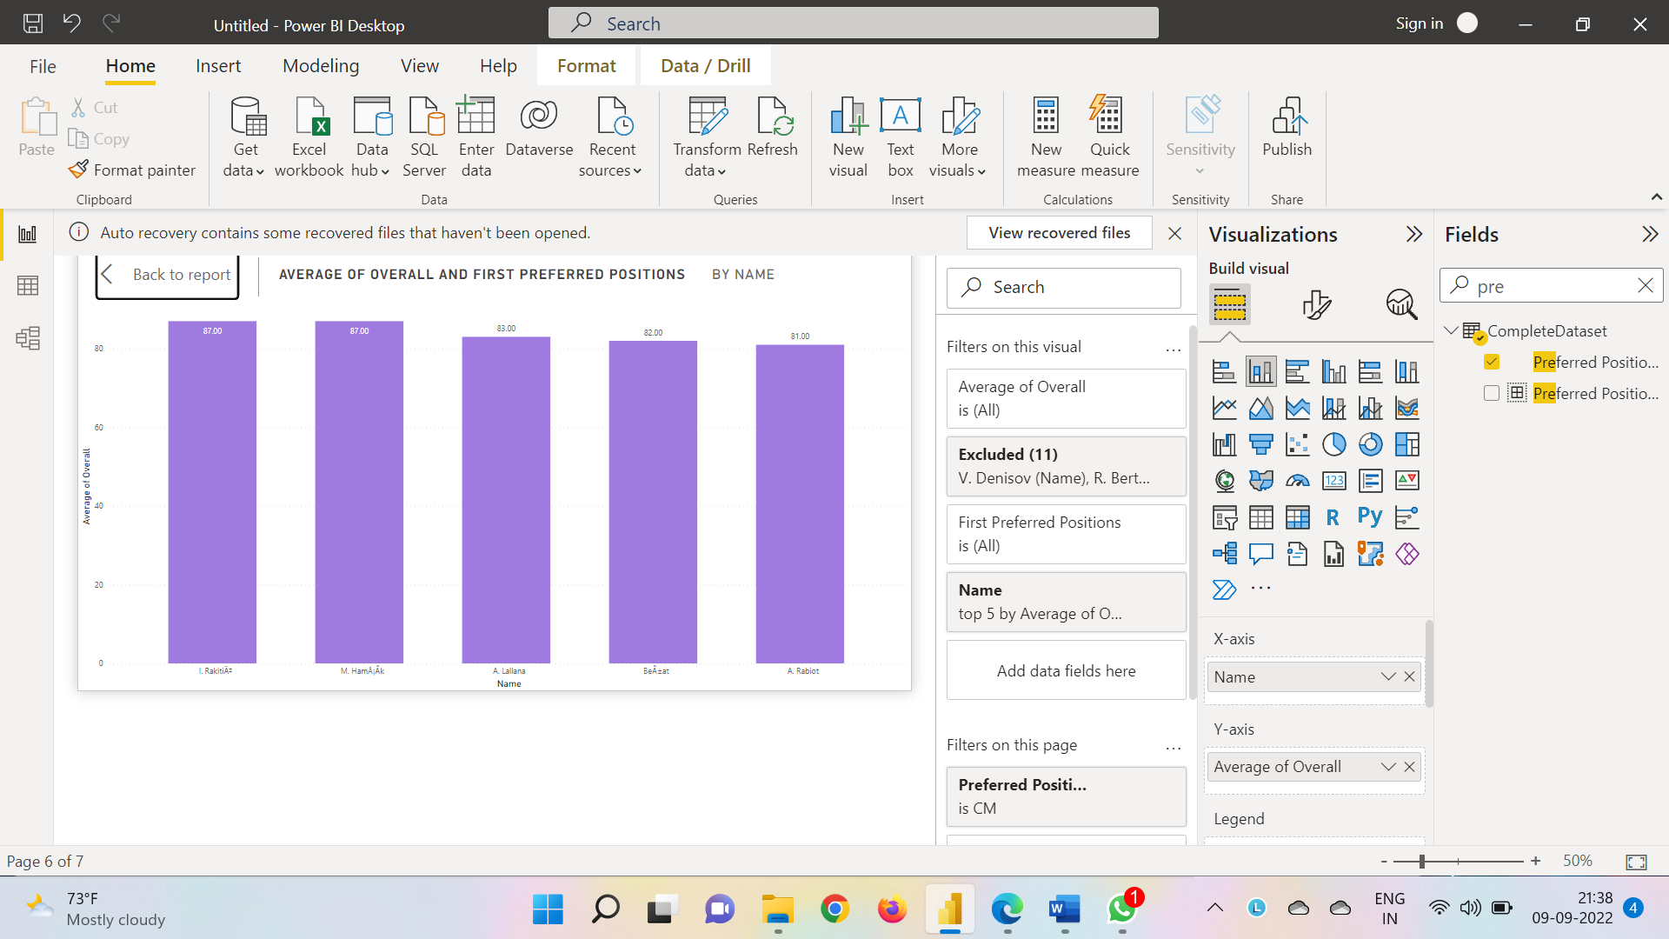CM Overall

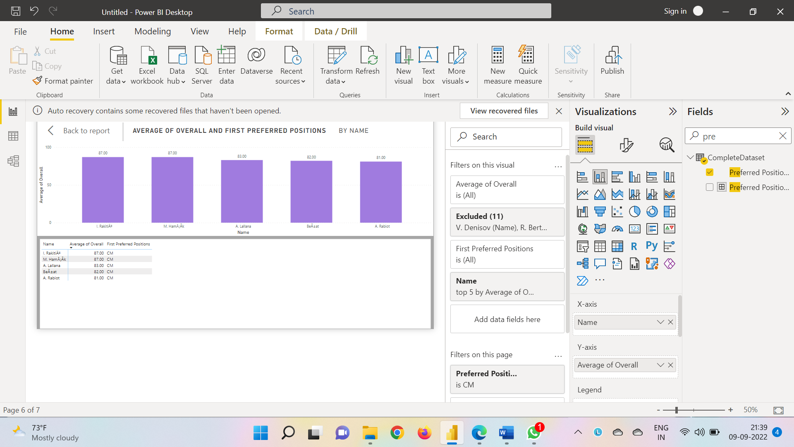

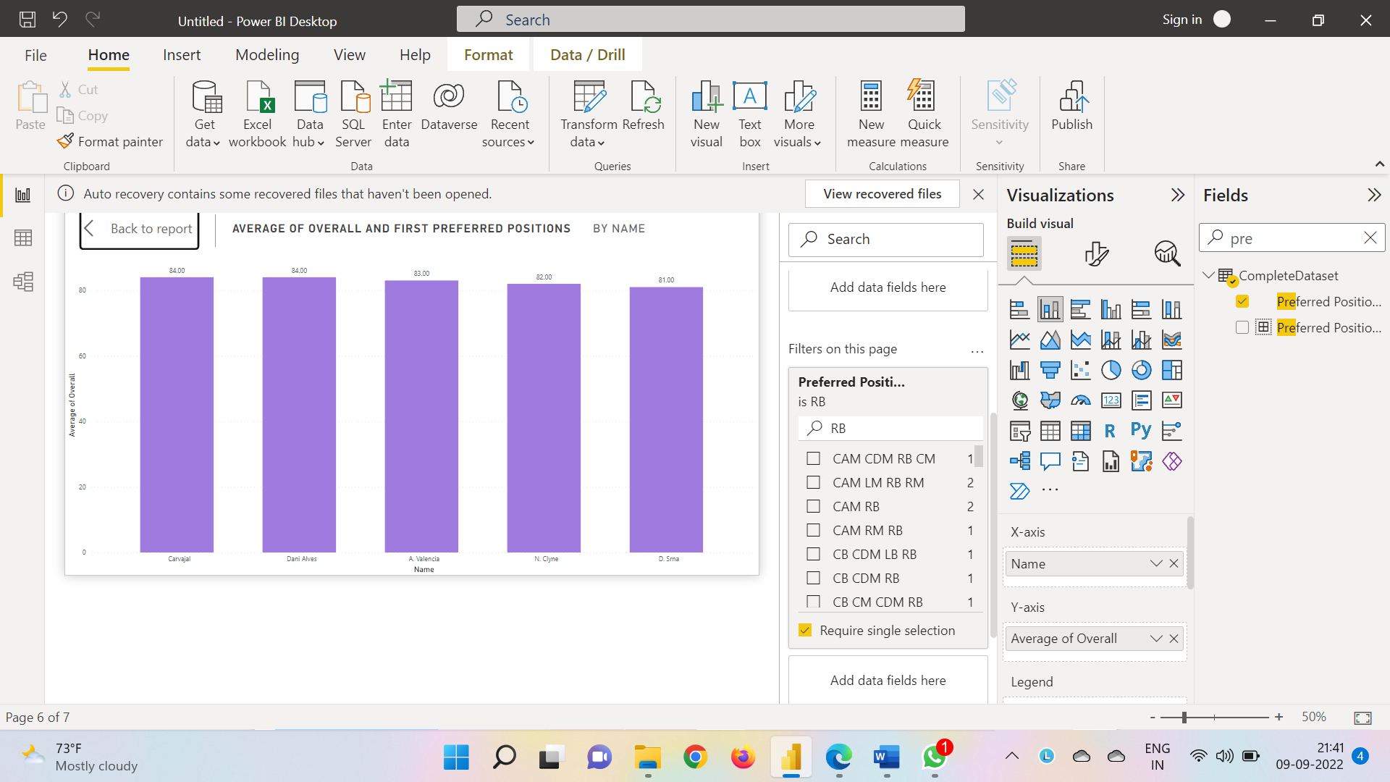RB Overall

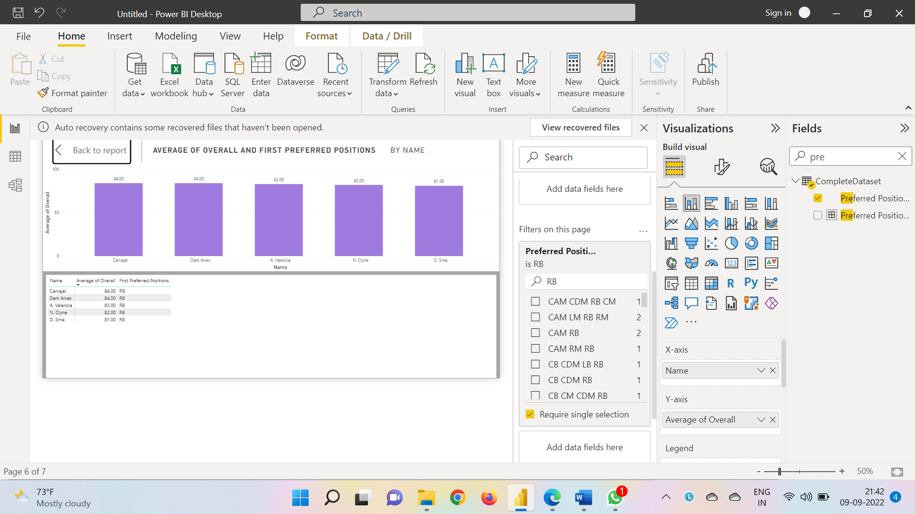

RM Overall

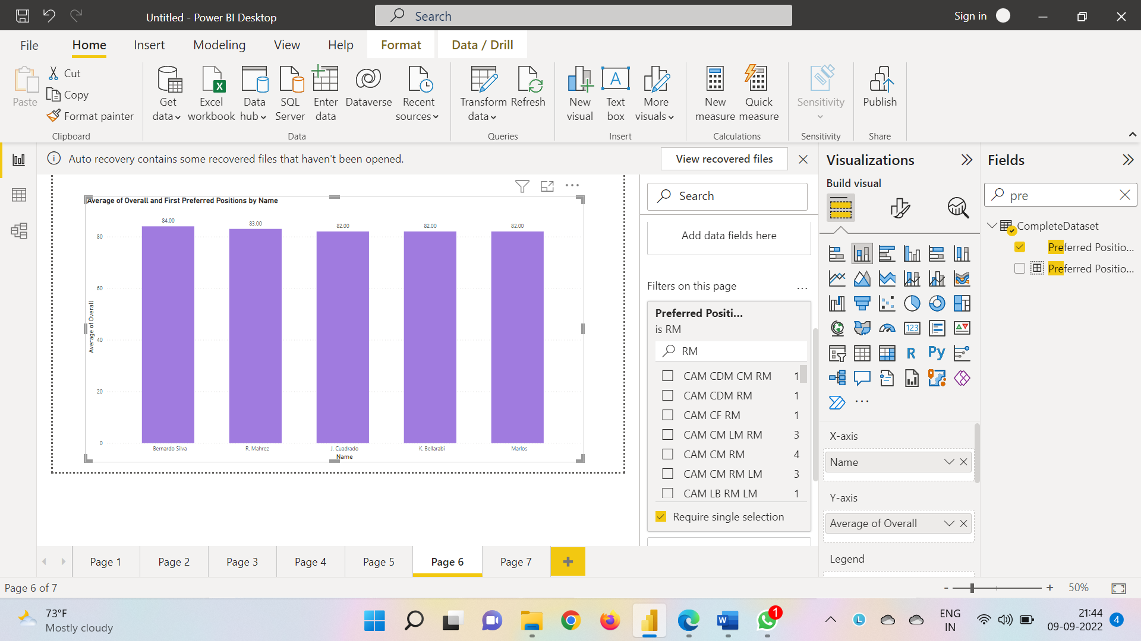

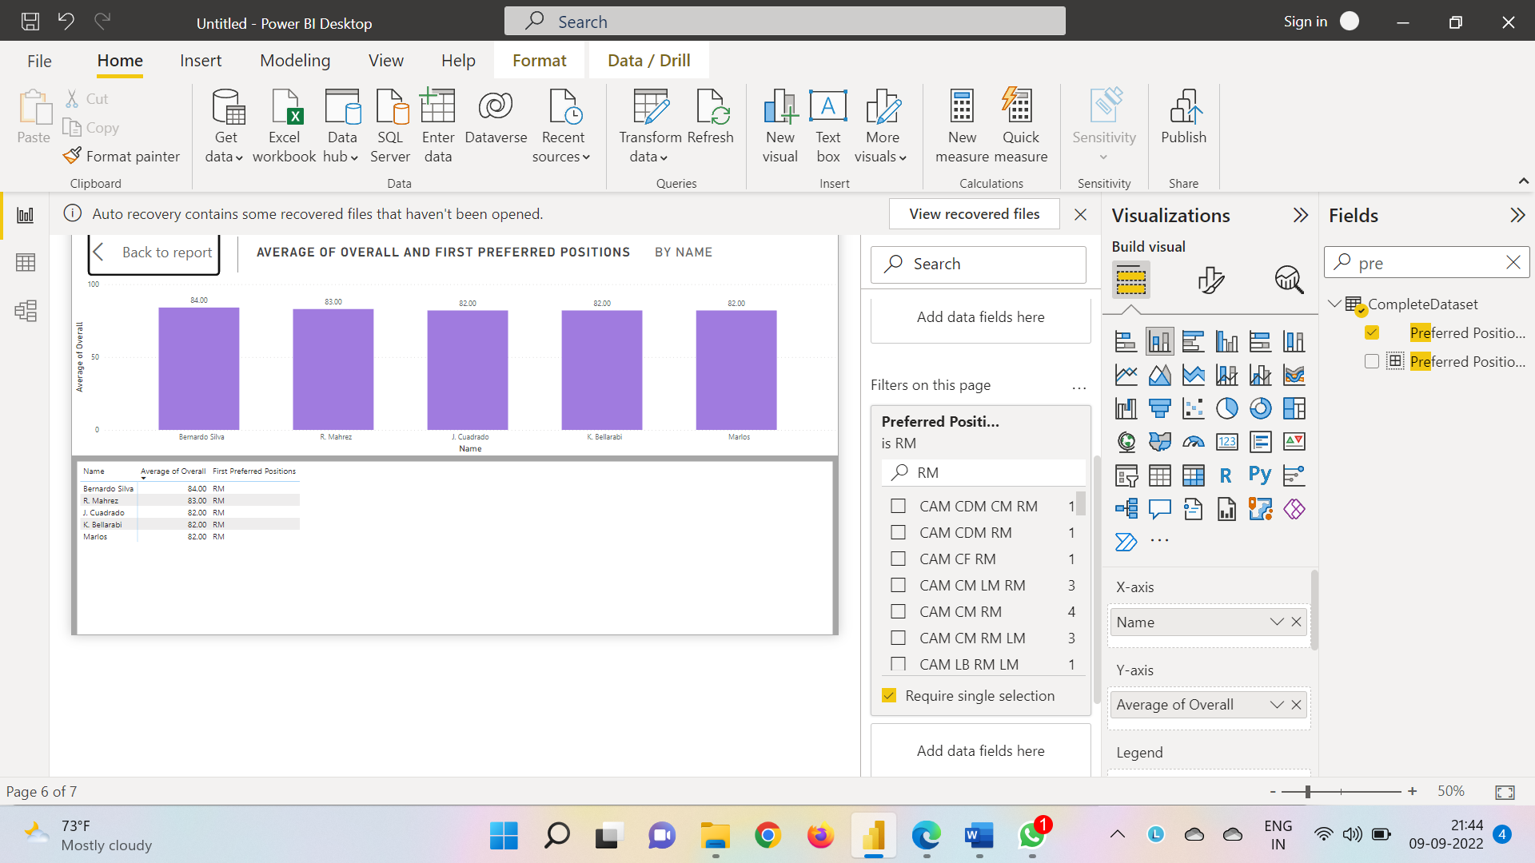

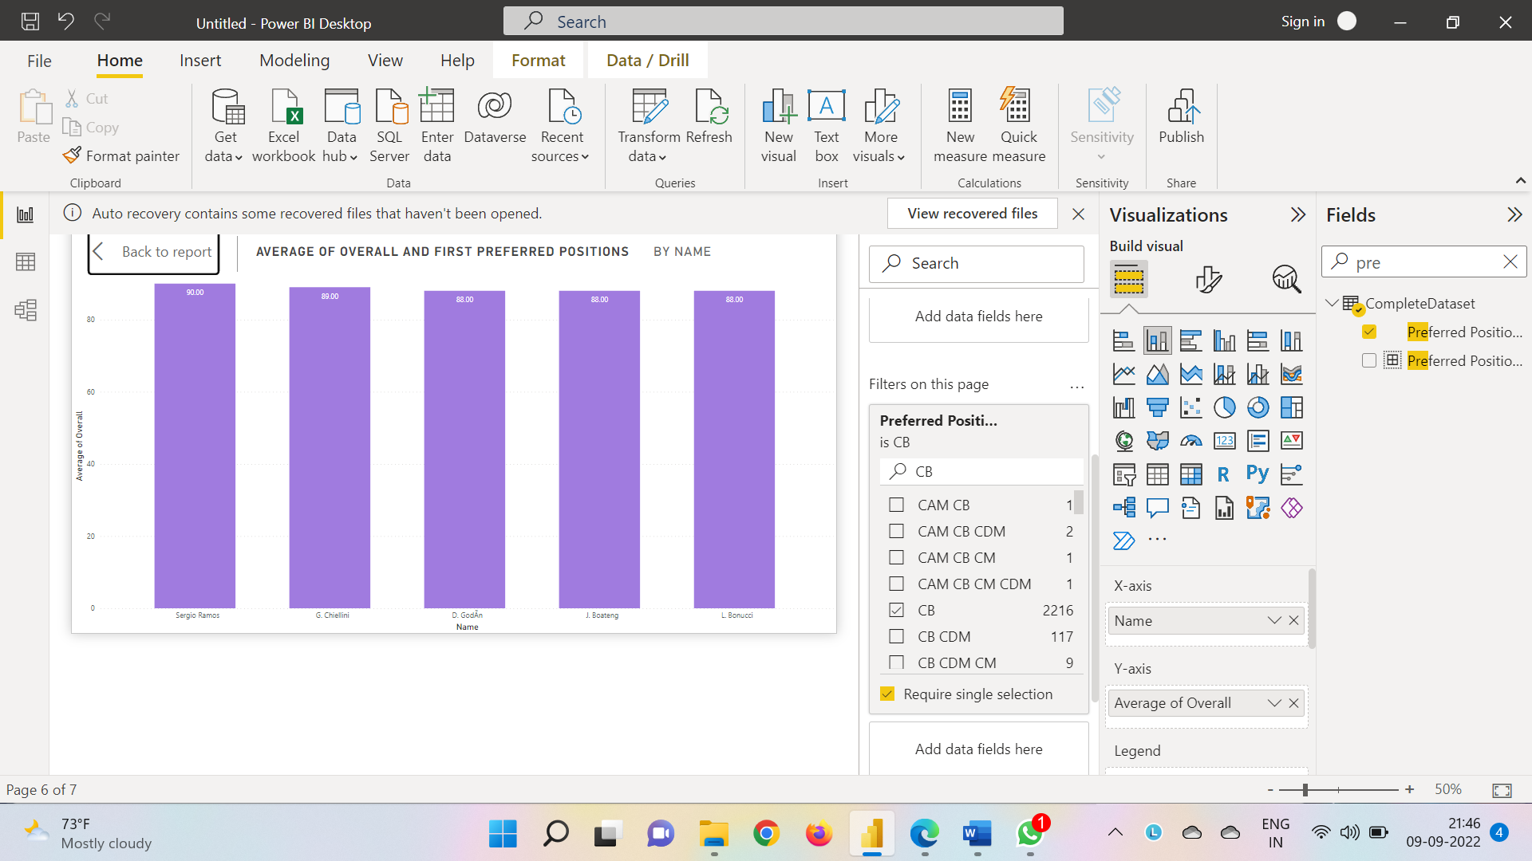CB Overall

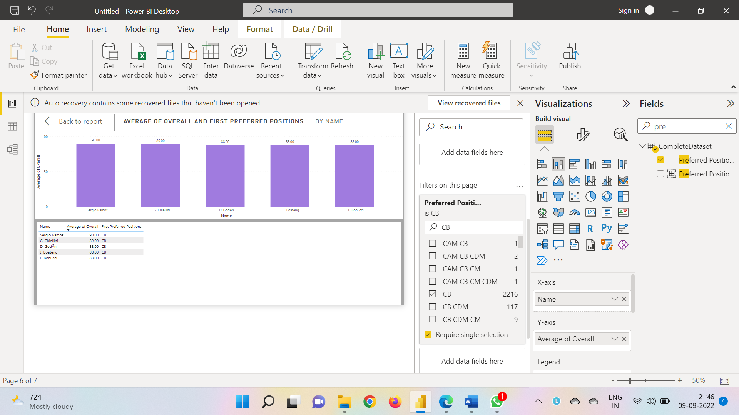

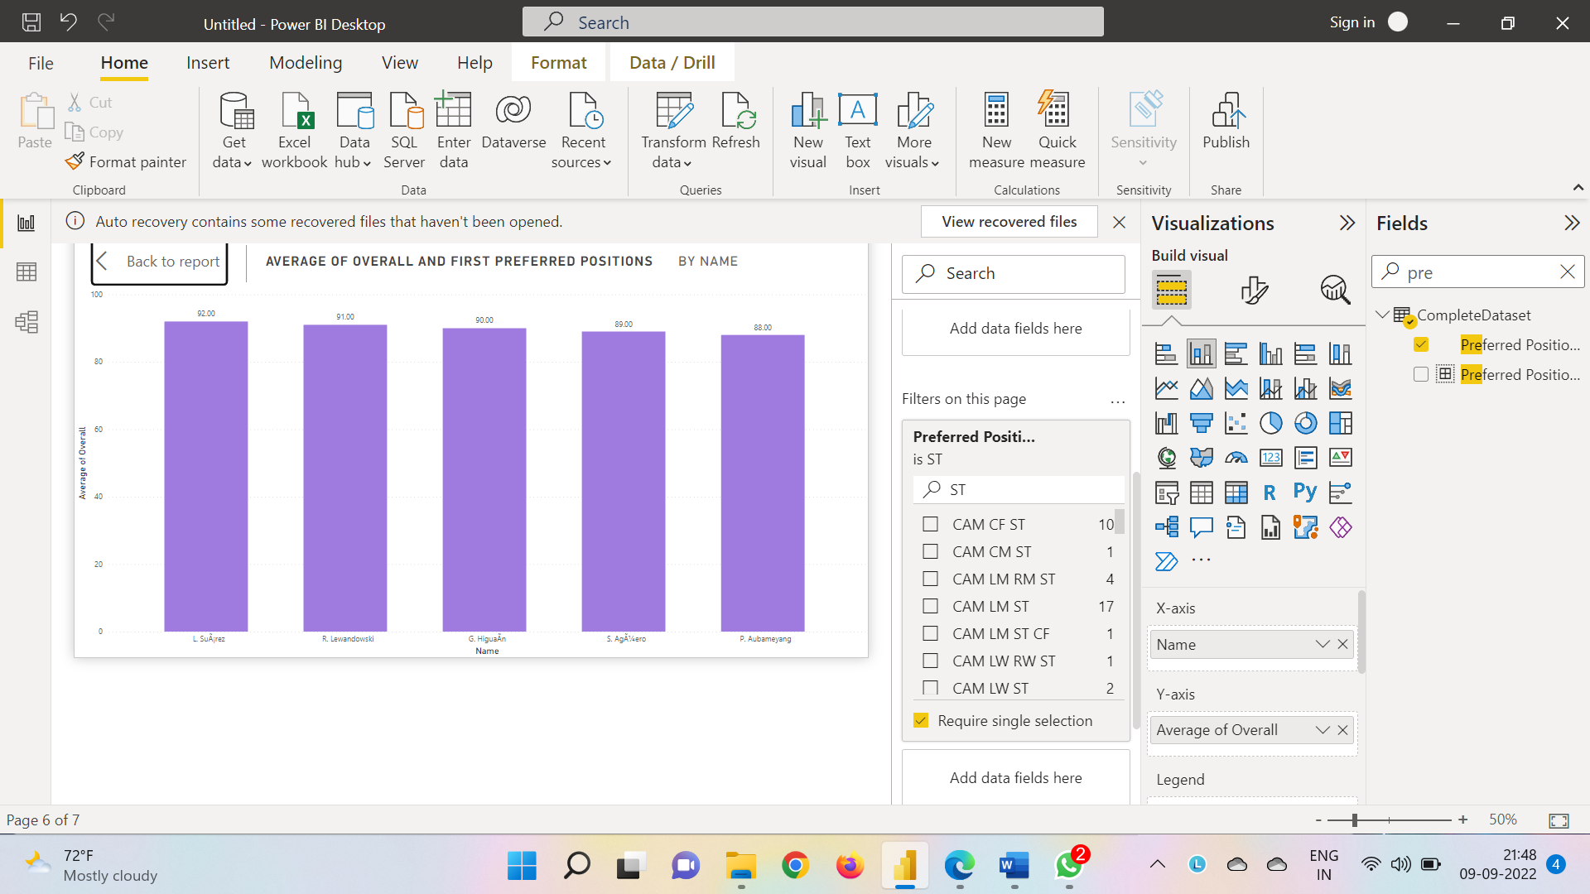ST Overall

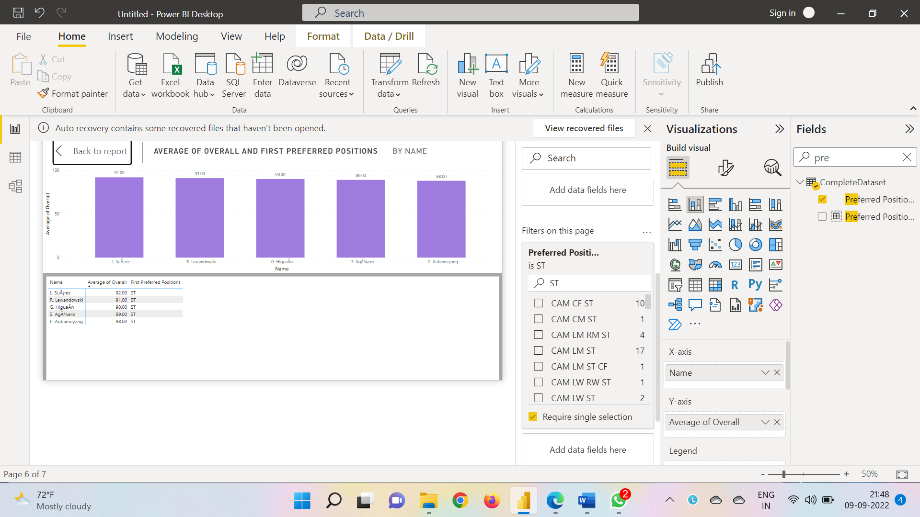

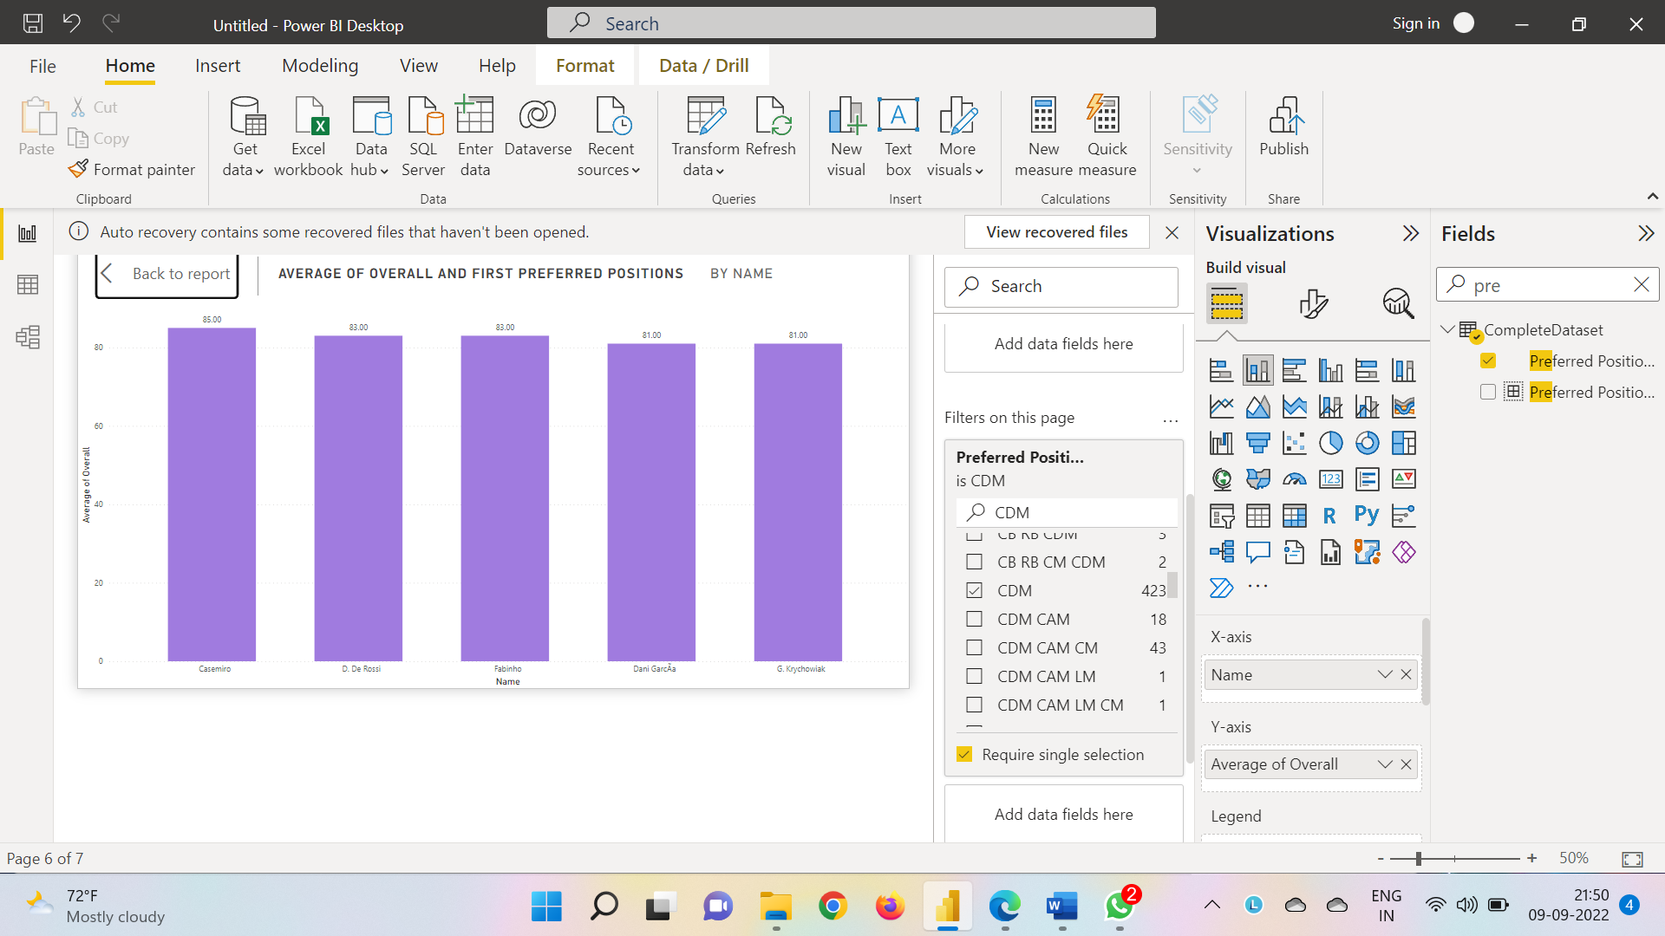CDM Overall

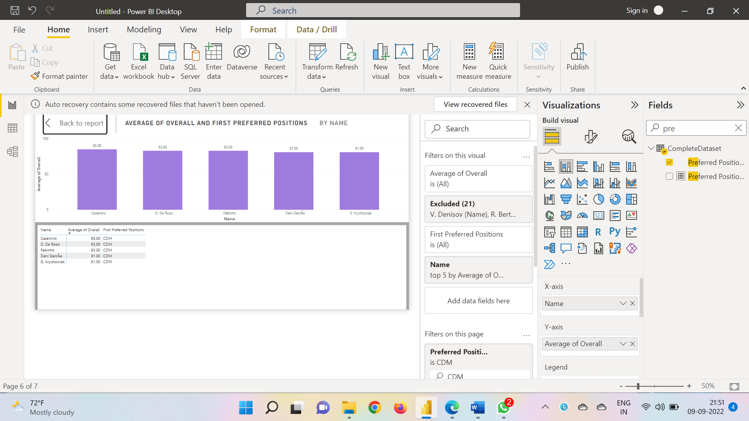

CDM Potential

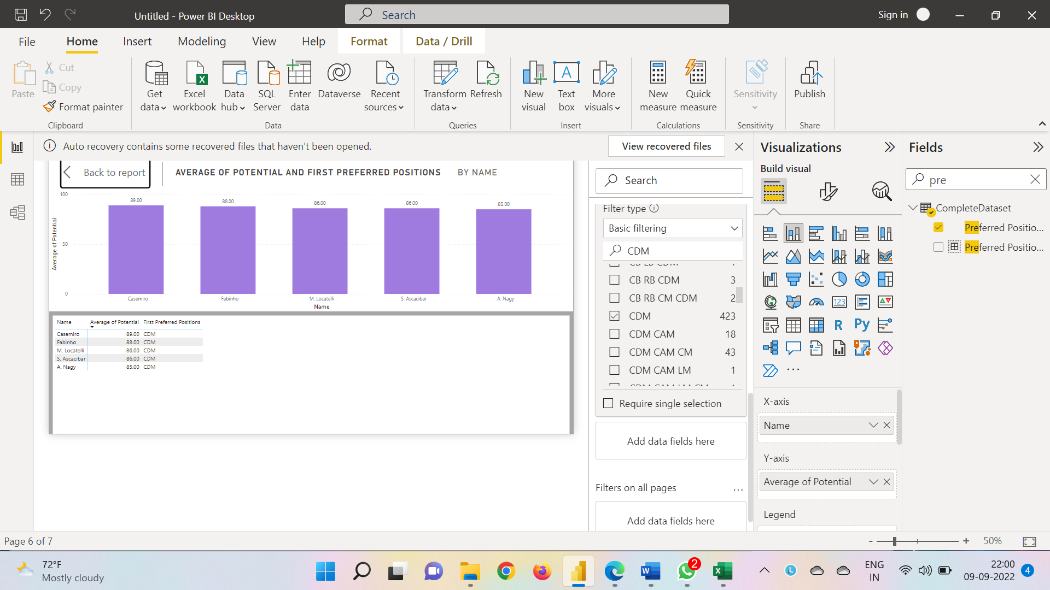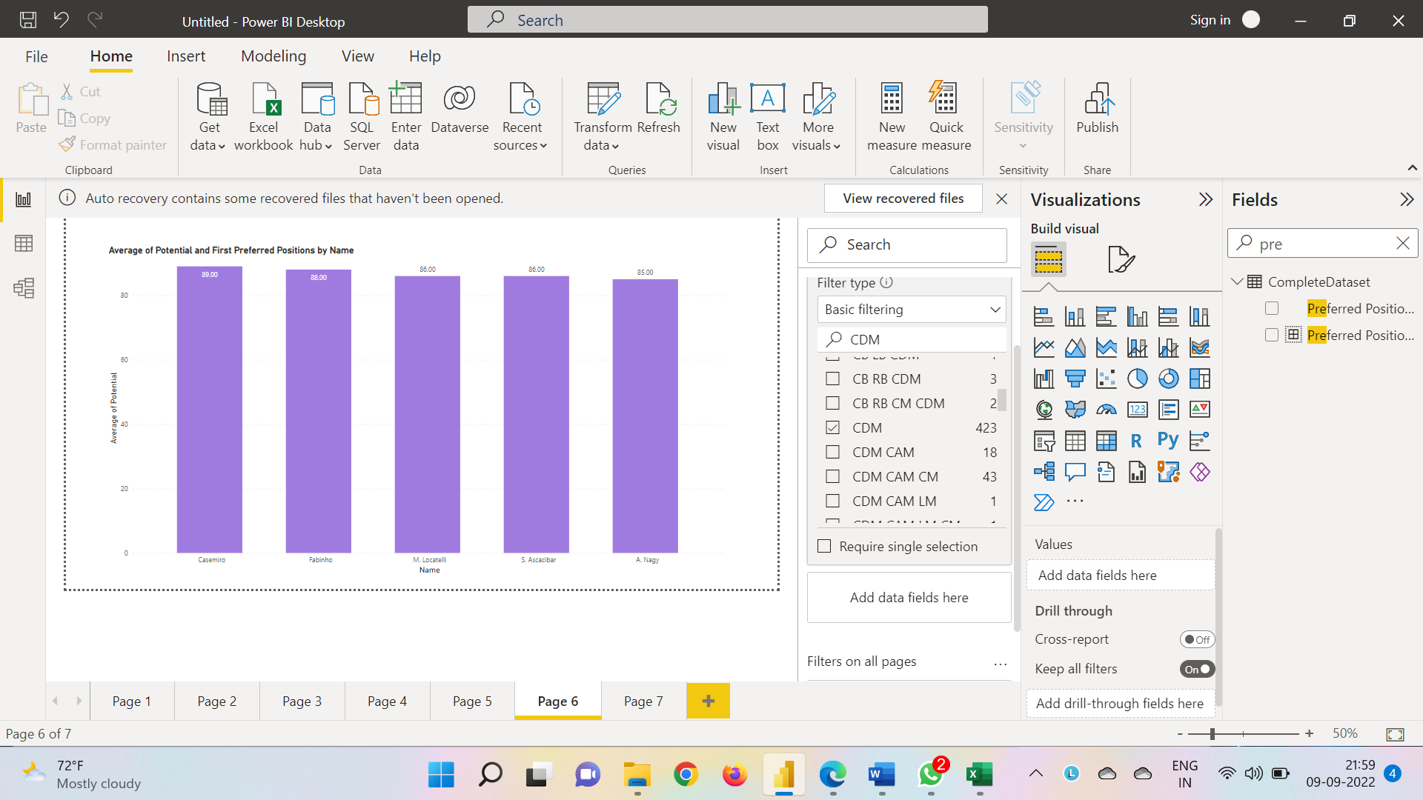

ST Potential

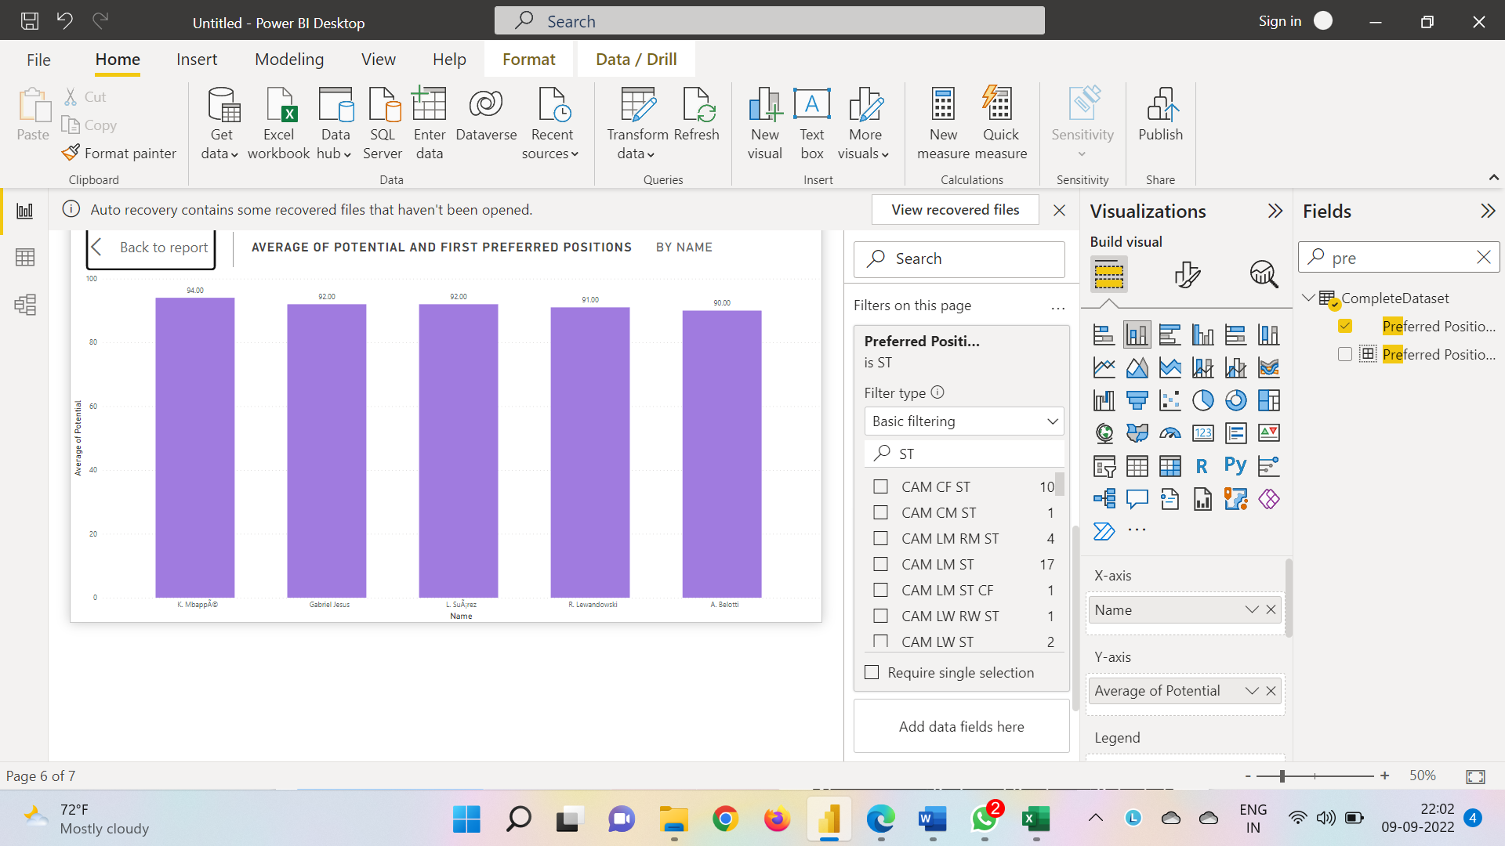

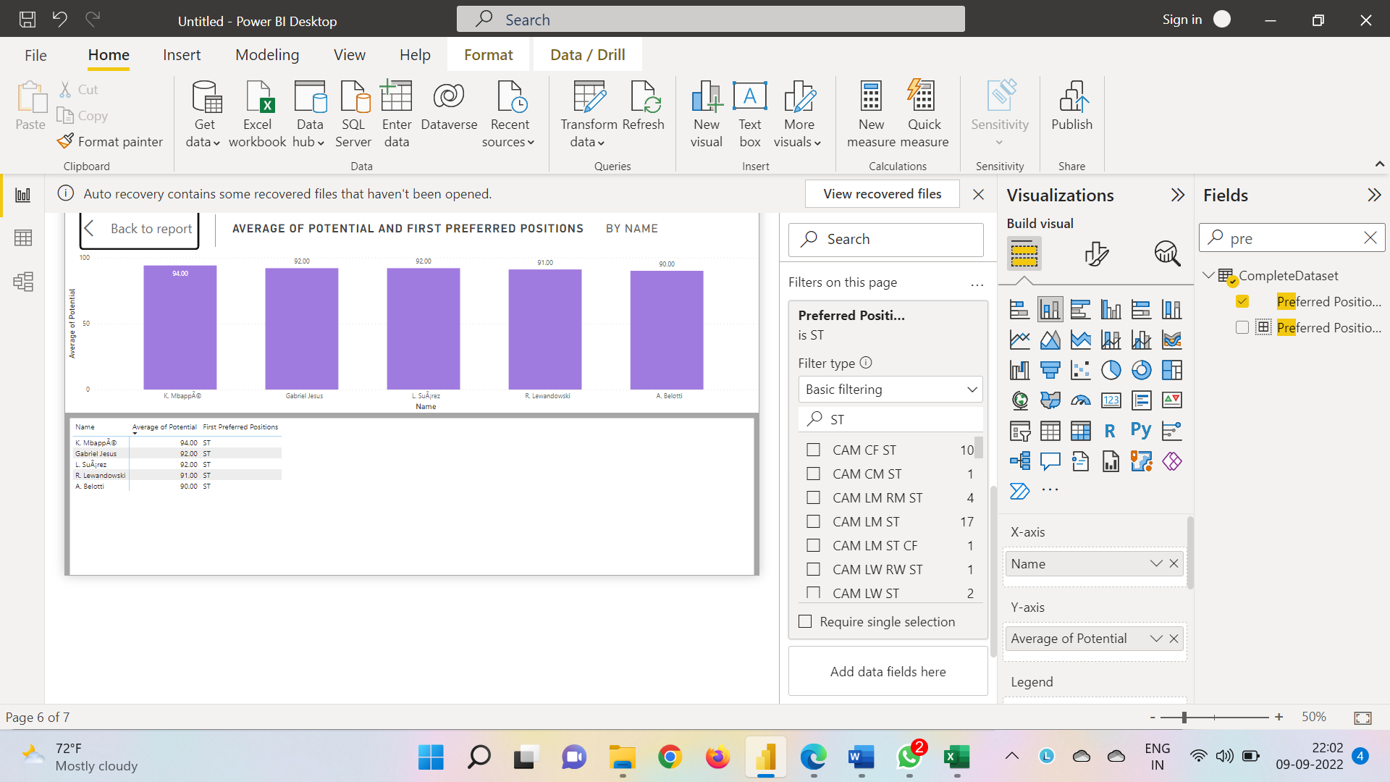

RM Potential

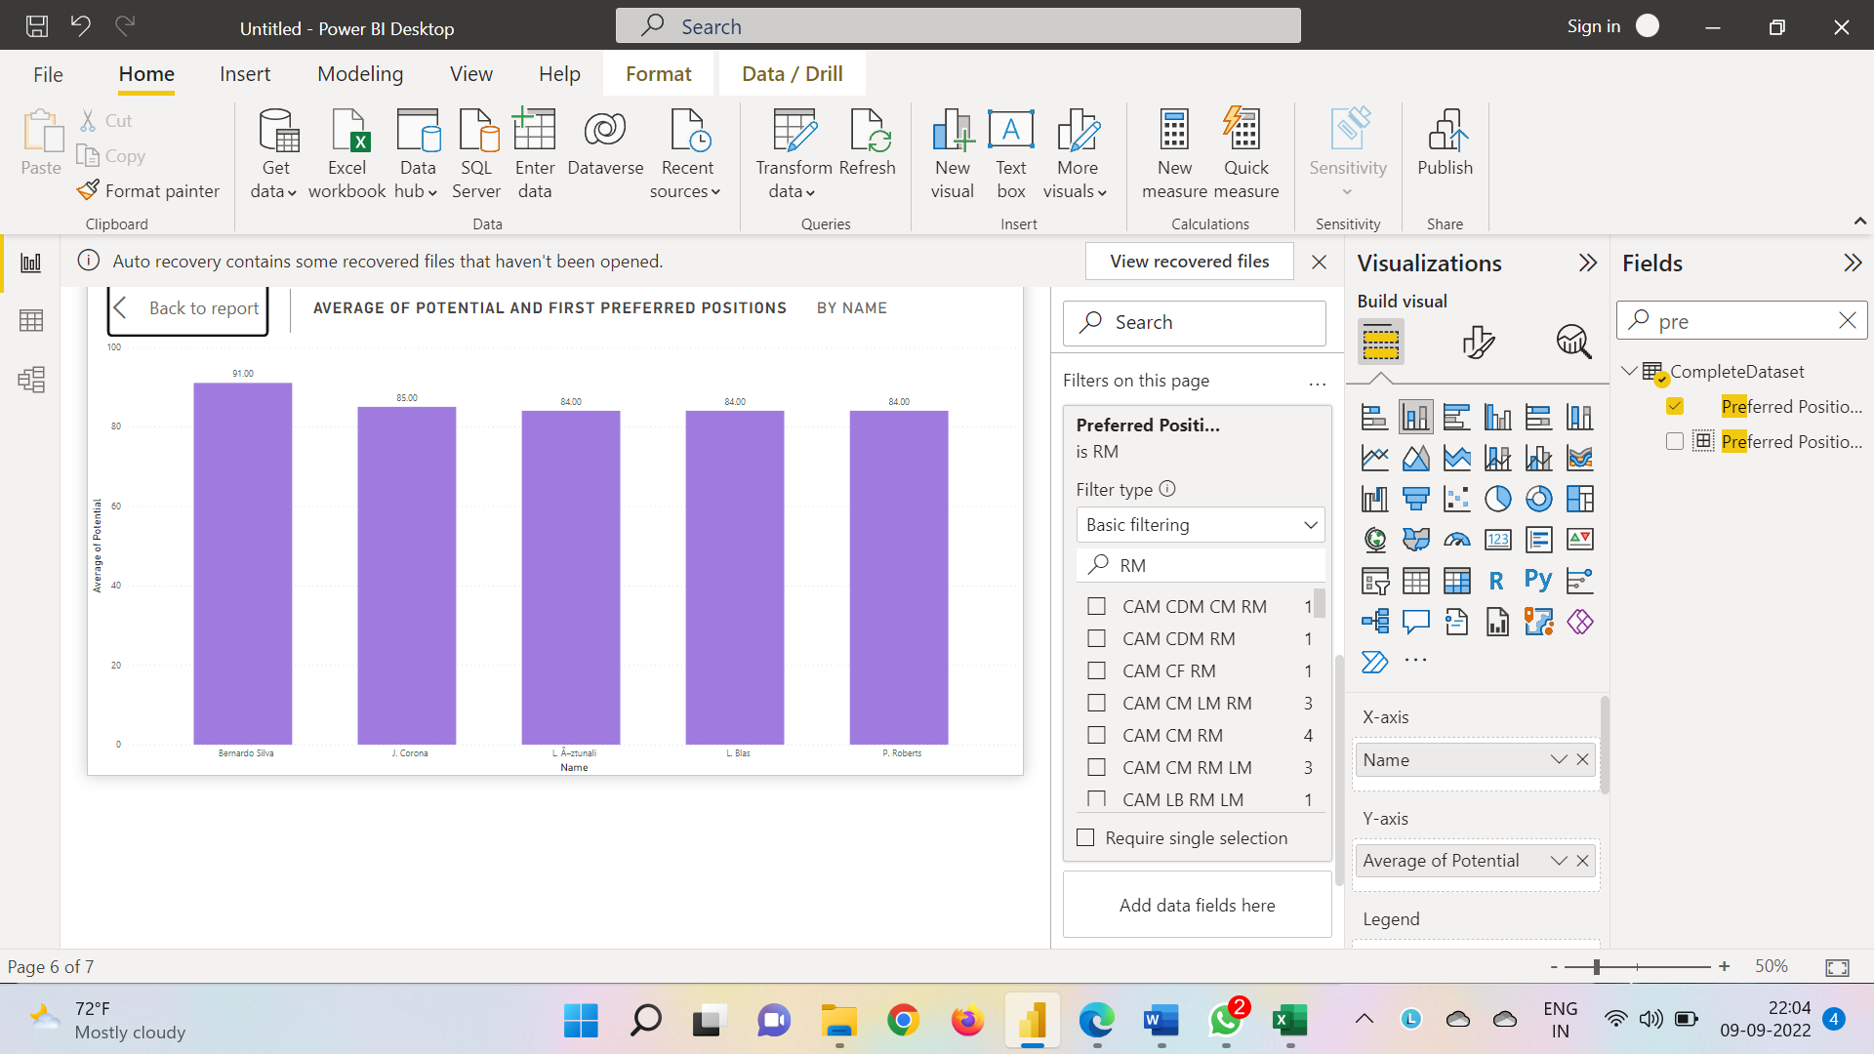

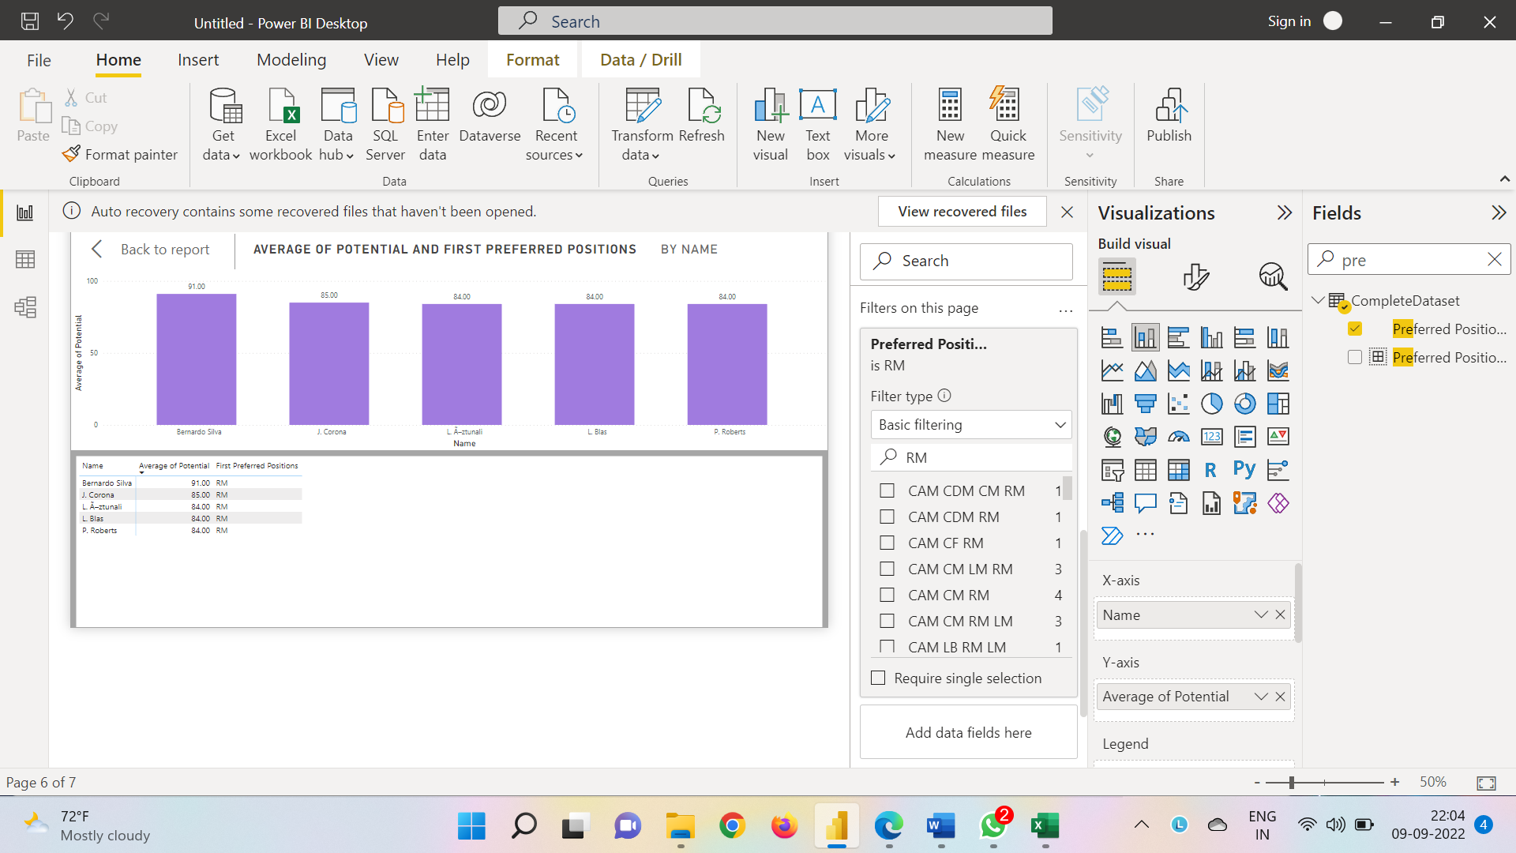

CB Potential

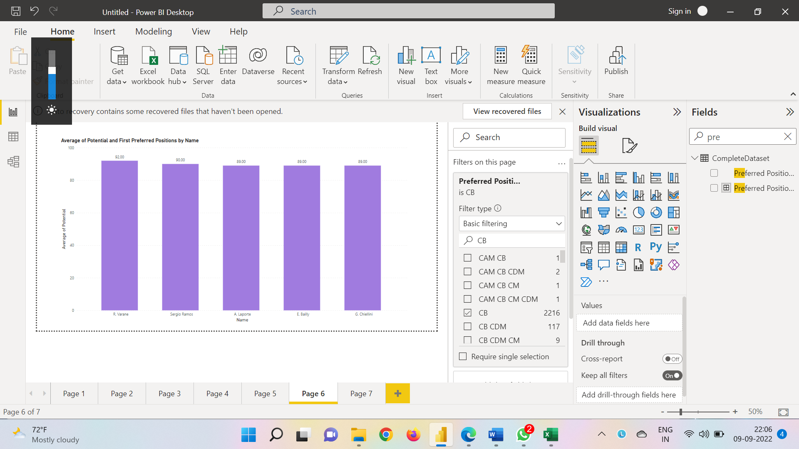

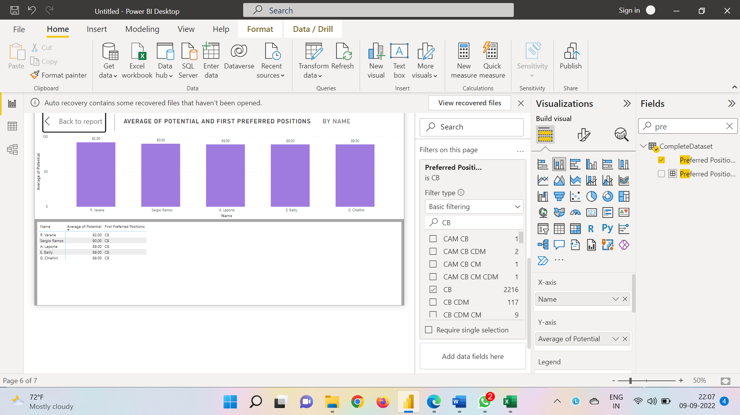

CM Potential

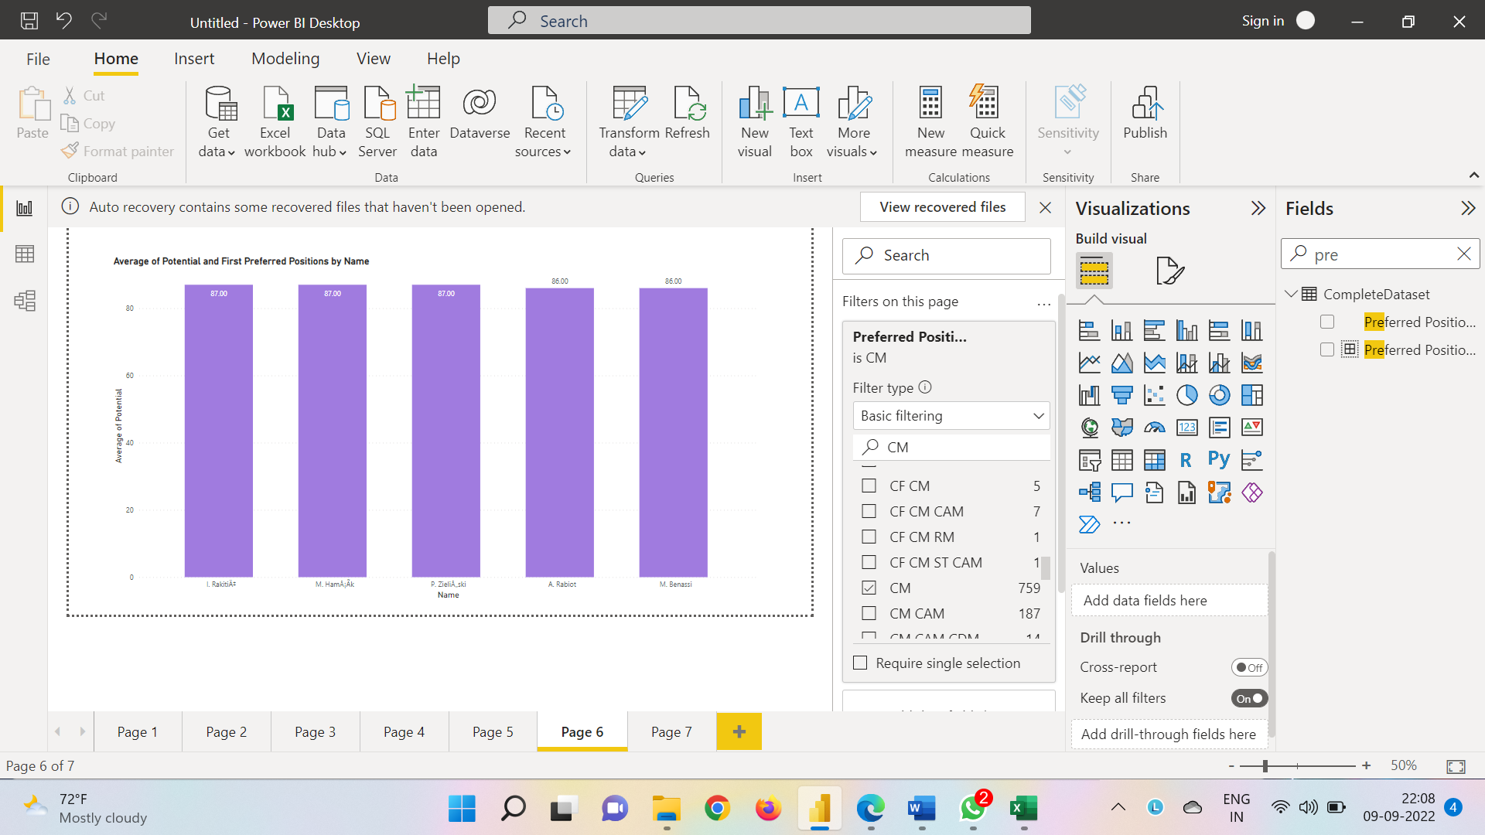

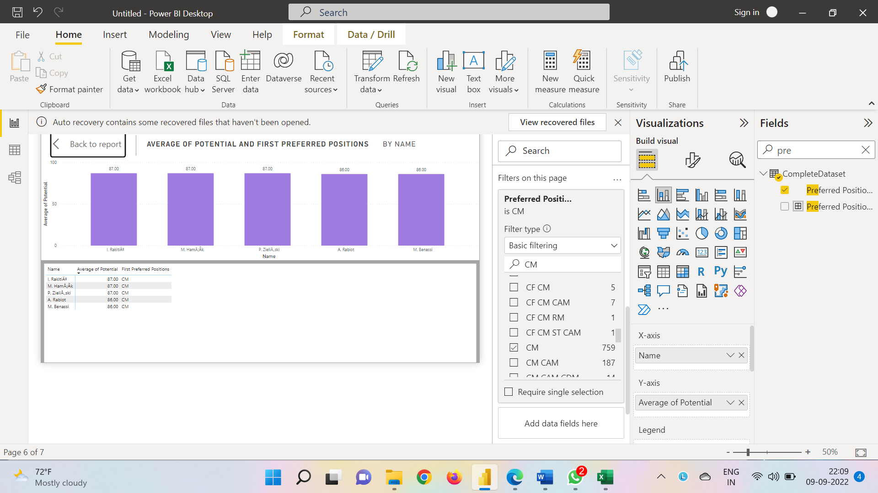

GK Potential

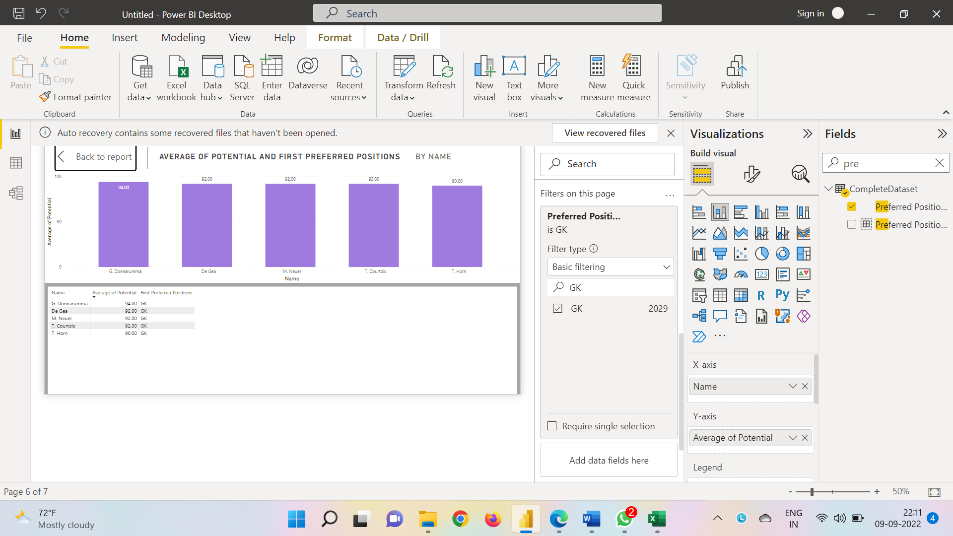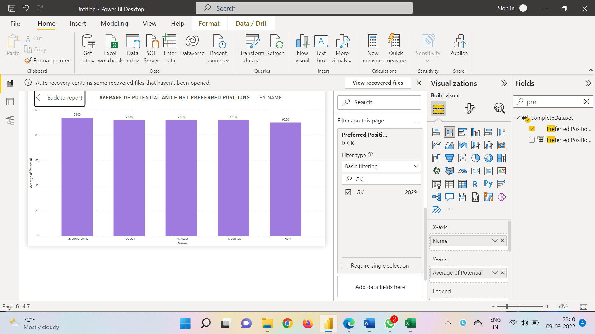

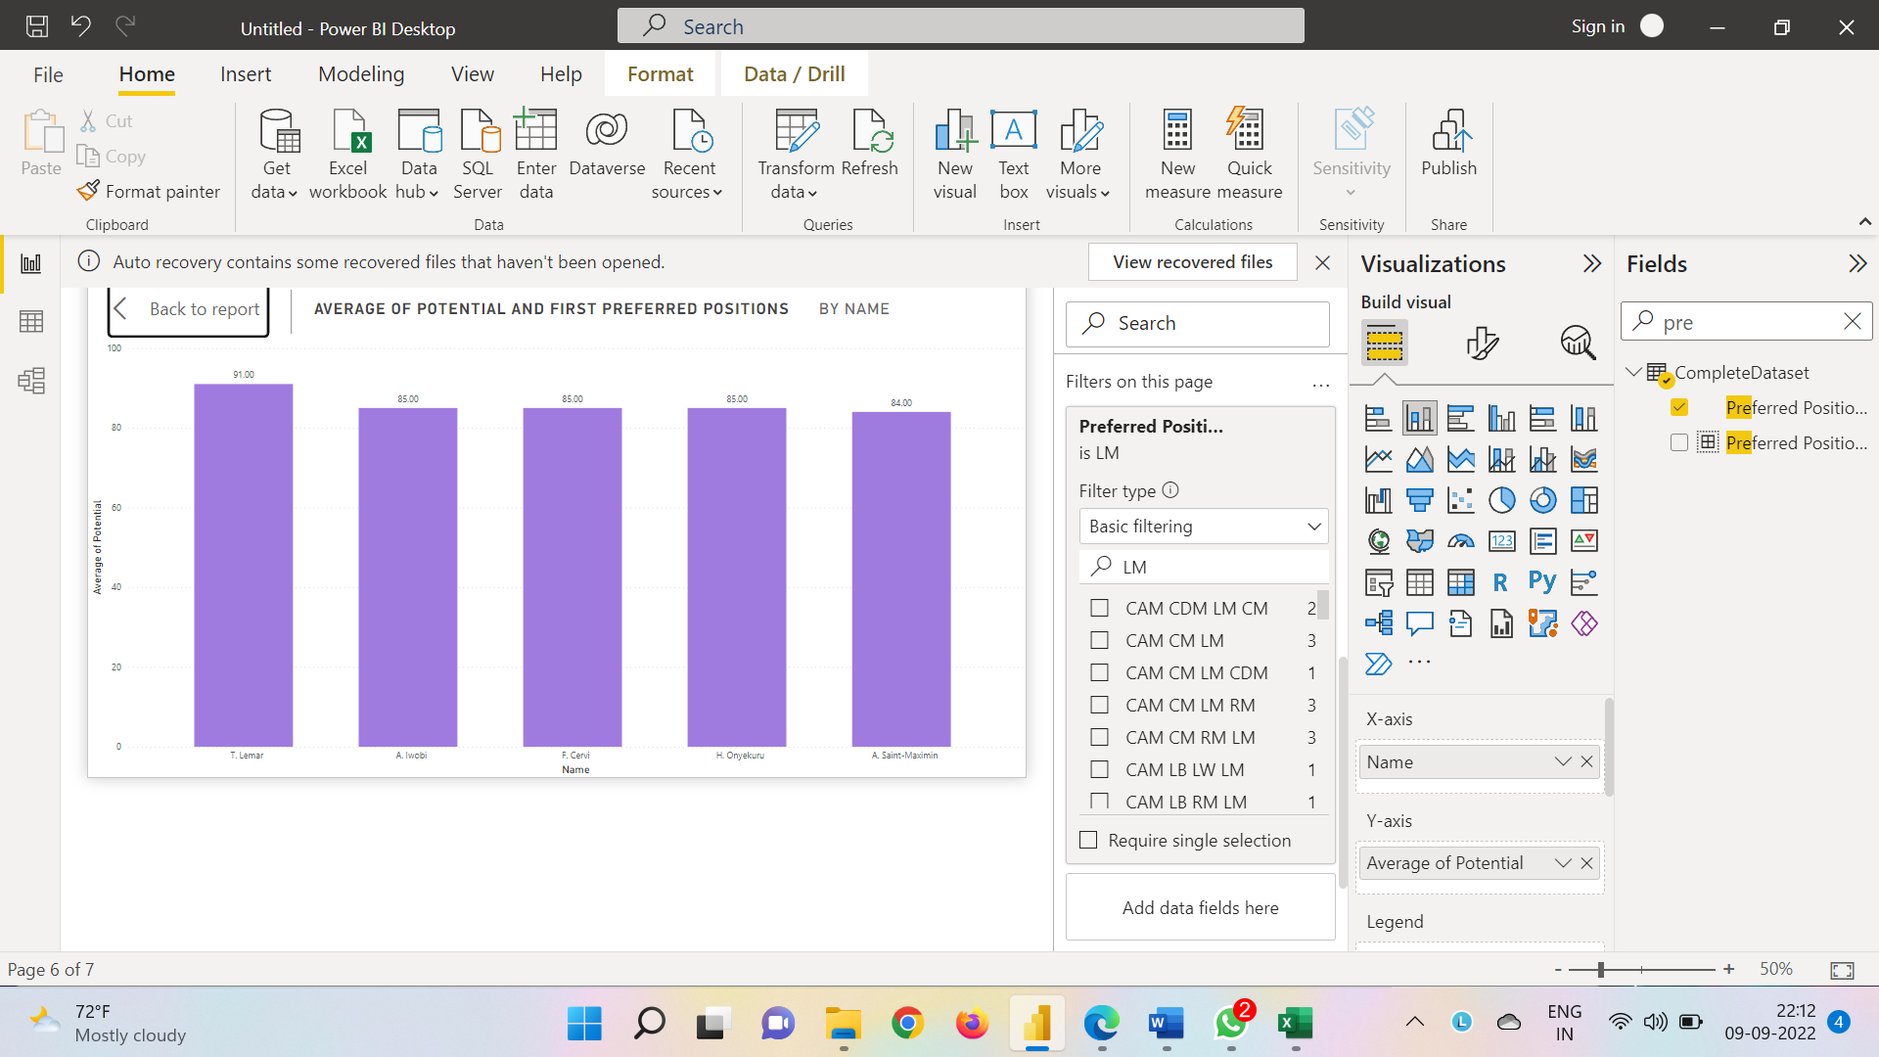LM Potential

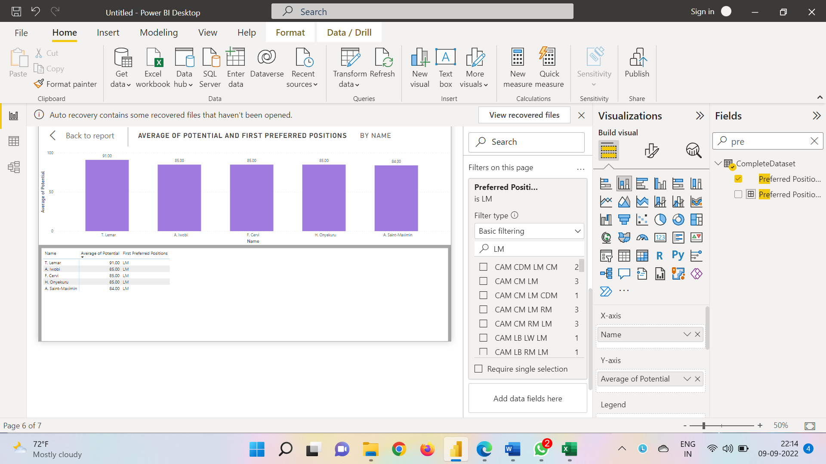

RB Potential

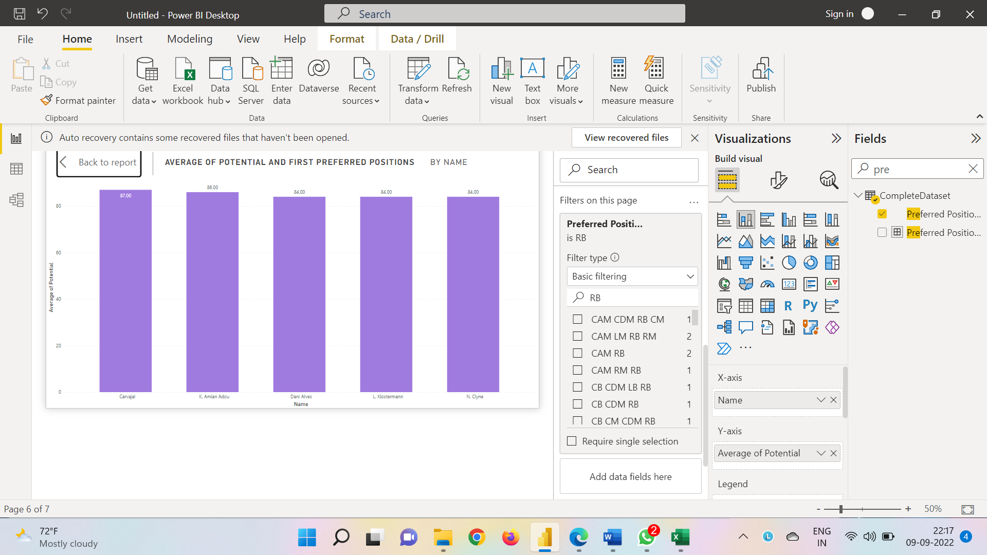

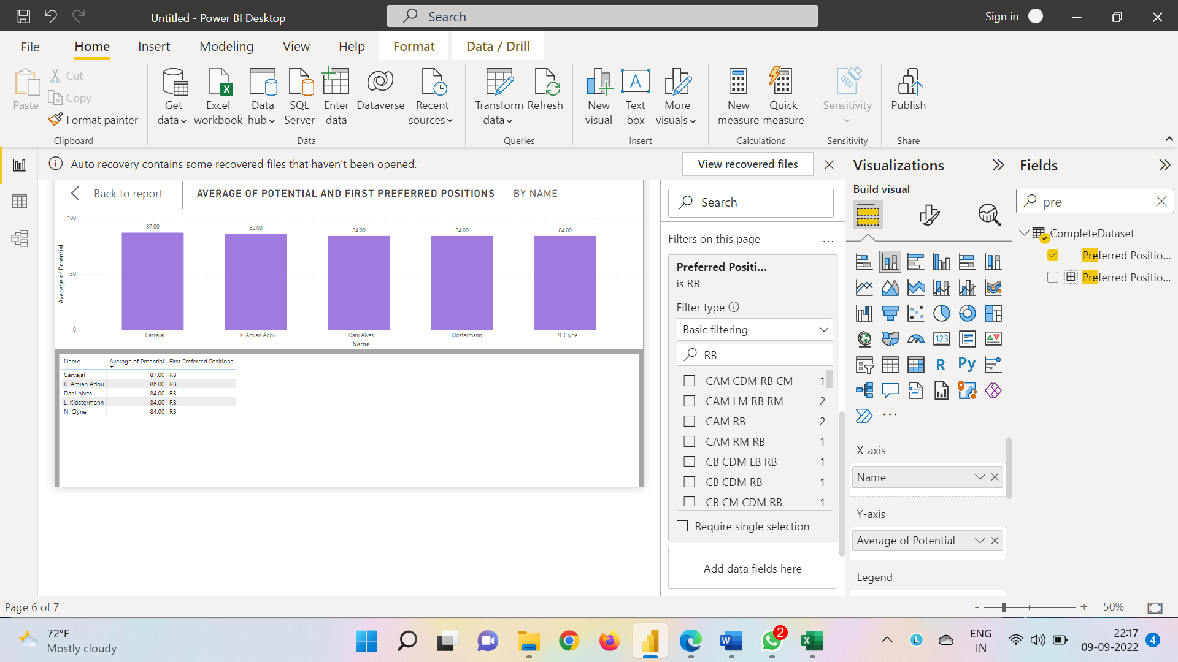

CAM Potential

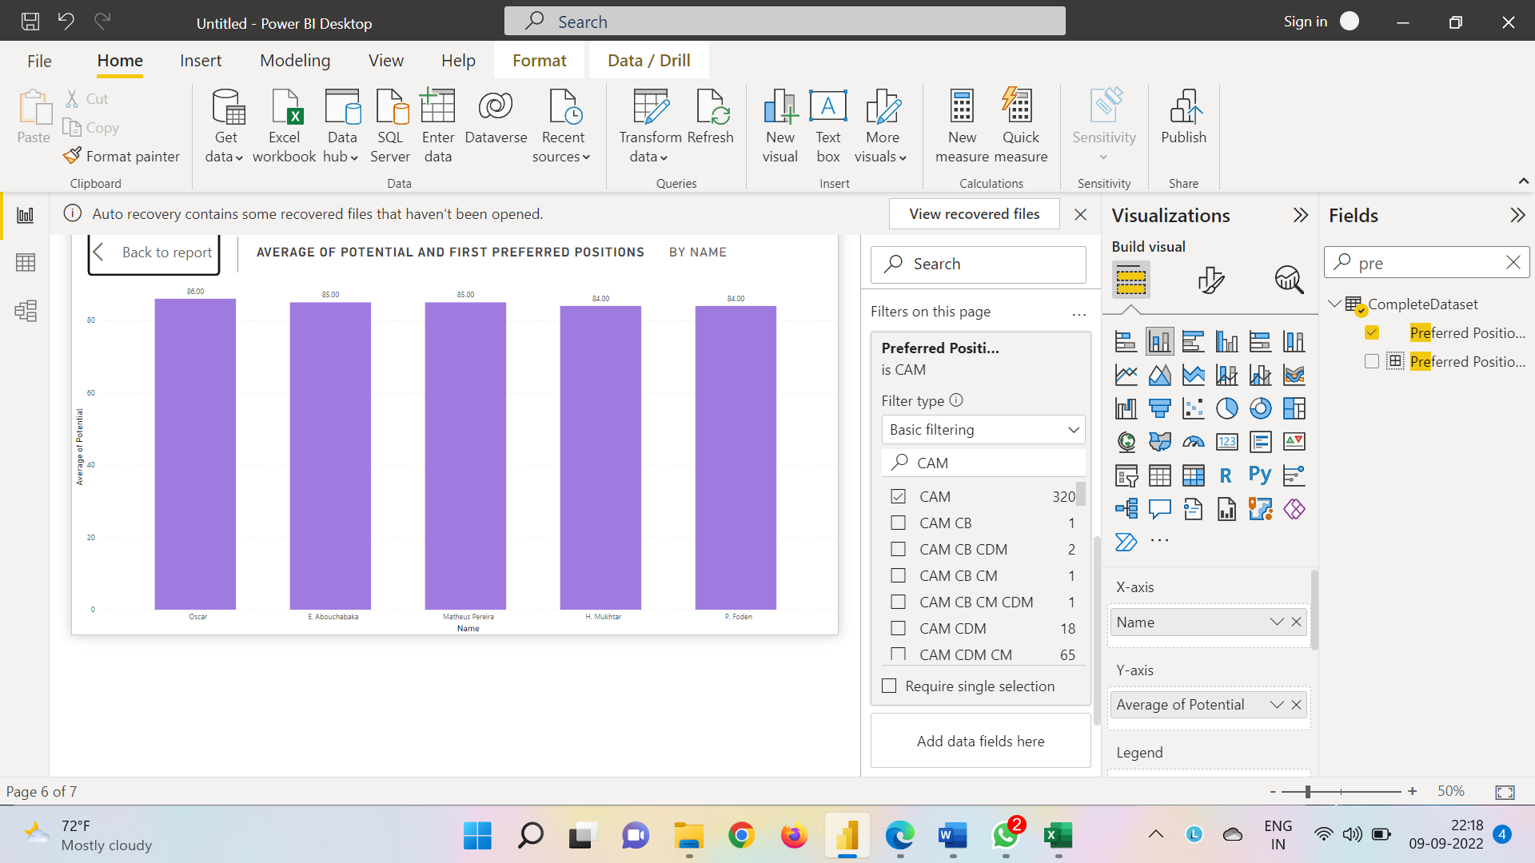

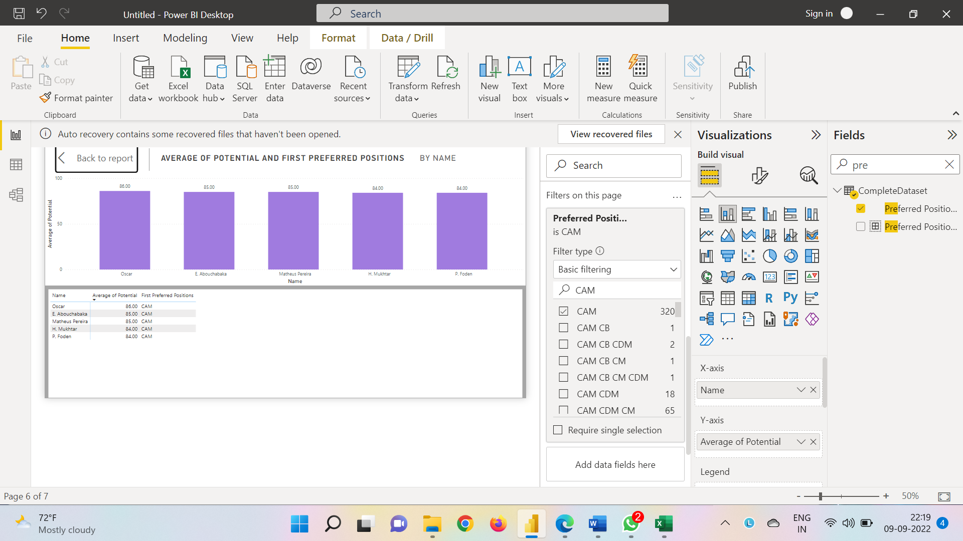

CF Potential

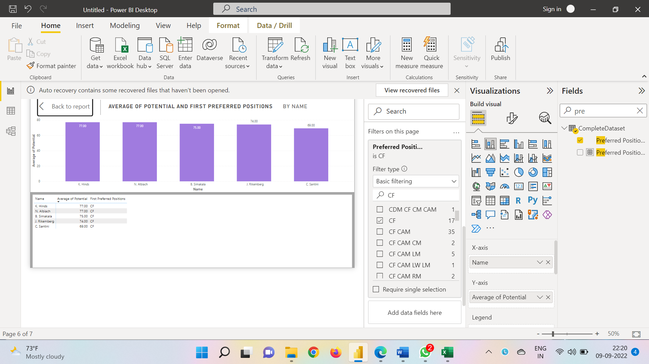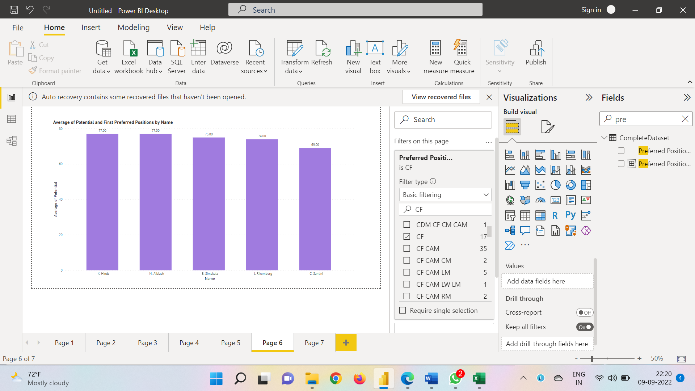

LW Potential

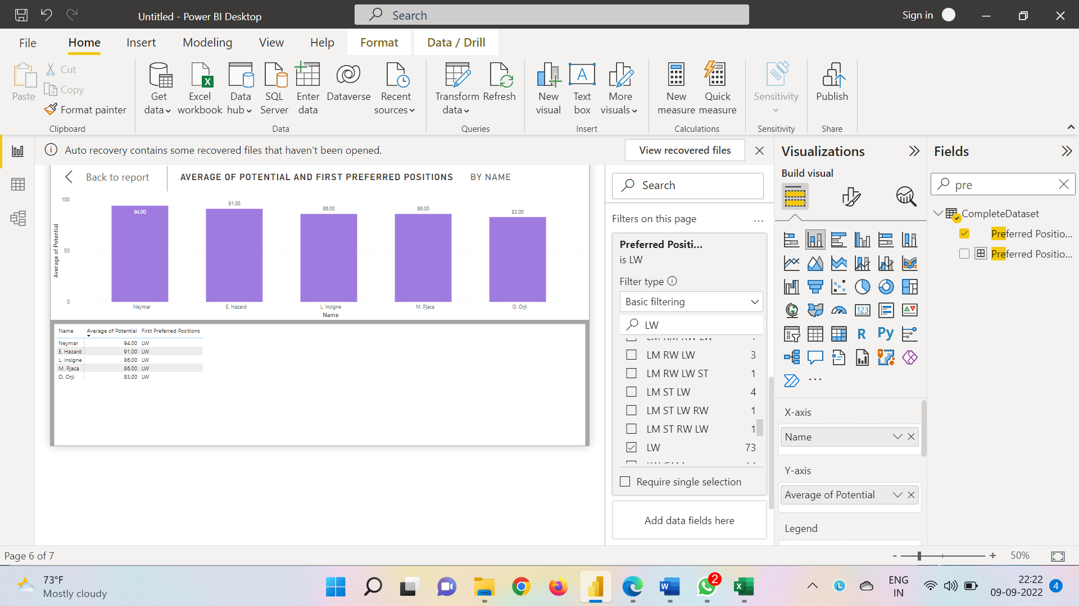

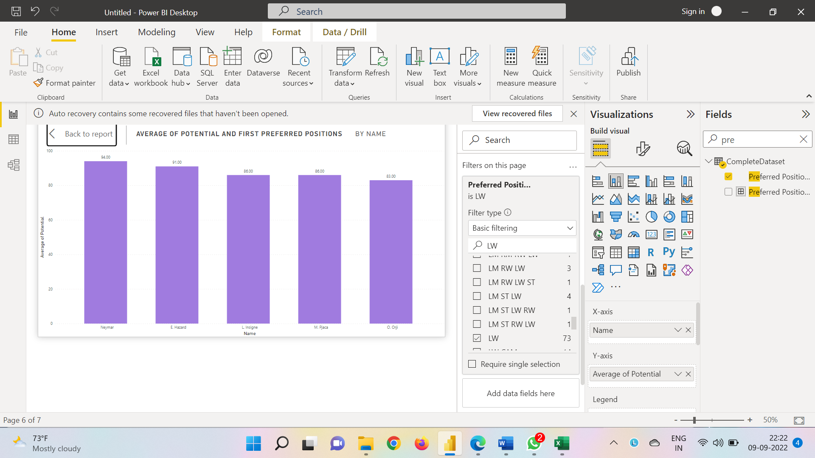

LB Potential

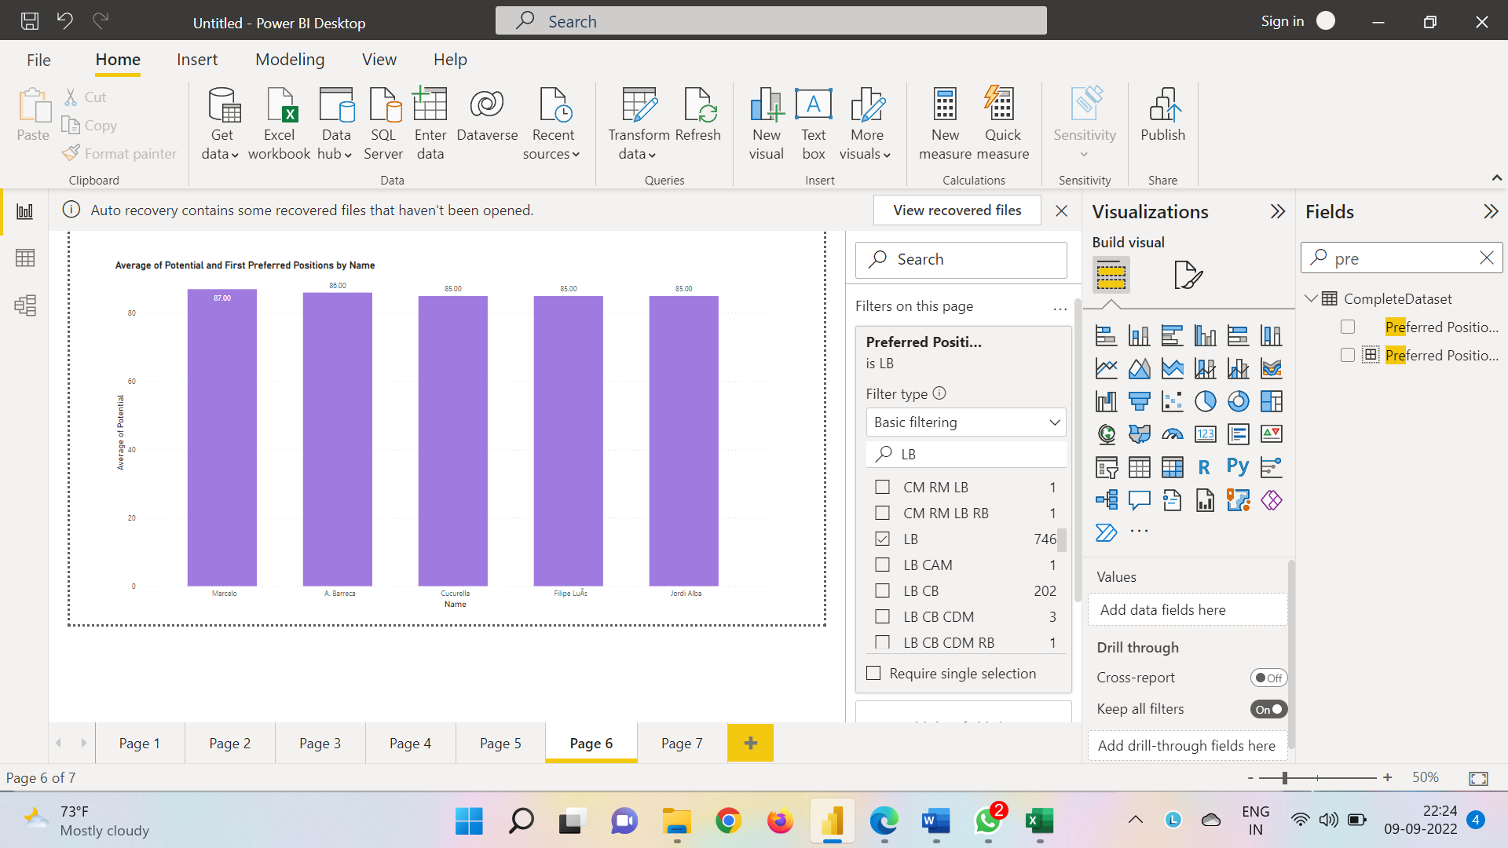

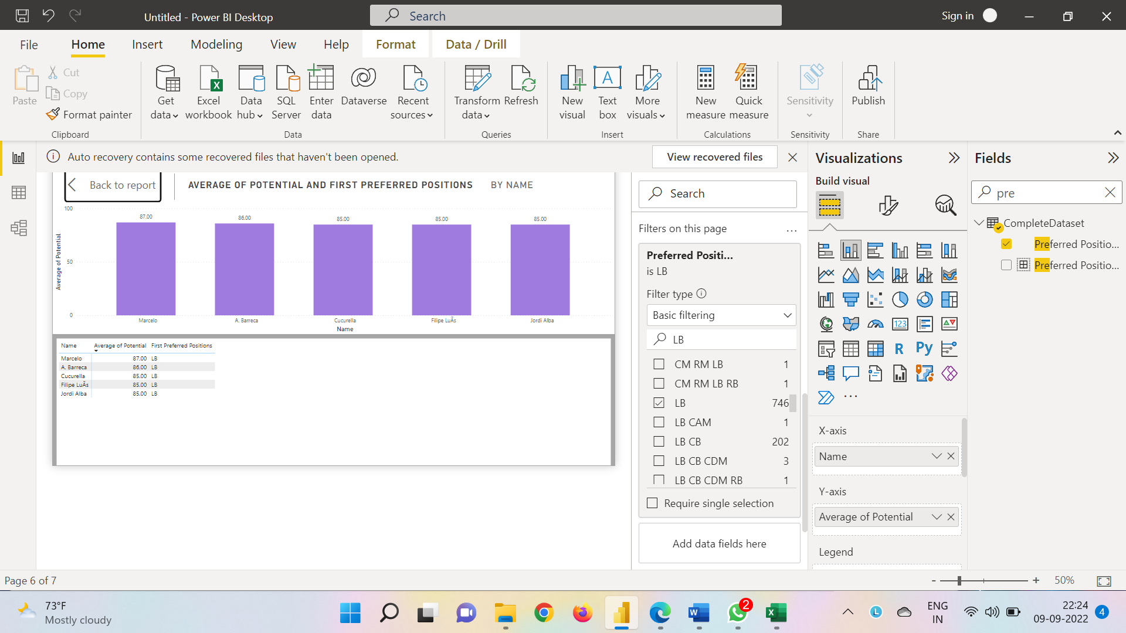

RW Potential

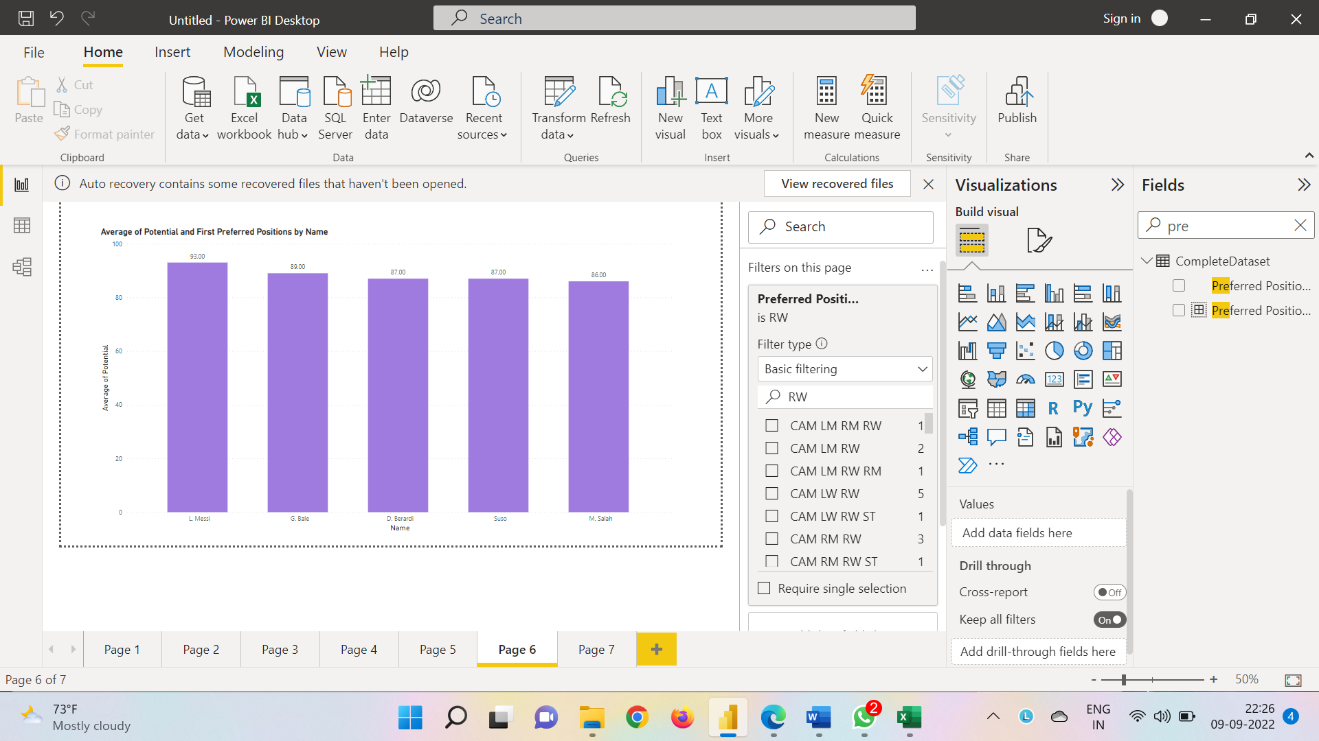

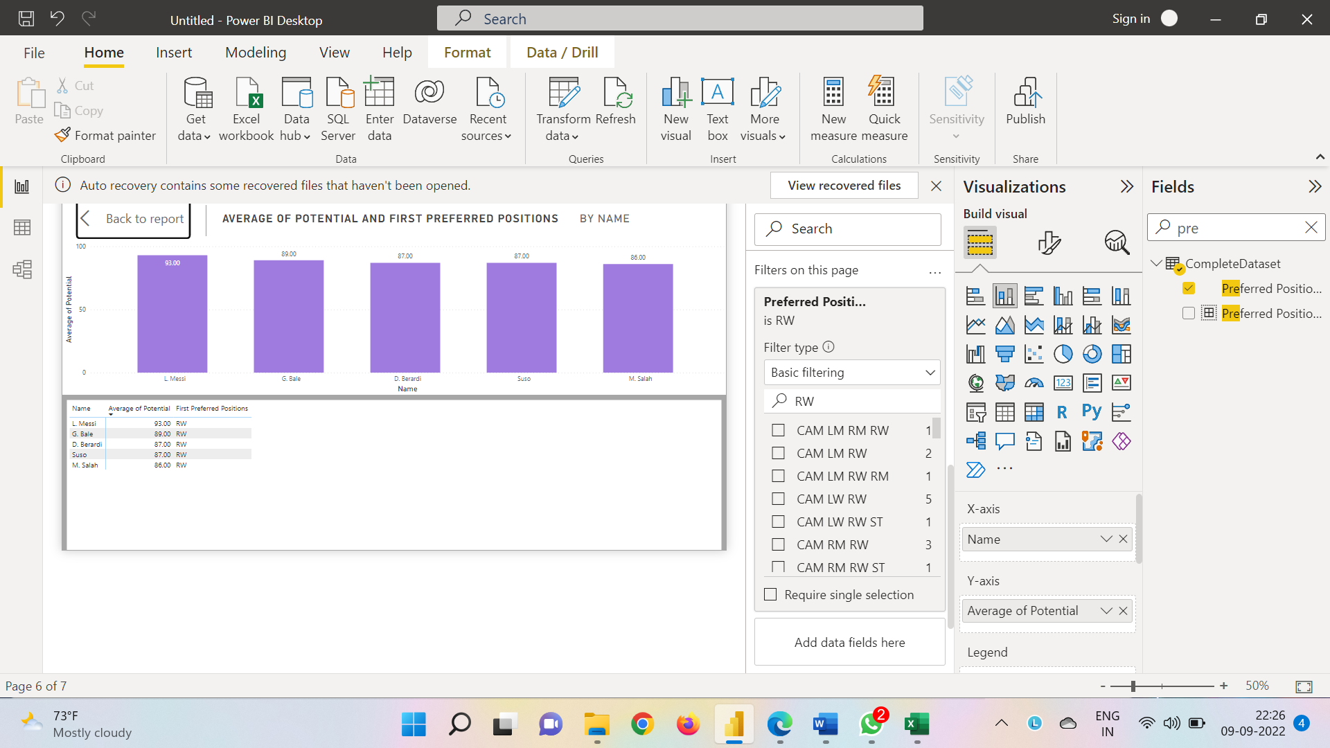

RWB Potential

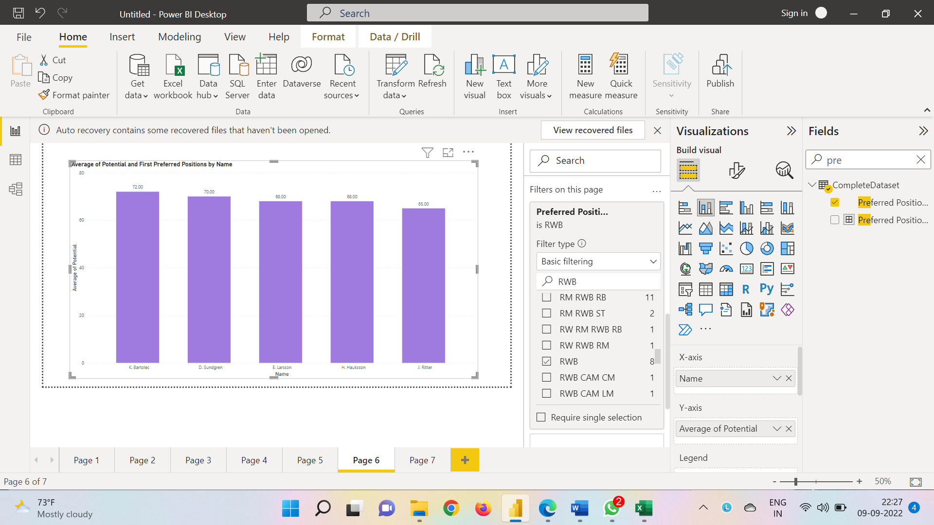

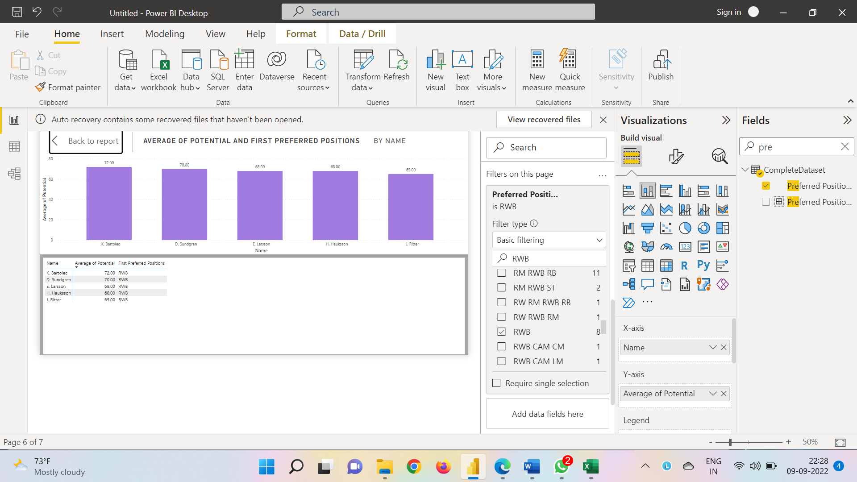

LWB Potential

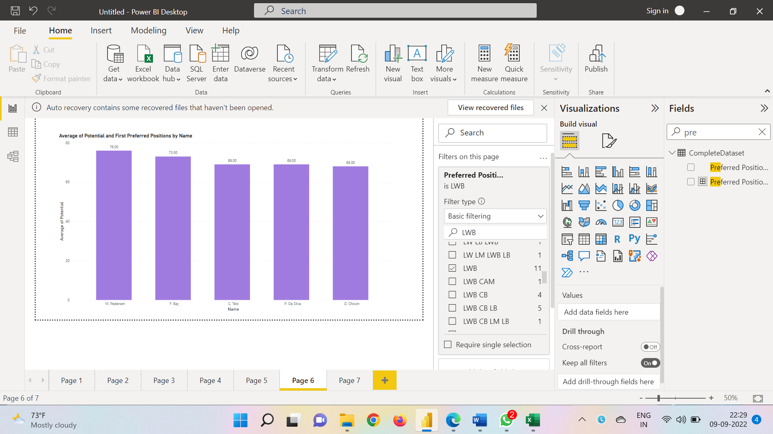

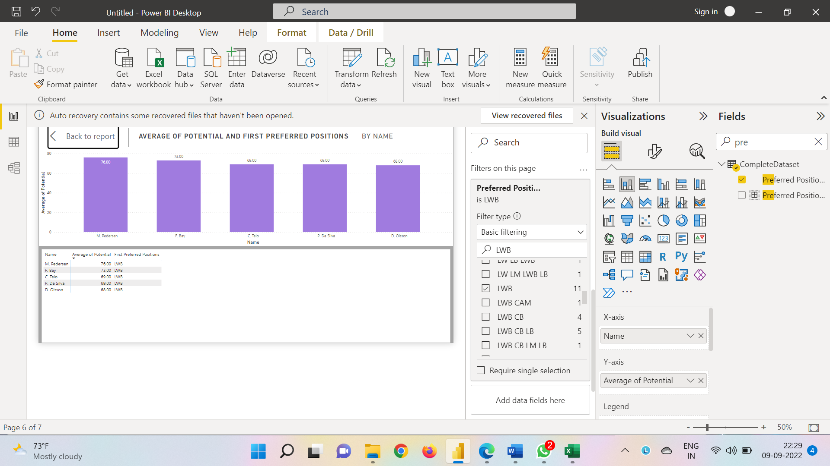

ST Overall

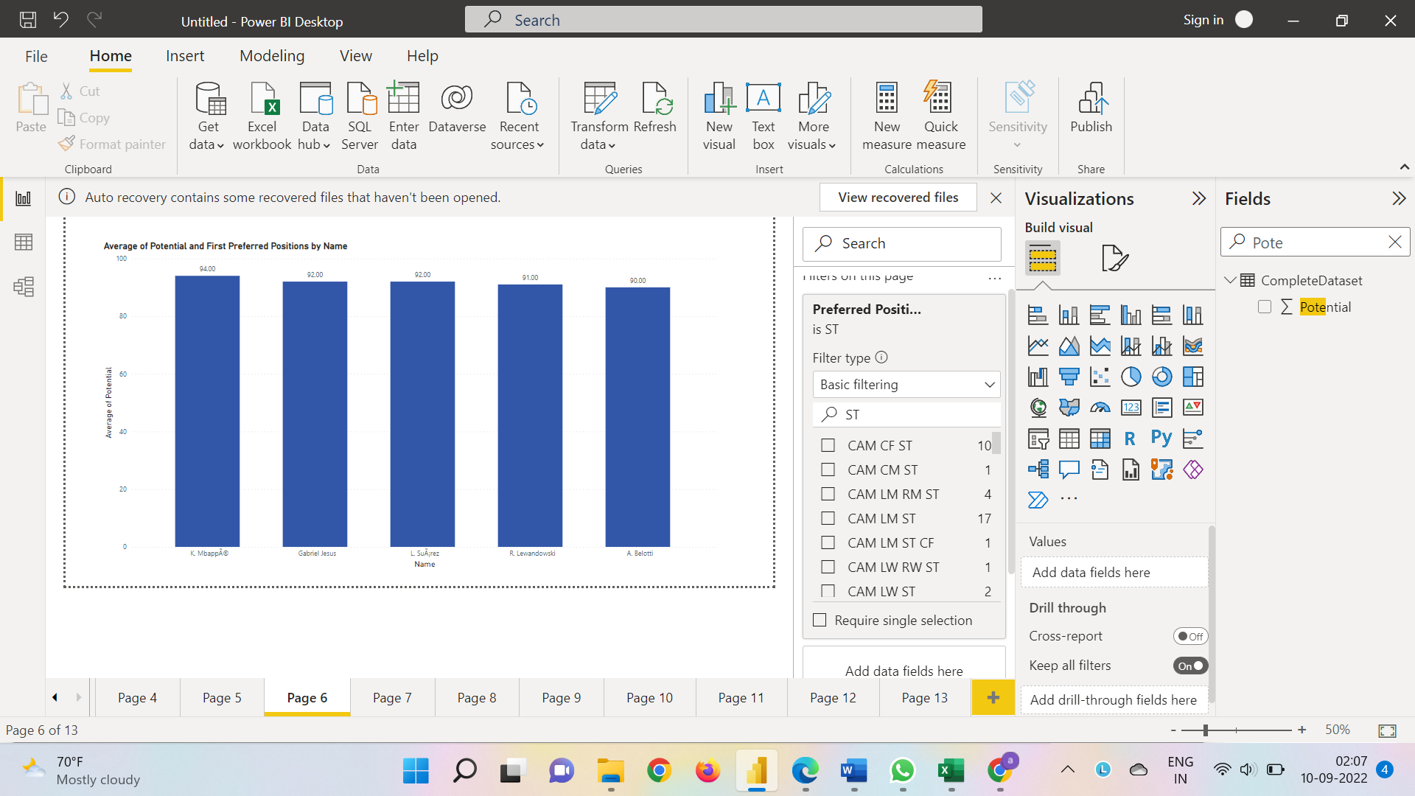

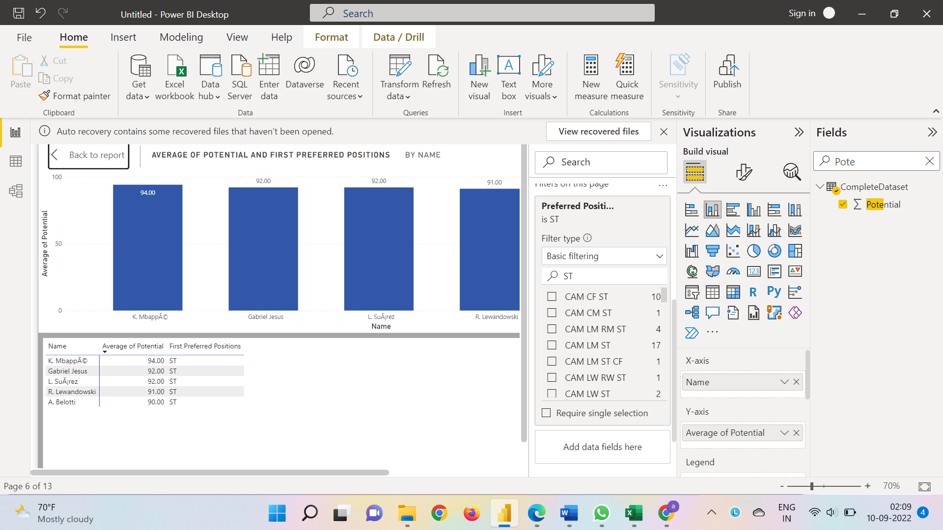

|  |  |  |  |
| --- | --- | --- | --- |
| **Preferred Position** | **Best Players of 2018** | **Player destined to be the future superstar** | |
| CAM | Oscar | Oscar | |
| CB | Sergio Ramos | R.Varane | |
| CDM | Casemiro | Casemiro | |
| CF | N.Albiach | K.Hinds | |
| CM | I. RakitiÄ‡ | I. RakitiÄ‡ | |
| GK | M.Neuer | G.Donnarumma | |
| LB | Marcelo | Marcelo | |
| LM | N.GaitÃin | T.Lemar | |
| LW | Neymer | Neymer | |
| LWB | C.Telo | M.Pedersen | |
| RB | Carvajal | Carvajal | |
| RM | Bernando Silva | Bernando Silva | |
| RW | L.Messi | L.Messi | |
| RWB | D.Sundgren | K.Bartolec |
| KKST | L.Suariz | K.Mbappa | |

5). Which club(s) have the maximum share of players from England? Which club(s) have the maximum share of players from Spain? Which club(s) have the maximum share of players from Germany?

Clubs with maximum share of player England

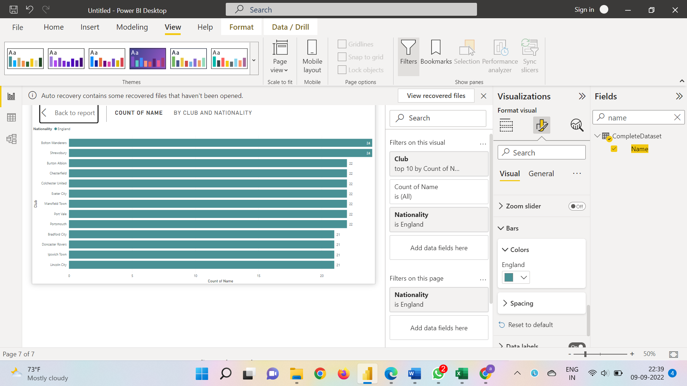

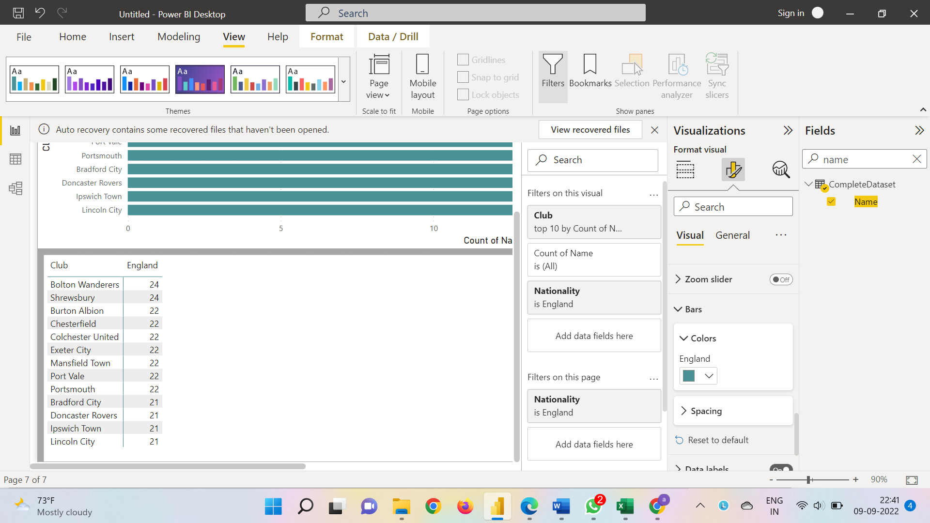

Clubs with maximum share of player Spain

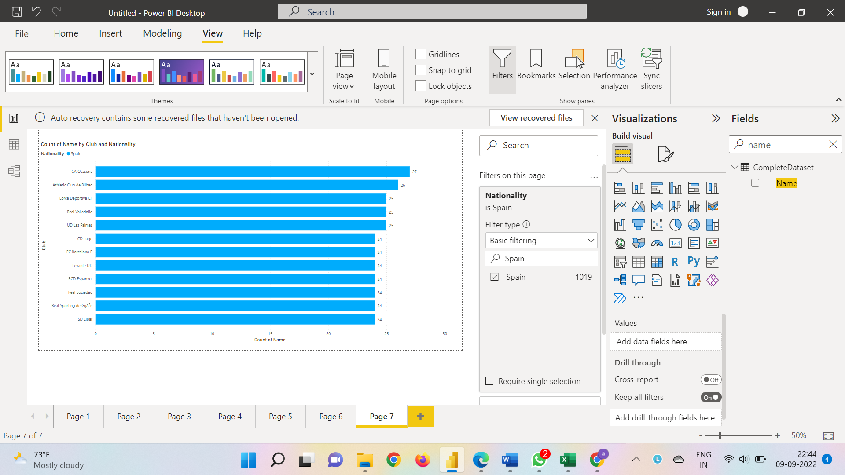

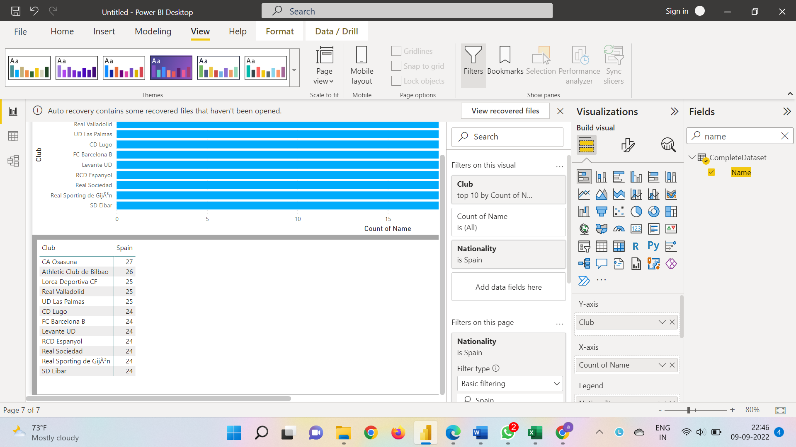

Clubs with maximum share of player Germany

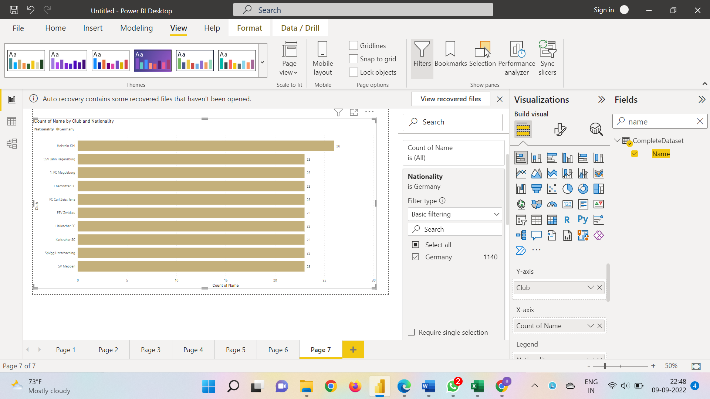

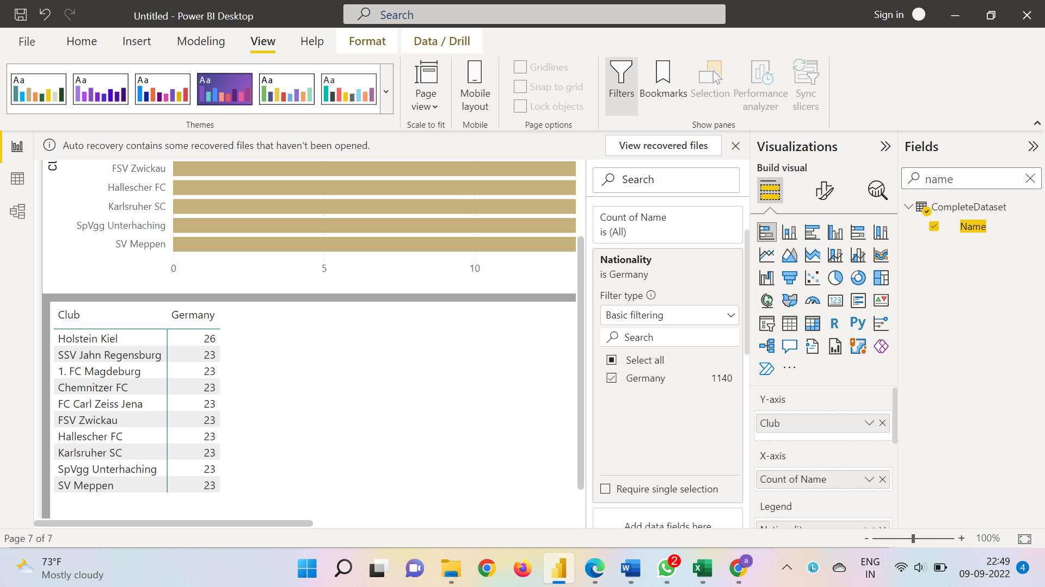

**Following clubs have the maximum shares of players from respective countries:**

**England - Bolton Wanderers and Shrewsbury**

**Spain - CA Osasuna**

**Germany - Holstein Kiel**

6). Are the wages of a player influenced by the potential of a player? Check it out for players with age Between 16 to 28?

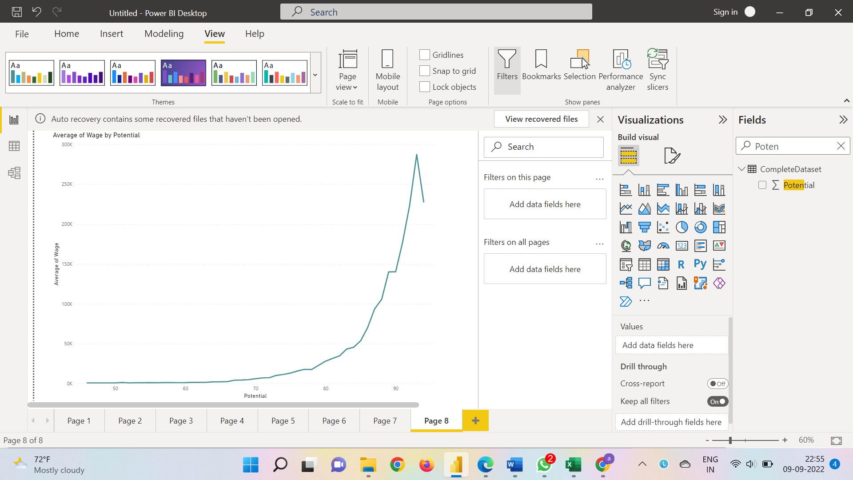

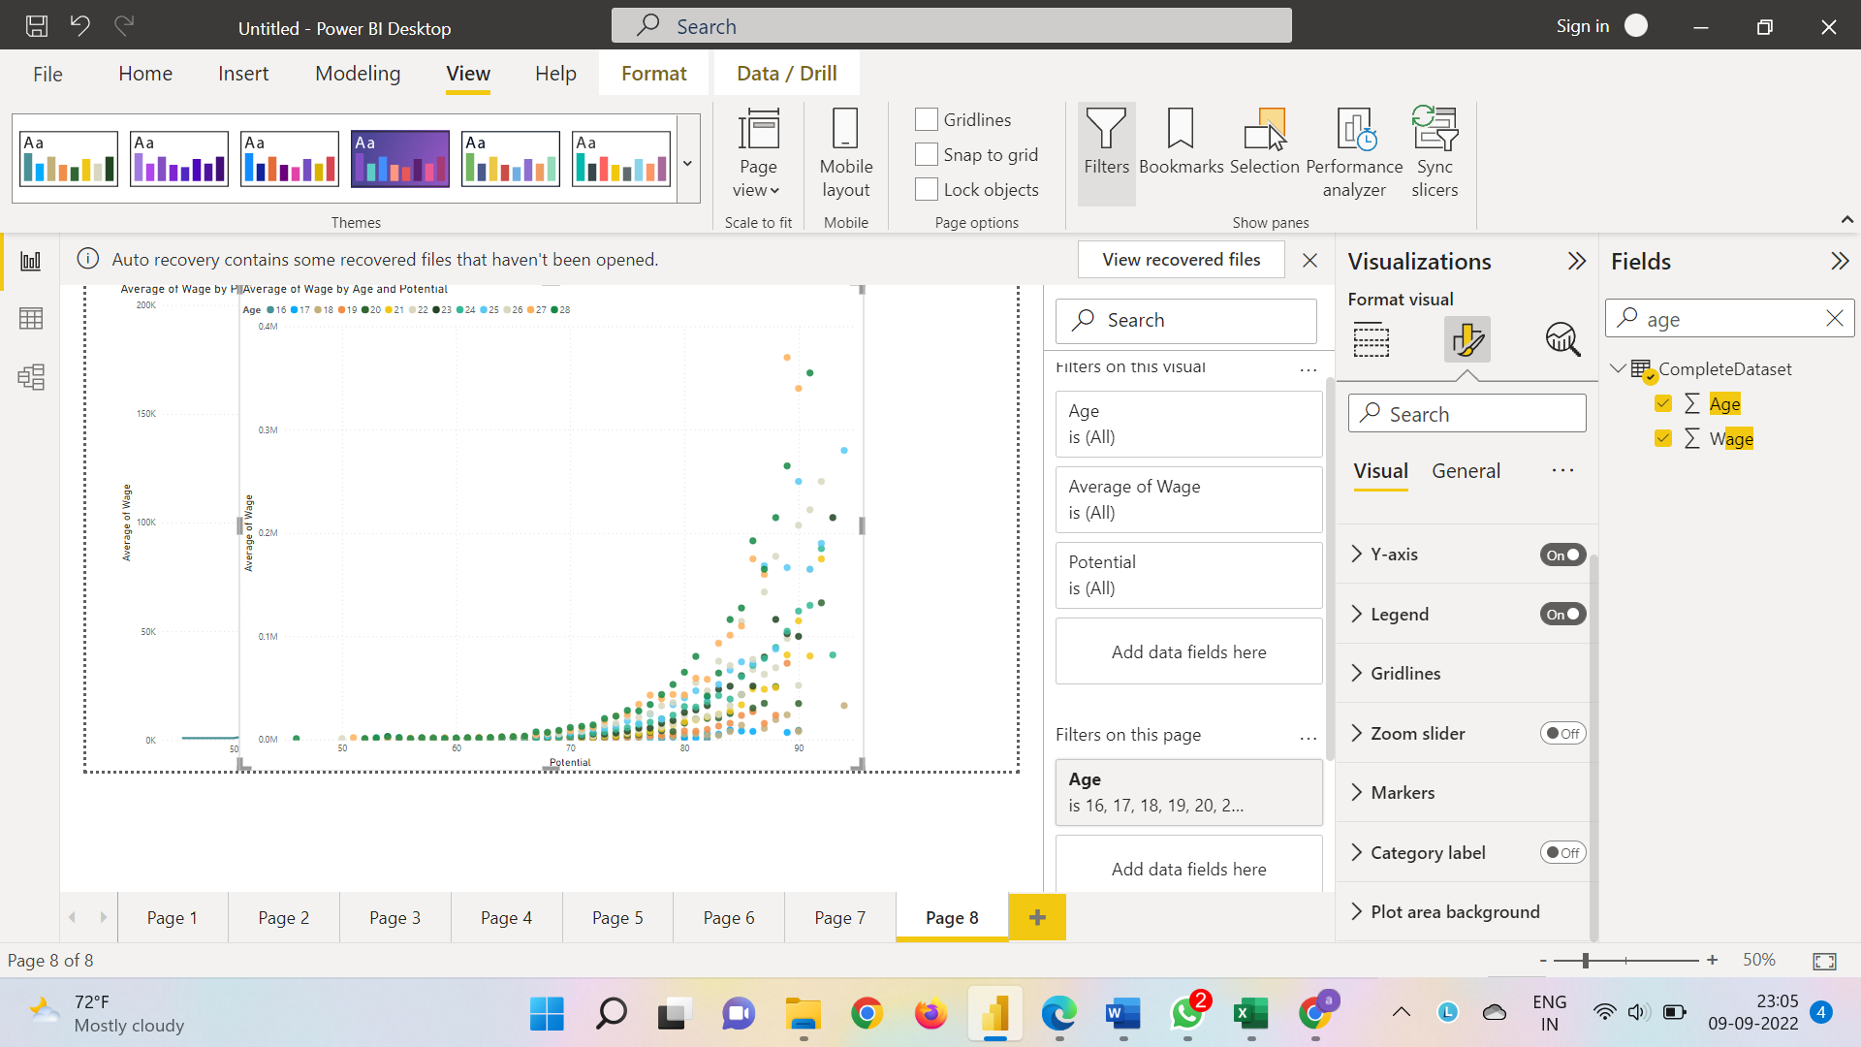

**The general pattern reveals that more the potential a player has, he is likely to have higher the wage. We have used a scatter plot and a line plot above to come to the conclusion. The presence of outliers or exceptions has caused the Average Wage Vs Potential line graph to have a sudden dip towards the end, otherwise, an exponentially increasing trend can be observed.**

7). Do Strikers score higher on "Aggression" than defenders do? Group both the set of players (from an overall score of 80 to 85) and compare their average aggression levels. Which particular position has the highest aggression as a given (players with an overall score of 80 to 90)?

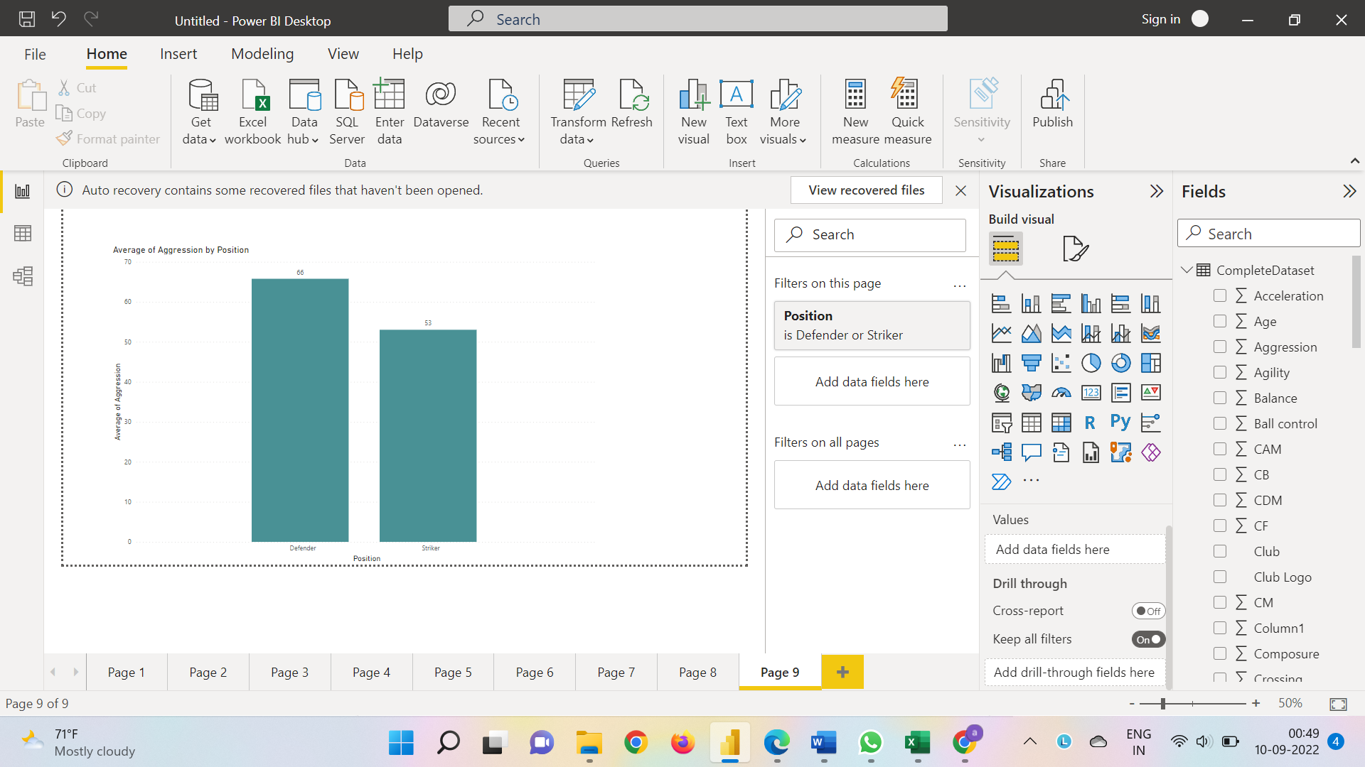

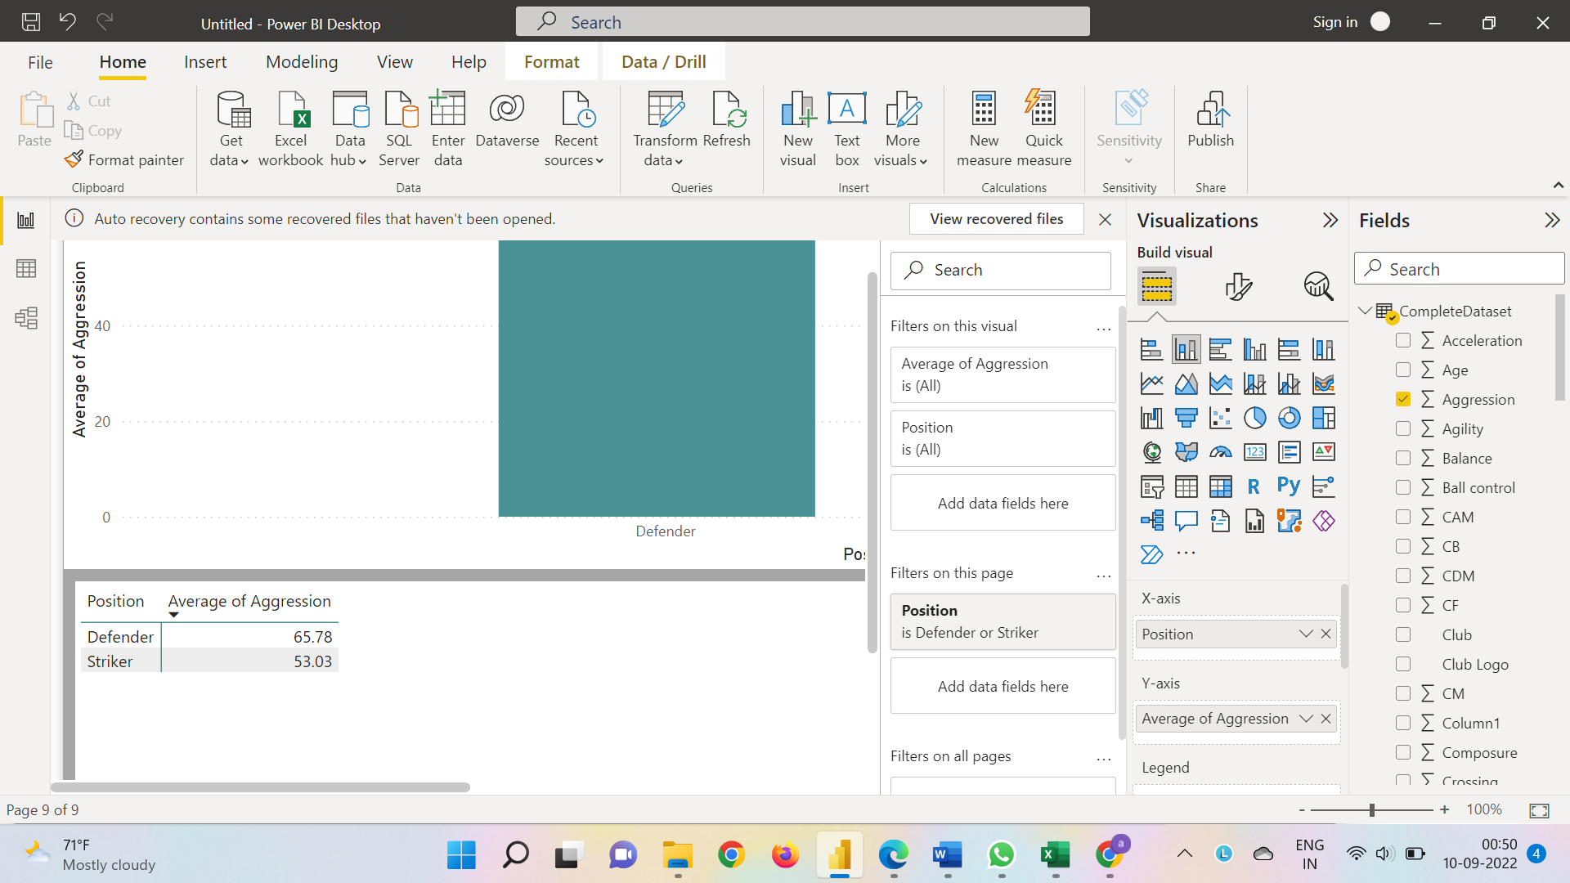

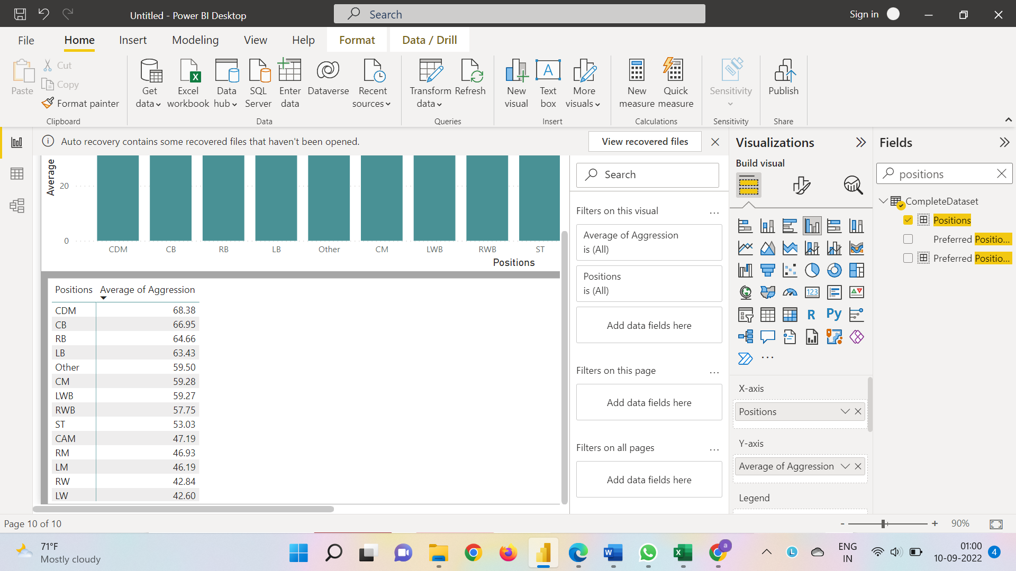

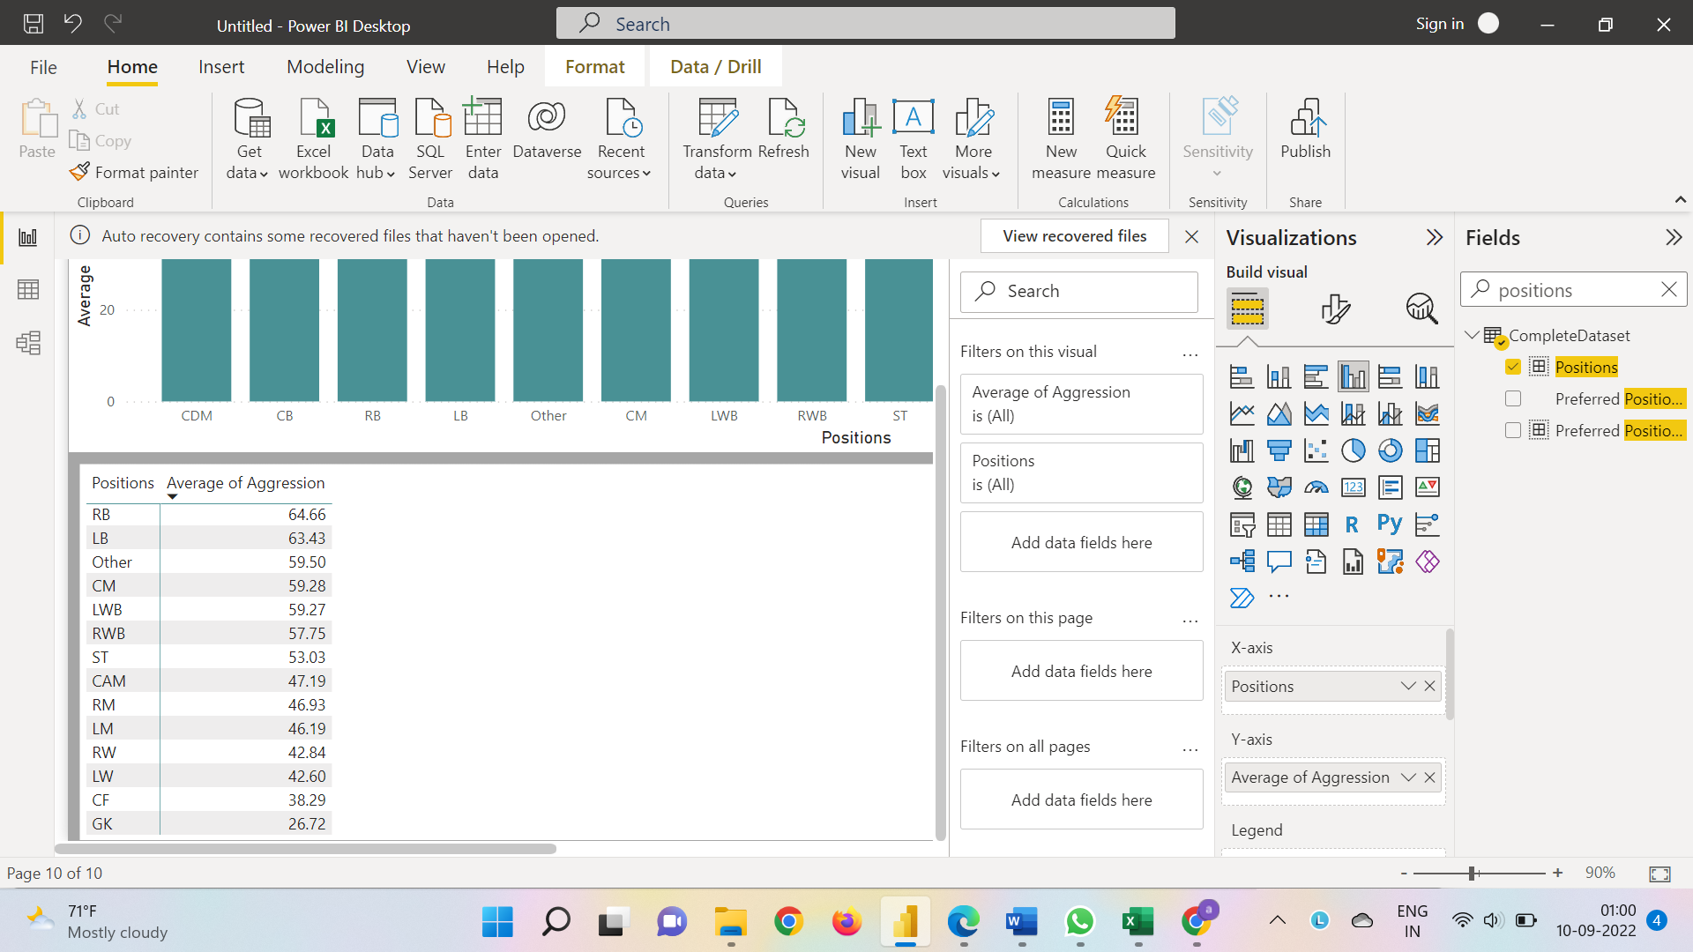

**It can be observed from the bar graph that the average aggression score of Strikers (ST) is much lower than that of the Defenders (CB, LB, RB, RWB, LWB) for the players with an overall score in the 80-90 bracket. Players with an overall of 80-90 and in the CDM position rank the highest in terms of average aggression score.**

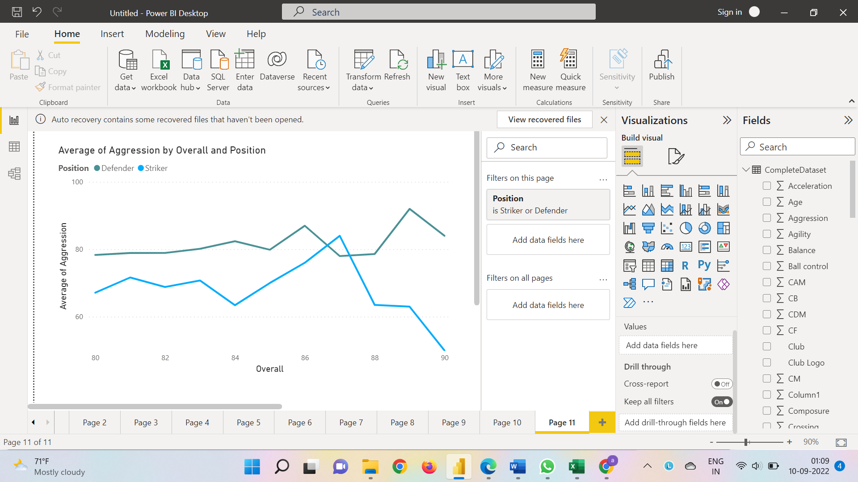

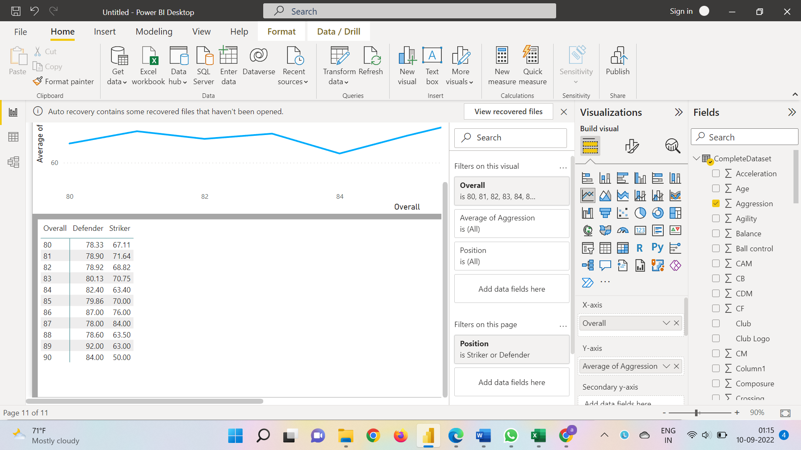

**From the above graph we can see that the defenders (LB, RB, CB, RWB, LWB) score higher that striker do up to an overall of 87.0 but later on the striker87 scored higher on aggression but later defender scored higher after overall crossed 89.0.**

8). How based on the positional data, players are profiled for different roles/classes. Plot Aggression, Acceleration, Agility, Balance and Ball Control for strikers and Goal Keepers in a single line/Bar plot to understand the positional difference

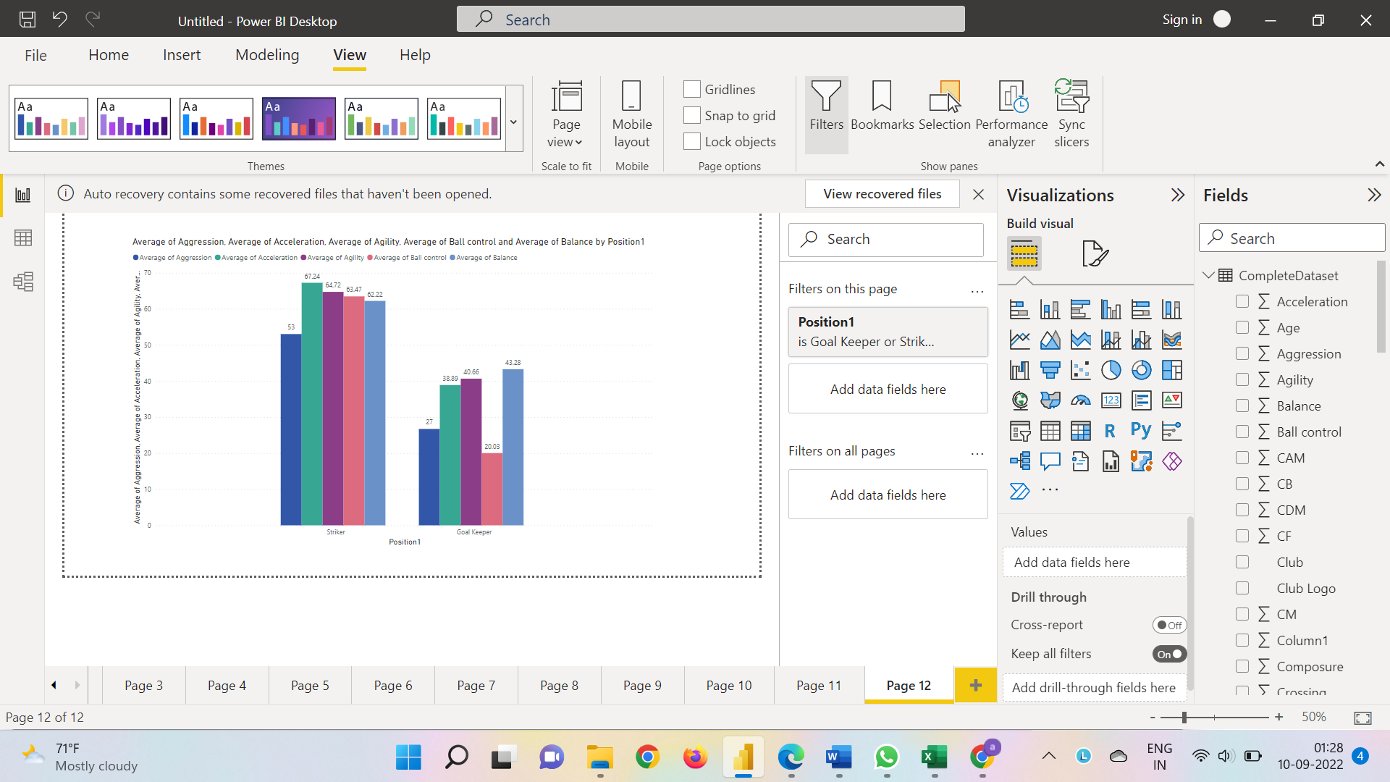

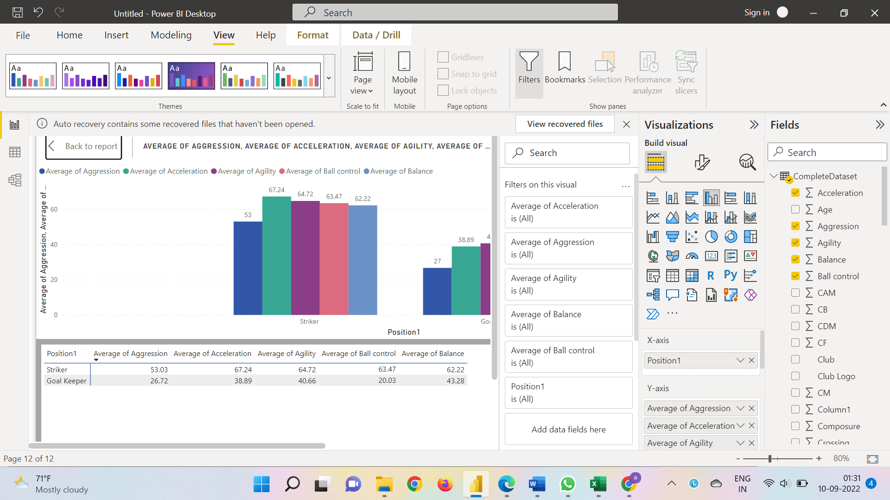

**It can be inferred with the help of the visualization above that the average score of Goalkeepers in terms of Aggression, Acceleration, Agility, Balance and Ball Control is lesser than that of the Strikers. The most contrasting difference can be observed for the average score of ball control for Strikers and Goalkeepers.**

9).Which clubs consists of the best future players? Consider only the players with Overall = 86, plot a graph to show which are the top 10 clubs with most number of best future players.

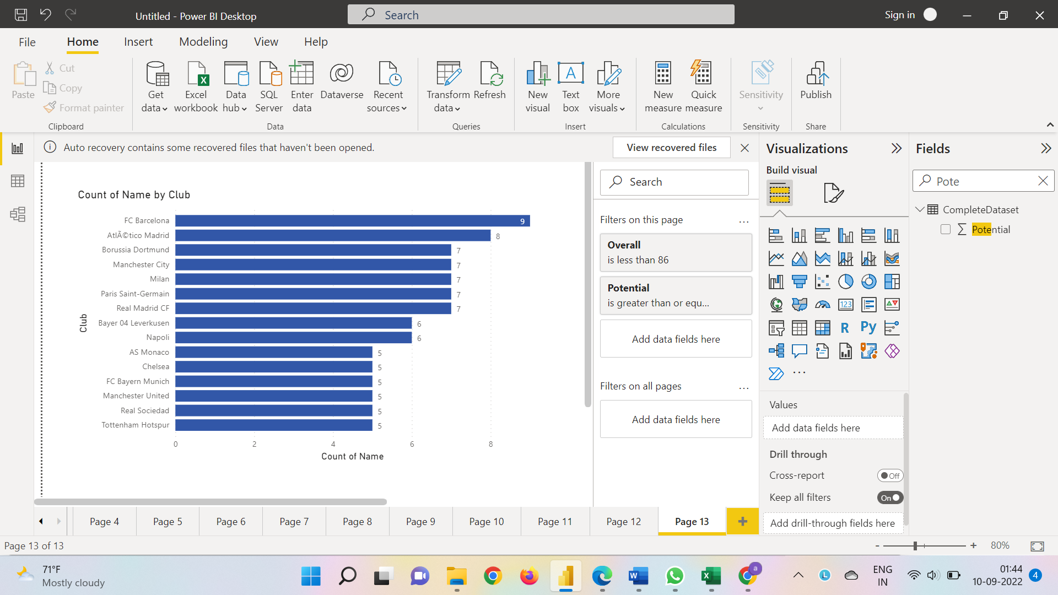

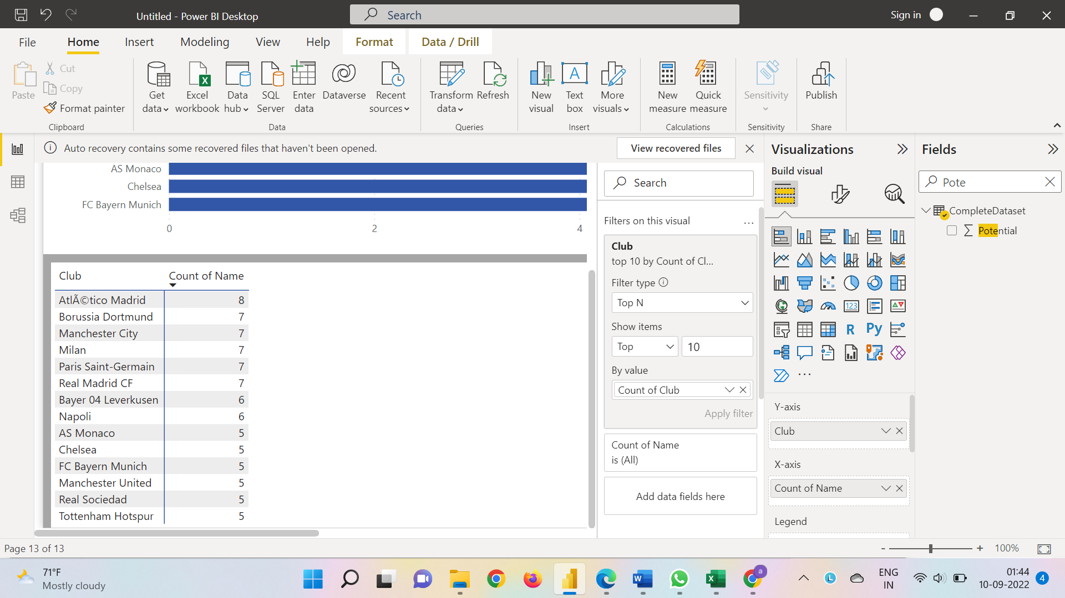

**We can see from the graph and the table that FC Barcelona has the maximum number of best future players followed by Atlético Madrid. Borussia Dortmund, Manchester City, Milan, Paris Saint-German and Real Madrid CF all lie in the third position with an equal number of best future players.**